A Christmas Hack@Speed



Author: Chris Huntingford

Email: Chris.Huntingford@Microsoft.com

Contents

Introduction 3

How to Hack? 3

All or Nothing 3

Go Rogue 3

Double or Nothing 3

Dream Team 3

Lab 1: Data & Dataverse - Mandatory 4

Solution Components 4

Let’s Begin 4

Lab 2: Configuring Forms, Views & Charts in the Dataverse* 14

Solution Components 14

Let’s Begin 14

Form Configuration 16

View Configuration 19

Charts Configuration 20

Lab 3: Configuring your Business Process Flow and Model Driven App experience 24

Solution Components 24

Let’s Begin 24

Business Process Flow 24

Model Driven Application 32

Lab 4: Configuring your Microsoft Flow Notifications* 47

Solution Components 47

Let’s Begin 48

Flow 48

Lab 5: Configuring the Sleigh Sightings Canvas App 52

Solution Components 52

Let’s Begin 52

PowerApps Canvas App 52

Lab 6: Configuring a Basic Power BI Dashboard 68

Solution Components 69

Let’s Begin 70

Power BI Desktop 70

Final Learnings 86

# Introduction

Welcome to the Hack@speed masterclass walkthrough. This document will take you throught the Sleigh Sightings christmas hack.

## How to Hack?

The key part of this Hack is the data supplied in the excel sheet. The ability to get the data into Dataverse is of vital importance, Therefore Lab number 1 is Mandatory. After that you are able to select the Labs you would like to do as there is not always an interdependancy between labs, OR you may build what ever you would like on top of the data, as long as it solves the business problem. Any lab that has a title with a * means that it can be done independantly of the others (based on the completion of Lab 1). The below table will help you understand the dependancies.

|  |  |  |
| --- | --- | --- |
| **Lab Title** | **Technology** | **Dependencies** |
| **Lab 1:** Dataverse | Dataverse & Dataflows | Lab 1 |
| **Lab 2:** Forms, Views Charts | Dataverse | Lab 1 |
| **Lab 3:** Business Process Flow, Model Apps & Dashboards | Flow & Model-Driven Power Apps | Lab 1 & Charts from Lab 2 |
| **Lab 4:** Microsoft Flow | Power Automate Flow | Lab 1 |
| **Lab 5:** Power Apps | Power Apps Canvas Apps | Lab 1 |
| **Lab 6:** Basic Power BI | Power BI | Lab 1 & Power BI Dashboard from Lab 5 |
|  |  |  |

There are a number of ways that you could approach this hack. These are as follows:

### All or Nothing

Go right ahead and try and knock out this entire hack in the time alocated. This whole build can be achieved in less than 90 min by an experienced Maker.

### Go Rogue

Get the data int the Common Data Service in Lab 1 and then build something completely unique on top of it. Do what works for you…

### Double or Nothing

Couple up and split the work. Get someone to do the CDS & Model driven related configuration and the someone else to do the Power BI, Flow and Canvas App build. This has proven to work very well as both areas do not conflict.

### Dream Team

Get a team together, knock out the first lab and then allocate each lab to a different person. This is also totally doable as various areas do not intersect but work well together.

# Lab 1: Data & Dataverse - Mandatory

We will start off by bringing in the Excel data structure into the Common Data service (CDS) by leveraging Data Flows within the CDS and Power Query.

***Please Note:***

***This Part of the Hackathon is mandatory as all other elements of the solution rely on the data being in the Dataverse***

## Solution Components

Microsoft Power Query

Dataverse

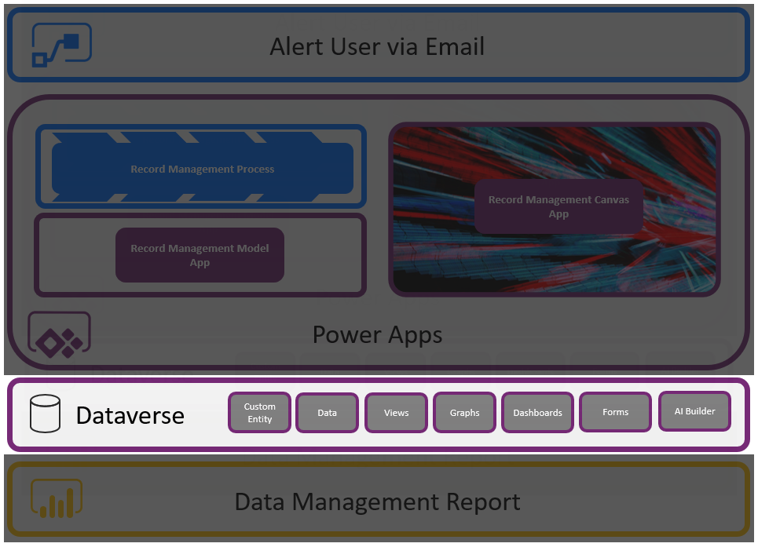

## Let’s Begin

Navigate to make.PowerApps.Com and make sure you are in the environment that you created in the Prerequisites. You MUST NOT be in the “Default Environment”, you must be in the environment that you added.

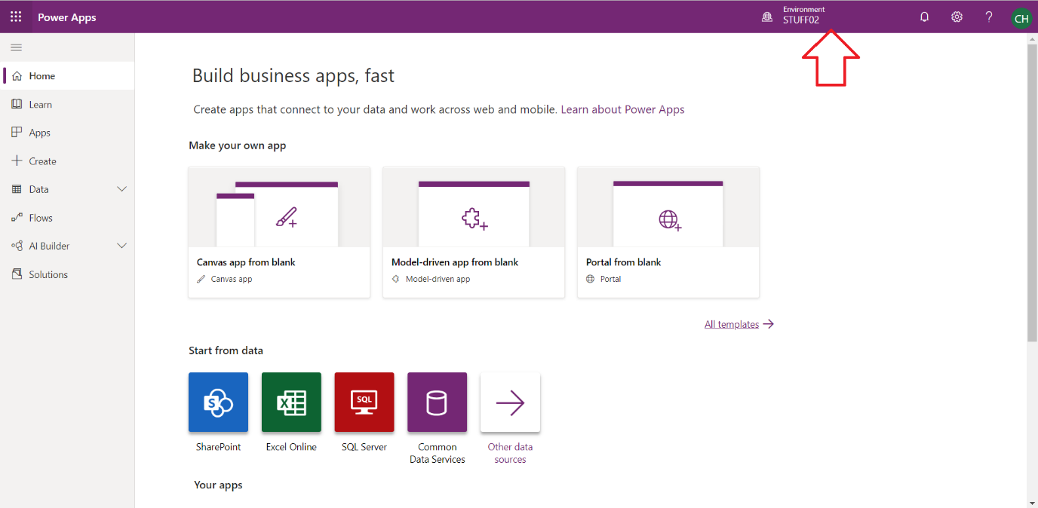

Select **DataFlows**

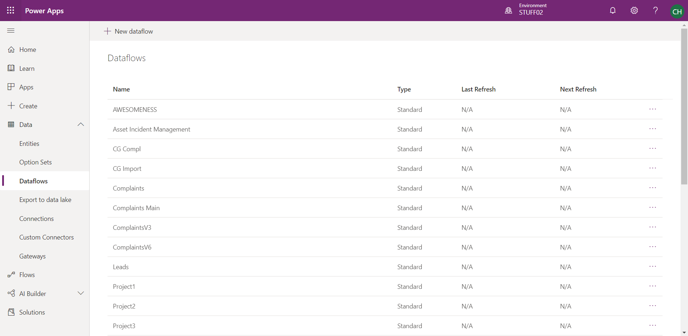

Create a New Dataflow and call it “Sleigh Sightings”.

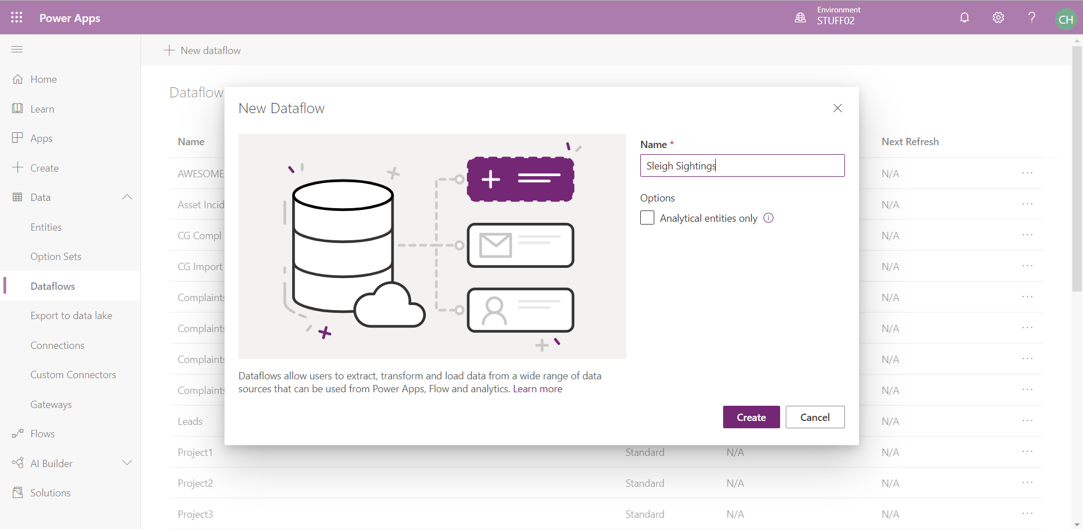

There are a load of options / Data Sources you could select from. Pick “Excel” in this scenario.

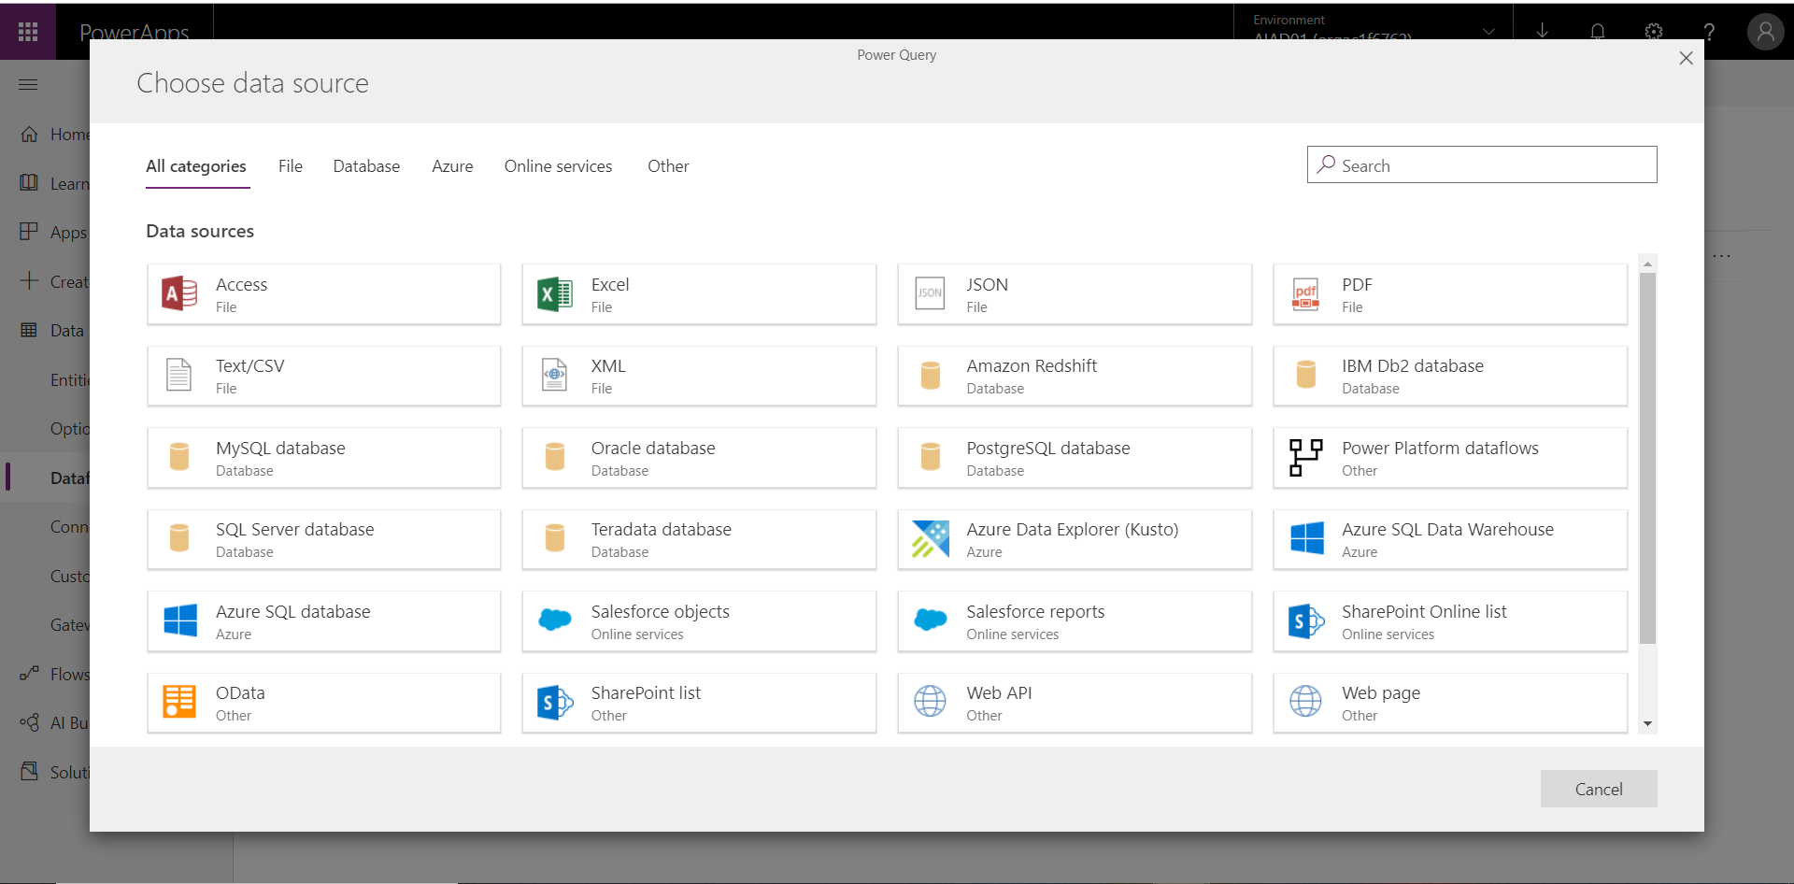

You will now be taken to a page where you need to specify the location of the Excel Document.

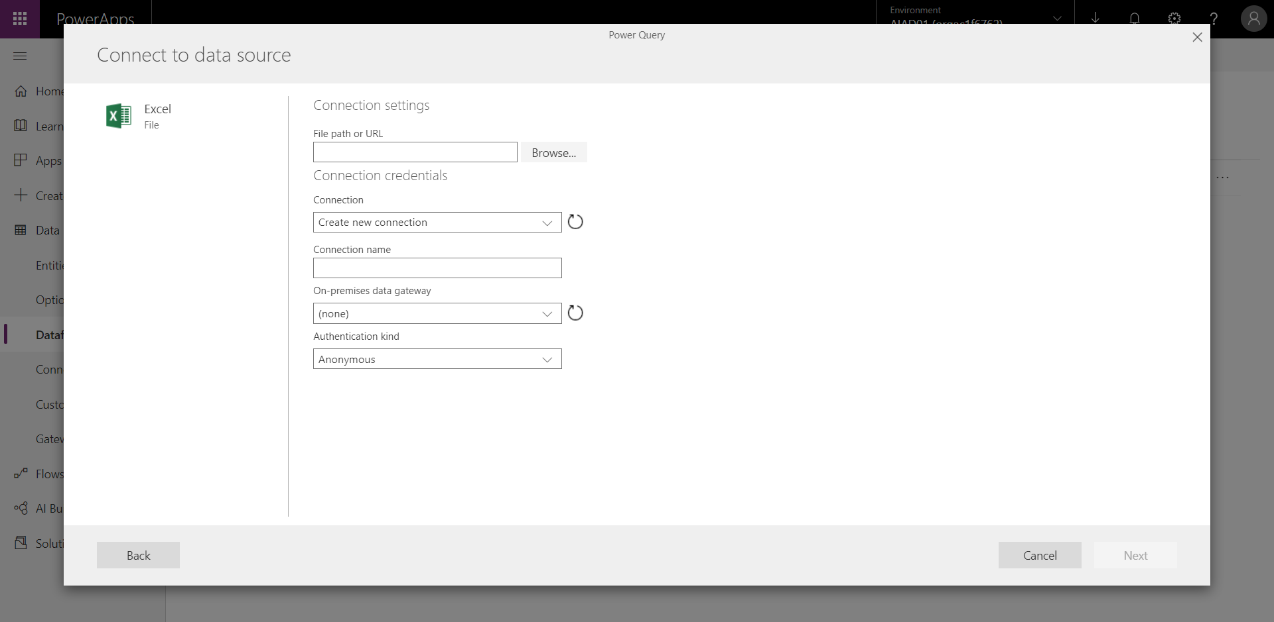

Click **Browse** and another OneDrive window will open. Assuming you have not done this exercise before, you will see no files in the OneDrive repository.

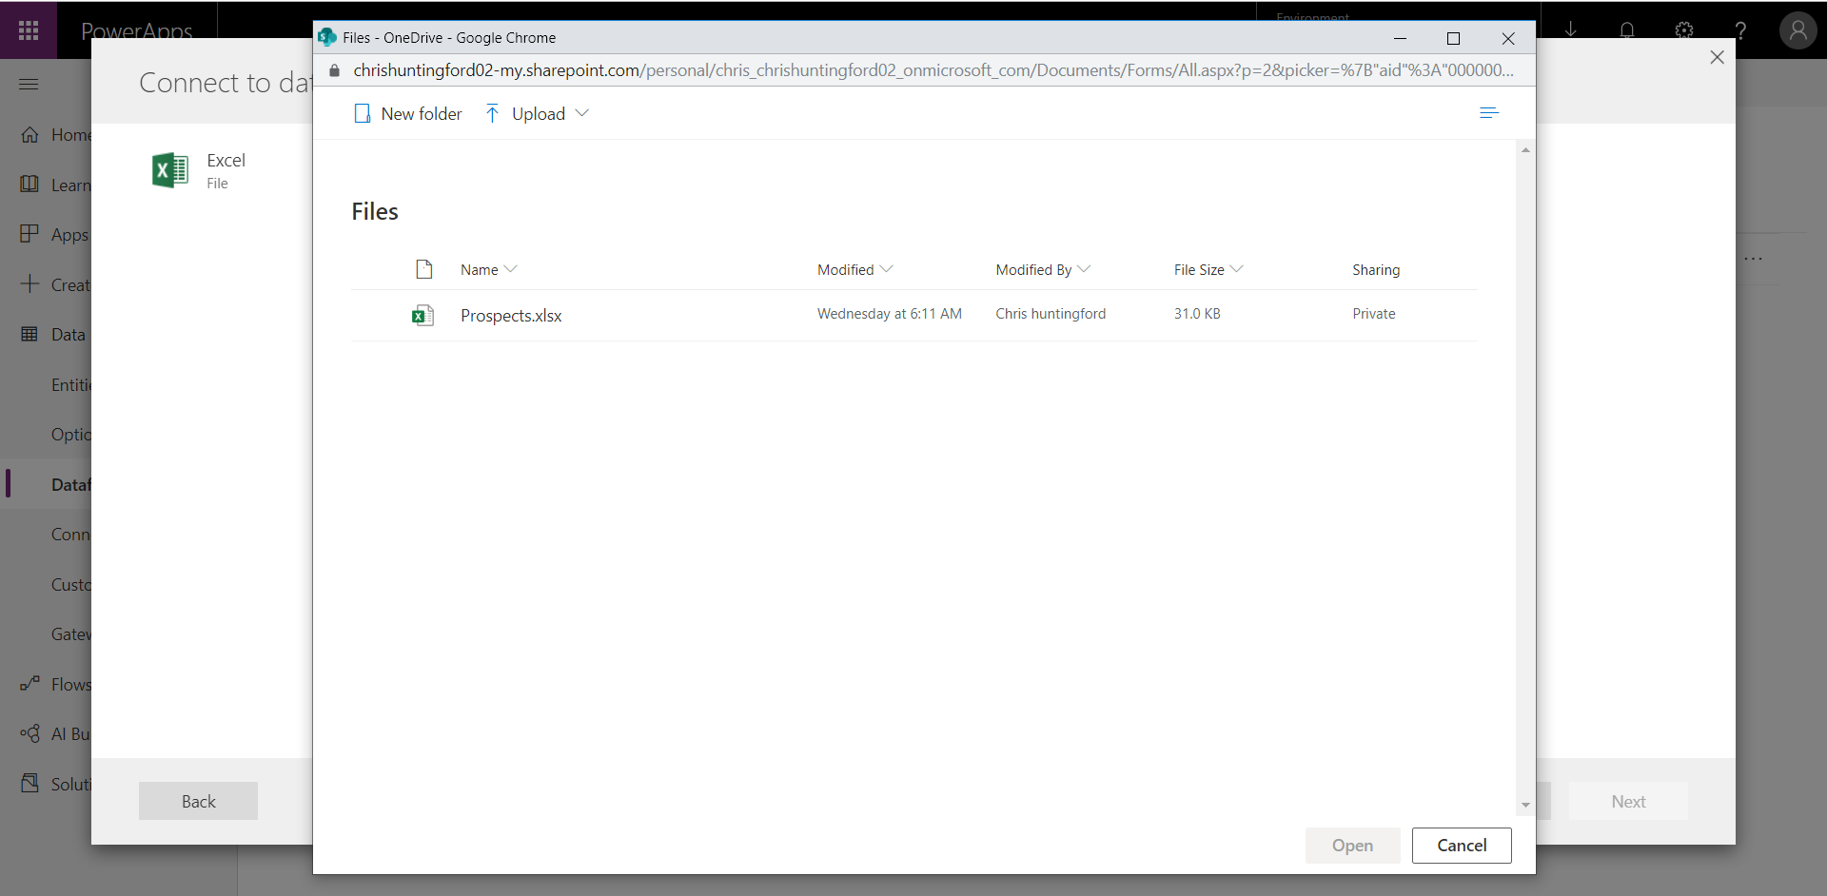

Click **Upload** and navigate to the location where you saved the “Sleigh Sighting” Excel file, Select the file and select Open.

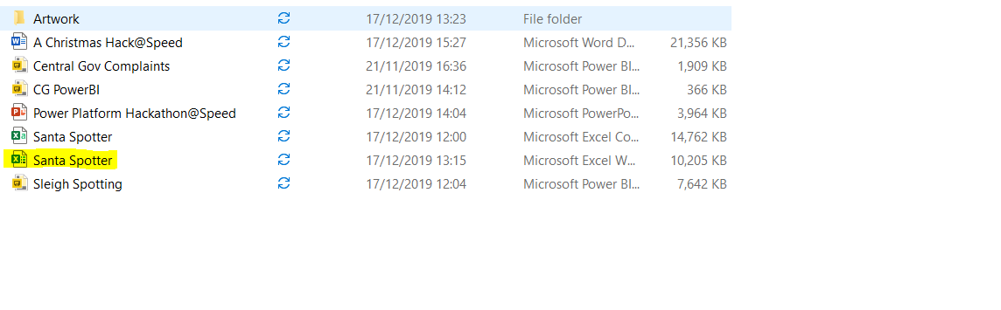

Once the file has been uploaded you will see it in the OneDrive repository.

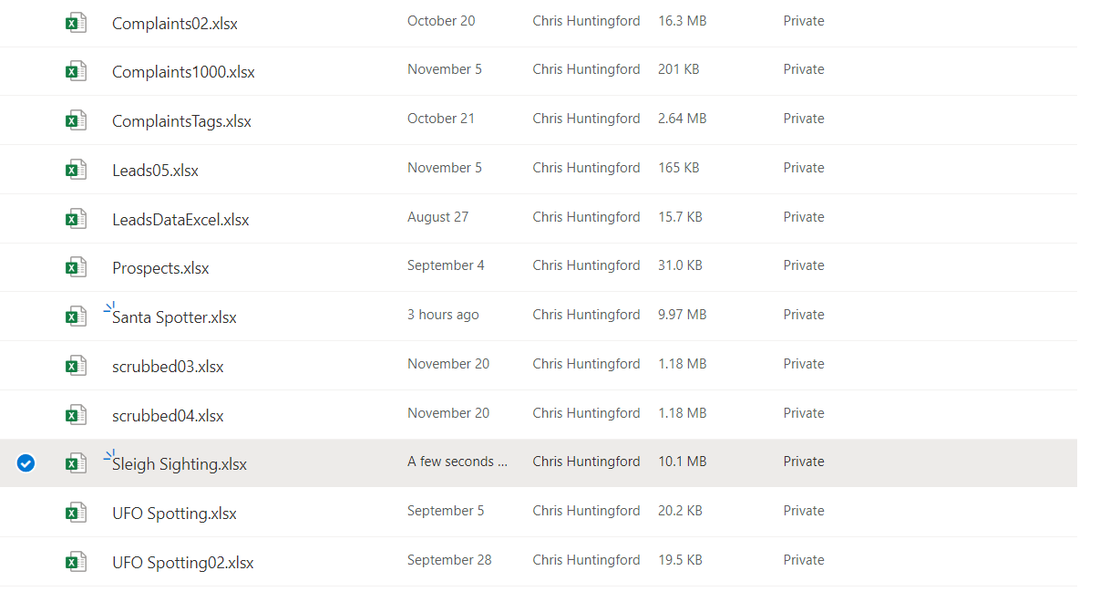

Select the file and click **Open**. This will load the file path into the Power Query Data Source connection settings.

Check the file location and click **Next** to progress to the next step.

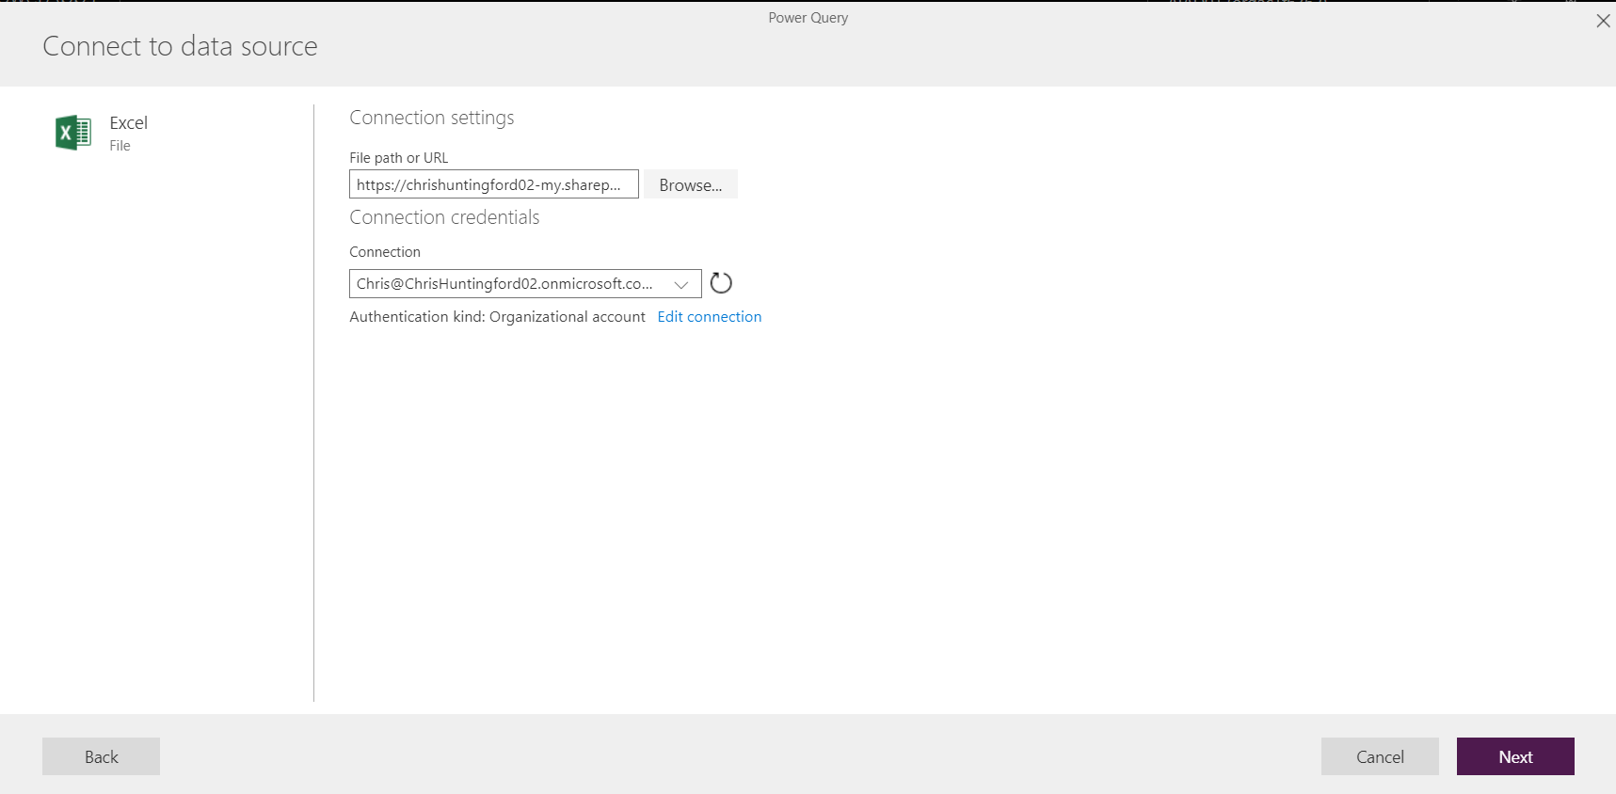

View the Excel dataset in Power query and select **Transform Data** to continue.

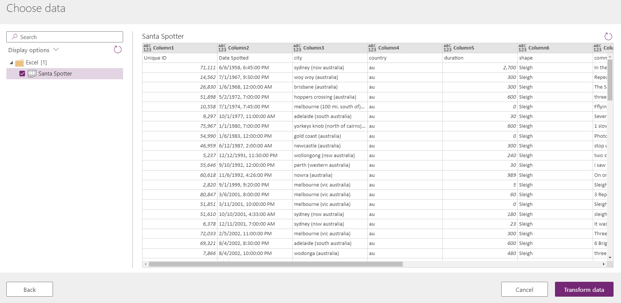

Select **use first Rows as Headers** from the **Transform Table**.

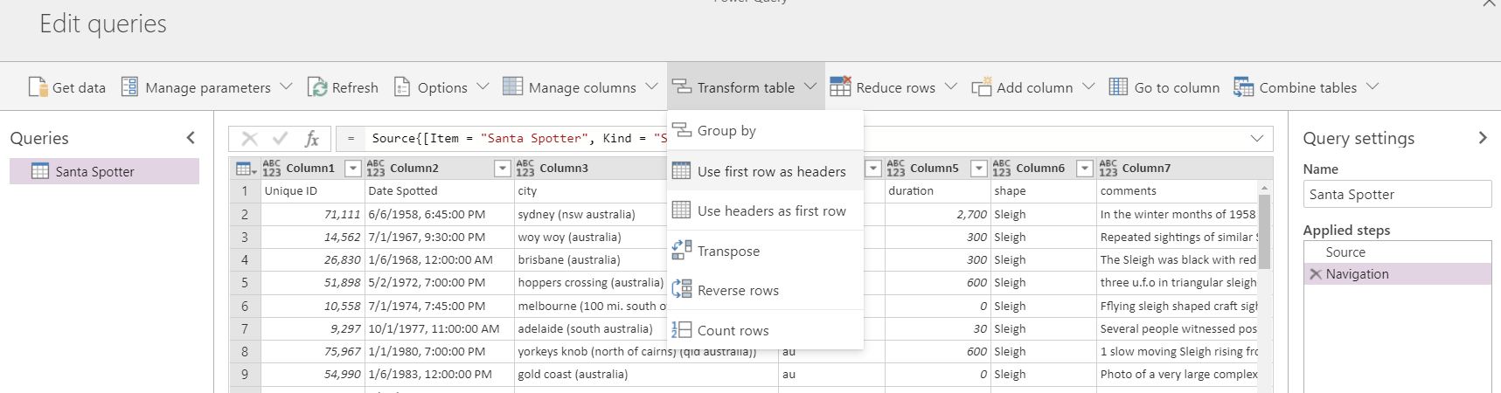

You will see that the new header names are now visible in the table.

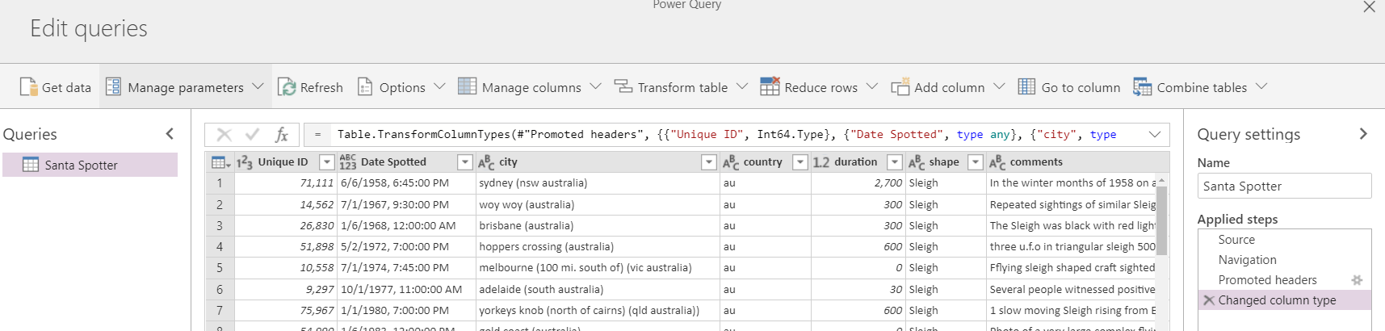

Change **Unique ID** to a text value

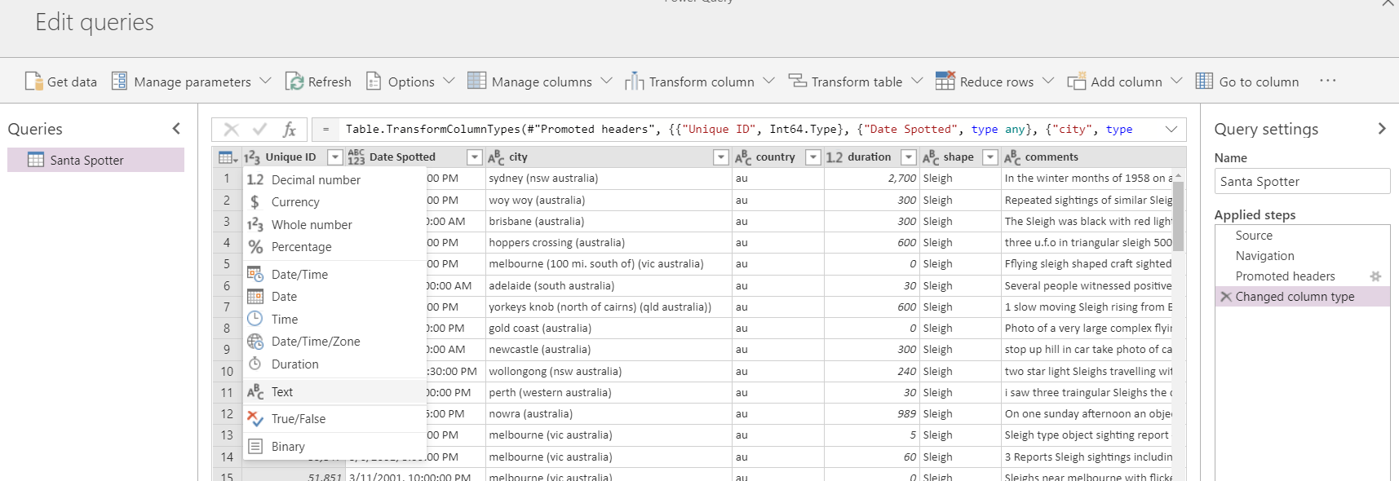

Select **Replace Current** when changing the data types.

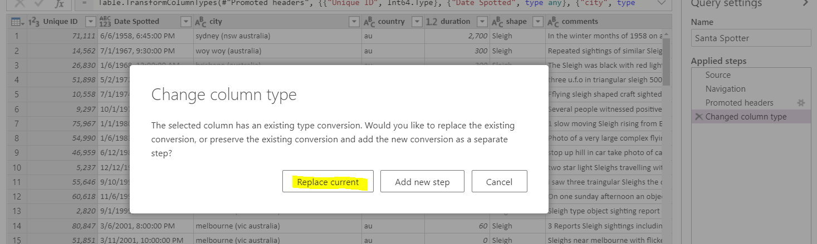

Change the Latitude and longitude data types from Numeric to Text.

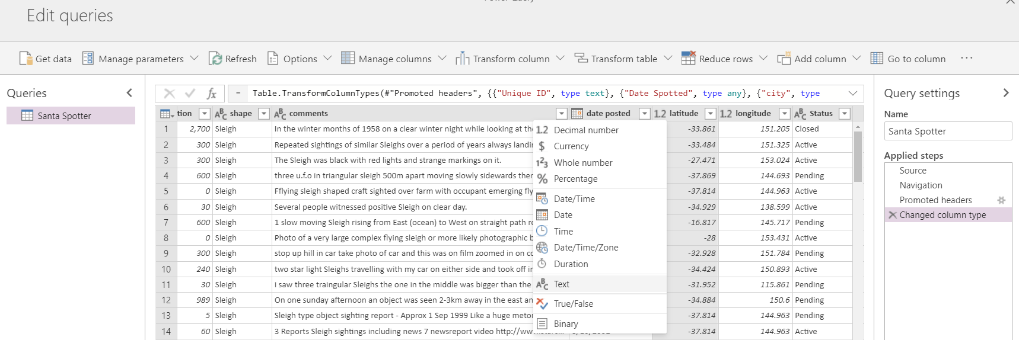

Select **Replace Current** when changing the data types.



Do the same for longitude.

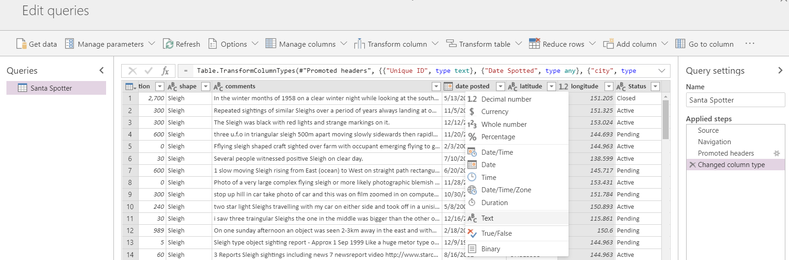

Select **Replace Current** when changing the data types.



Select **Next** to move onto the Power Query load screen.

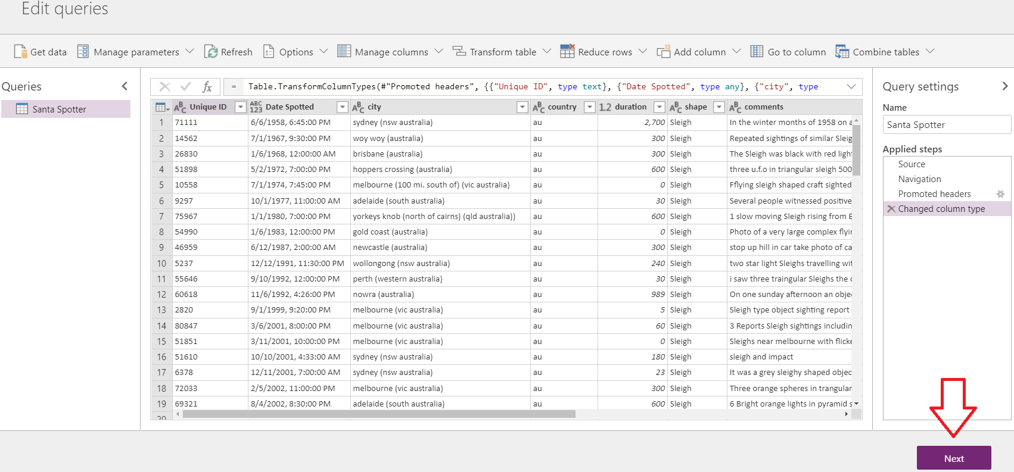

On the Mapping Entities screen select **Load to a New Entity**. This will create a brand-new entity when importing the data and will save you the time of having to create the entity and attributes from scratch.

Enter the Entity name as **Sleigh Sighting** and the Display name as **Sleigh Sighting**.

Select **Delete rows that no longer exist in the query output**.

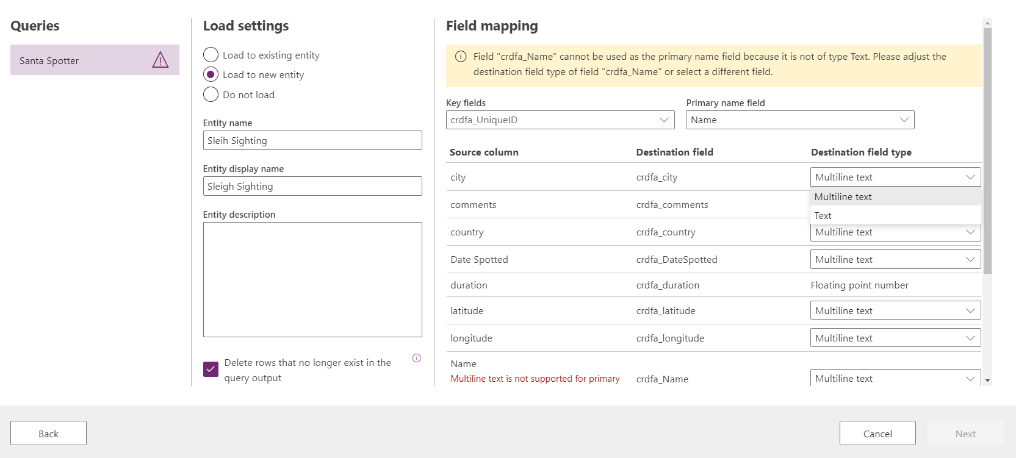

Set all the field types, **EXCEPT FOR “COMMENTS”**, that can be changed, to **Text**.

Set the Key field to **ID** and the Primary field name to **Unique ID** as well.

Set the Primary name field to **Name**.

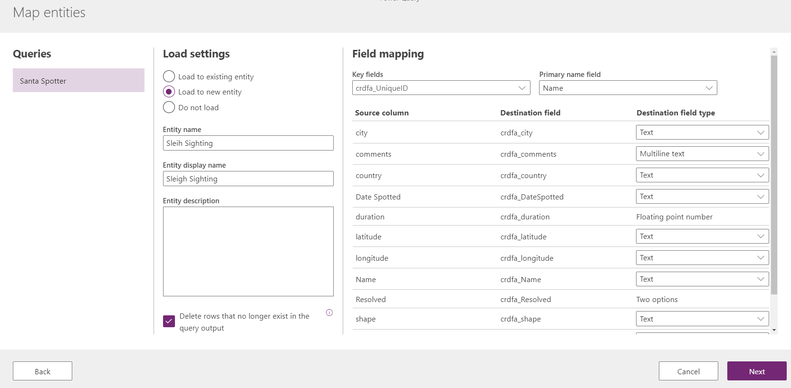

Hit **next** to continue.

Select **Refresh manually** and then click **Create**.

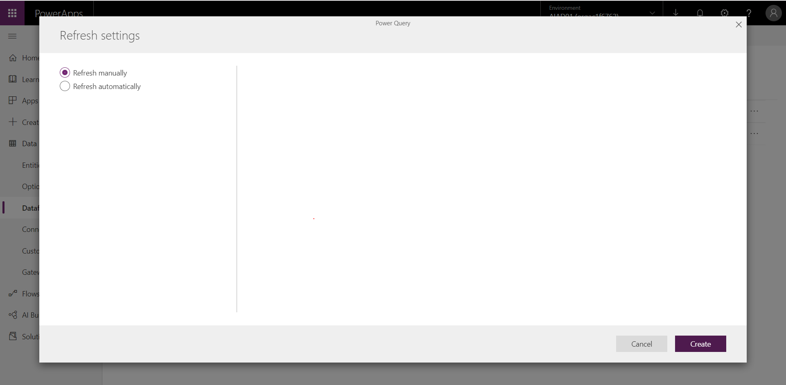

You will be able to see the indicator of the entity being created in the background, in the form of 3 resizing dots. This may take some time so use the time to plan your next steps….

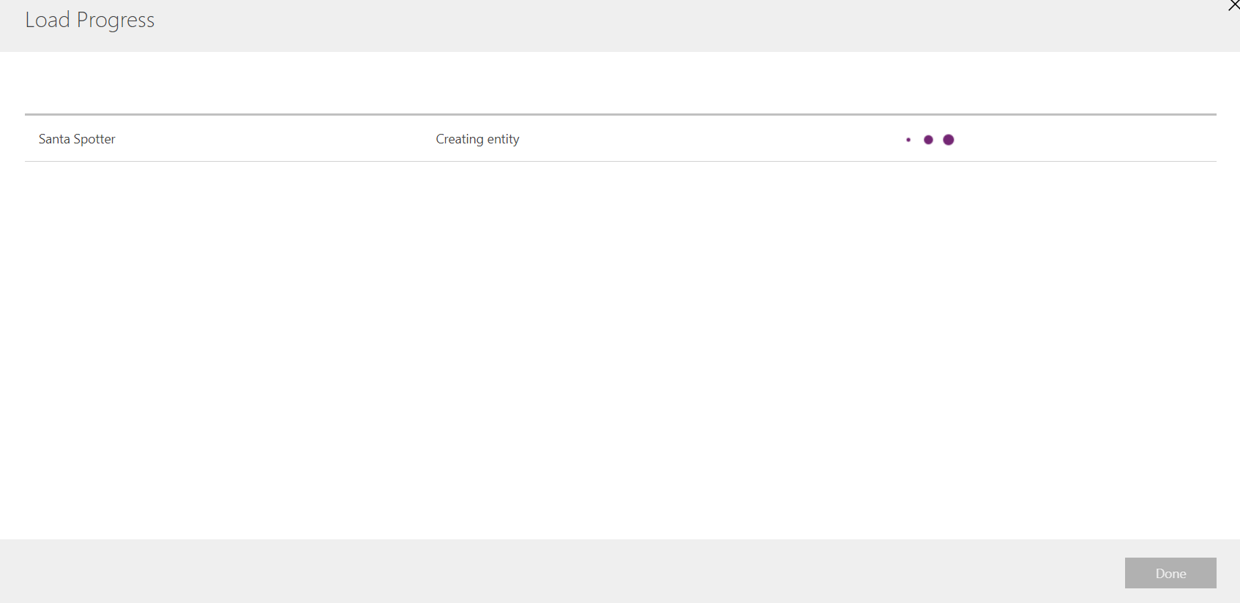

Once the process is complete you will be notified. Click the **Done** button to proceed.

You will see your Data flow has now been added to the list and your entity added to the Common Data Service

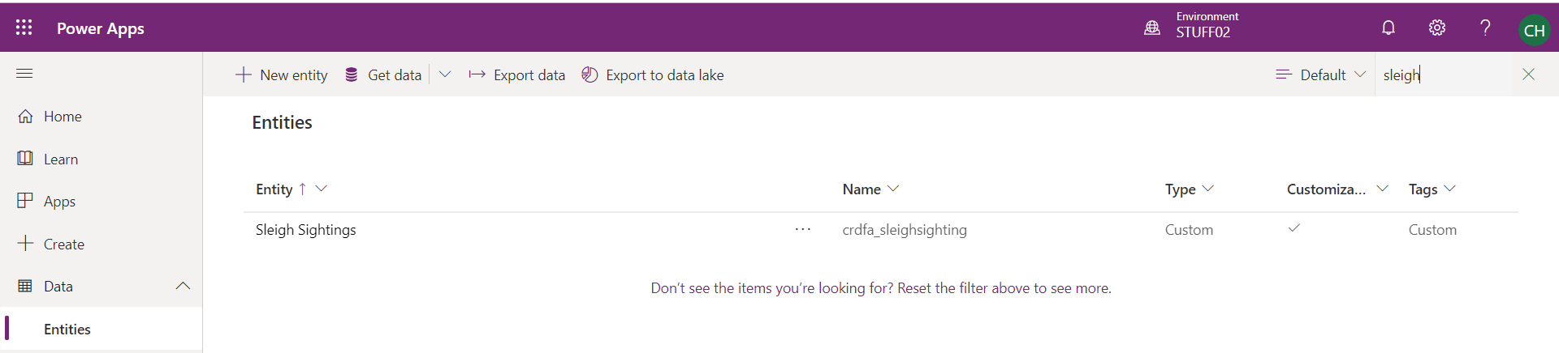

This concludes Lab number 1 and the focus around the bringing in data from a data source into the Common Data Service.

# Lab 2: Configuring Forms, Views & Charts in the Dataverse*

We will start off by leveraging the data structure you just brought into the Common Data Service (CDS) via Data Flows from Excel. This will give the users of the solution a much more efficient mechanism to interact with the data.

***Please Note:***

***This lab can be completed independently, with only Lab 1 being and no support of the other labs.***

## Solution Components

Dataverse: Forms, Views & Graphs



## Let’s Begin

Navigate to [*https://make.powerapps.com*](https://make.powerapps.com) and select **Data** from the menu on the left. Then select **Tables**. This will display a list of the standard data tables within Dataverse. This is the home of all tables that exist within your environment.

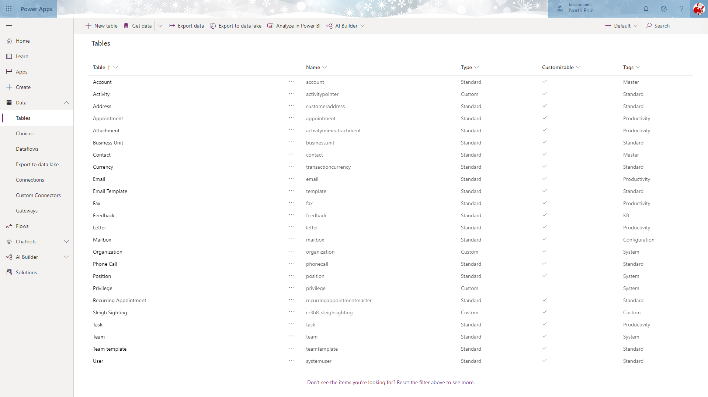

Search for “Sleigh Sightings” using the search box at the top right corner and you will see that a table has been created. If you do not see your Sleigh Sightings table listed check the following:

1. Make sure you are in the correct environment
2. Refresh the entire maker experience web page

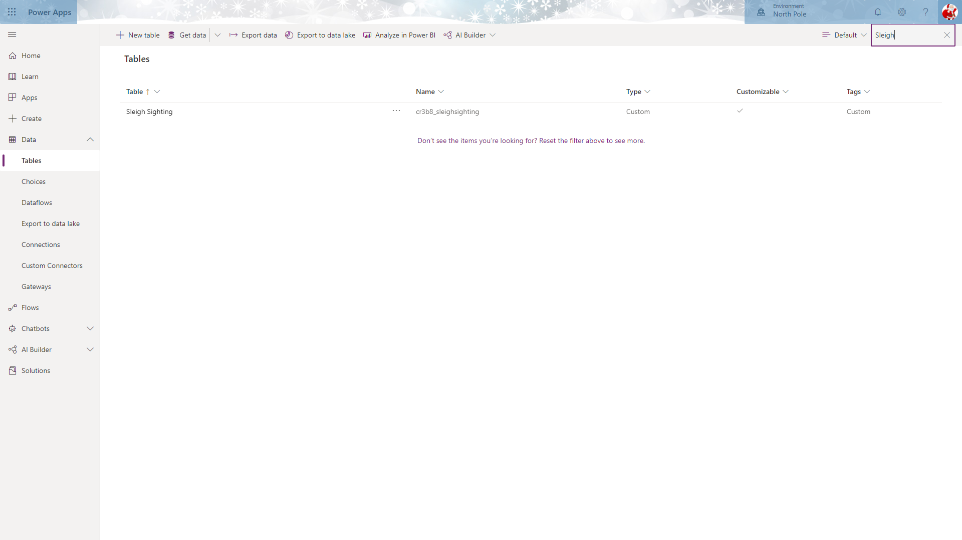

Clicking on the **Sleigh Sightings** will display the Columns that exist within that Table.

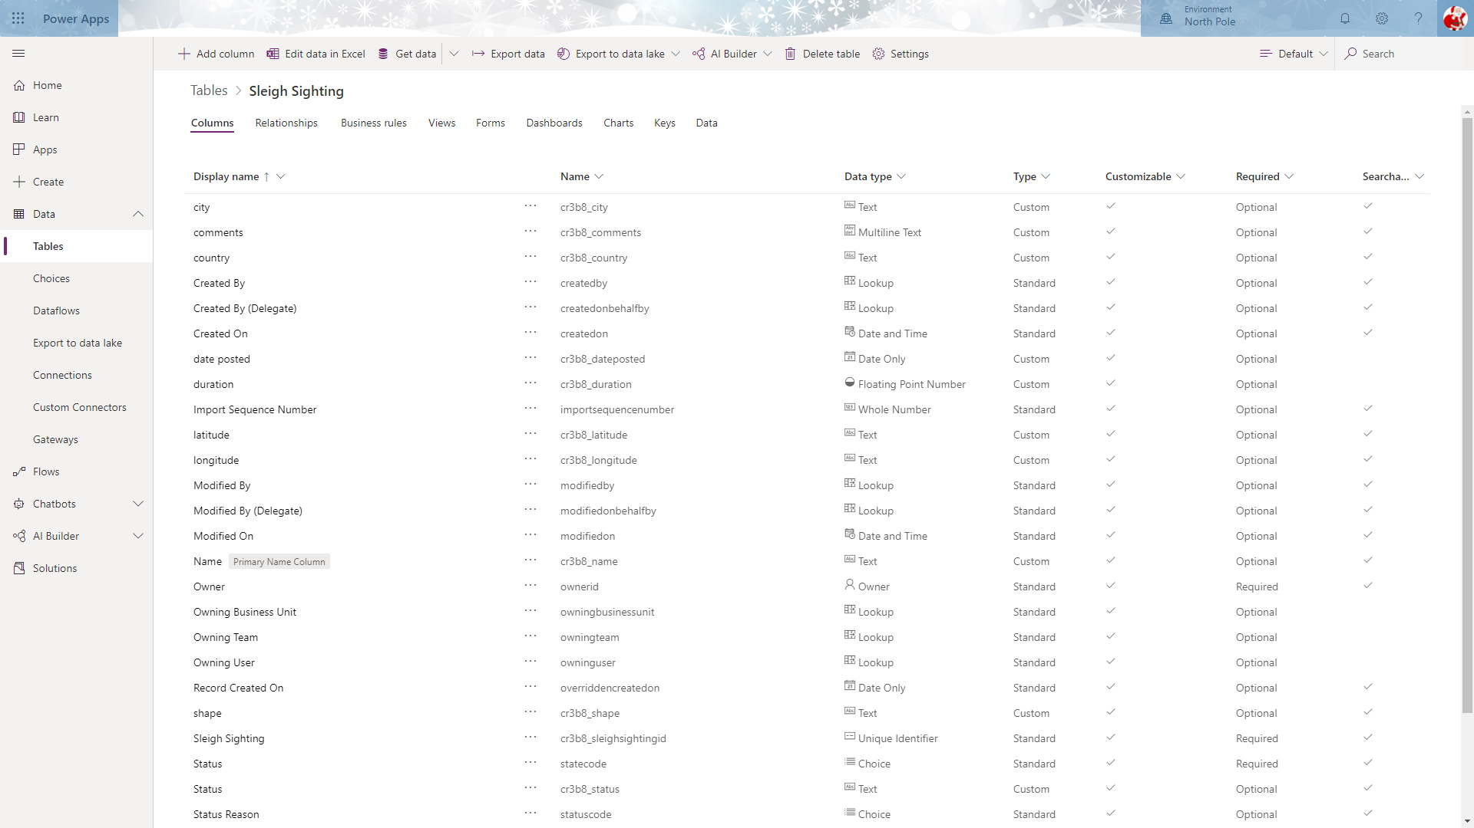

### Form Configuration

Forms are the mechanism used to capture and display data in Model Driven Applications.

Select the **Forms** option from the tab headings and click the form named “Information” with the **Form type** “Main”

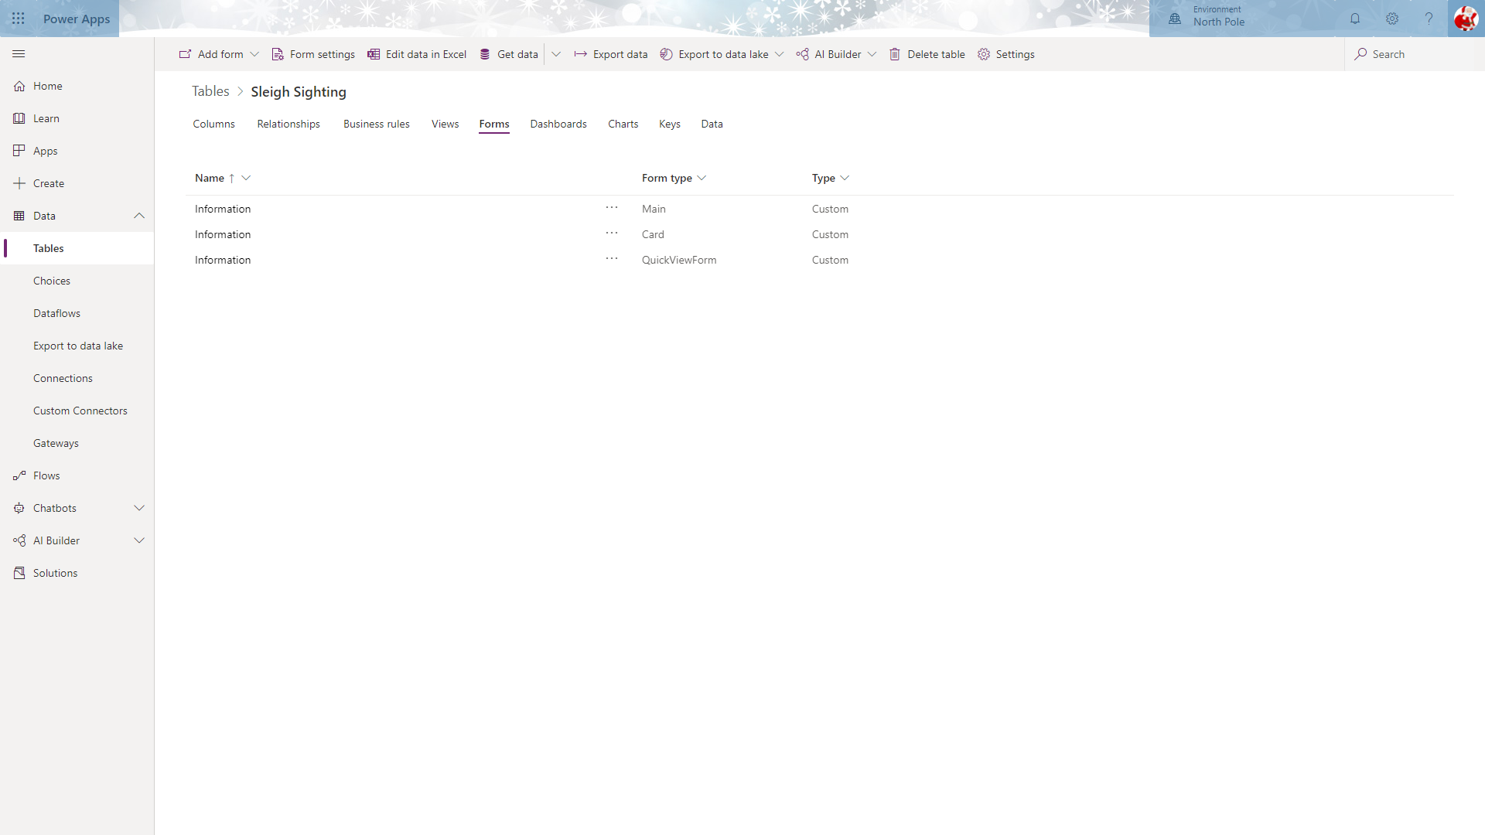

This will open the form editor.

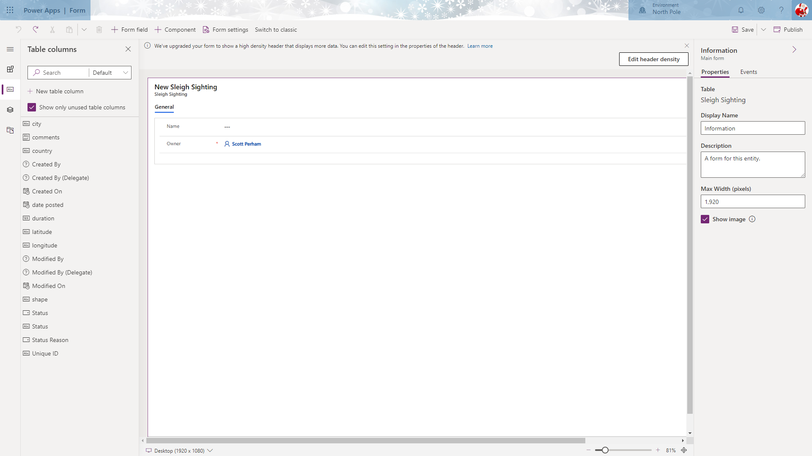

Drag and drop the following fields from the **Table Columns** panel on the left onto the designer:

1. city
2. country
3. latitude
4. longitude
5. date posted
6. duration
7. shape
8. comments
9. Status (There are two status fields, make sure you select the TEXT version of the field) 

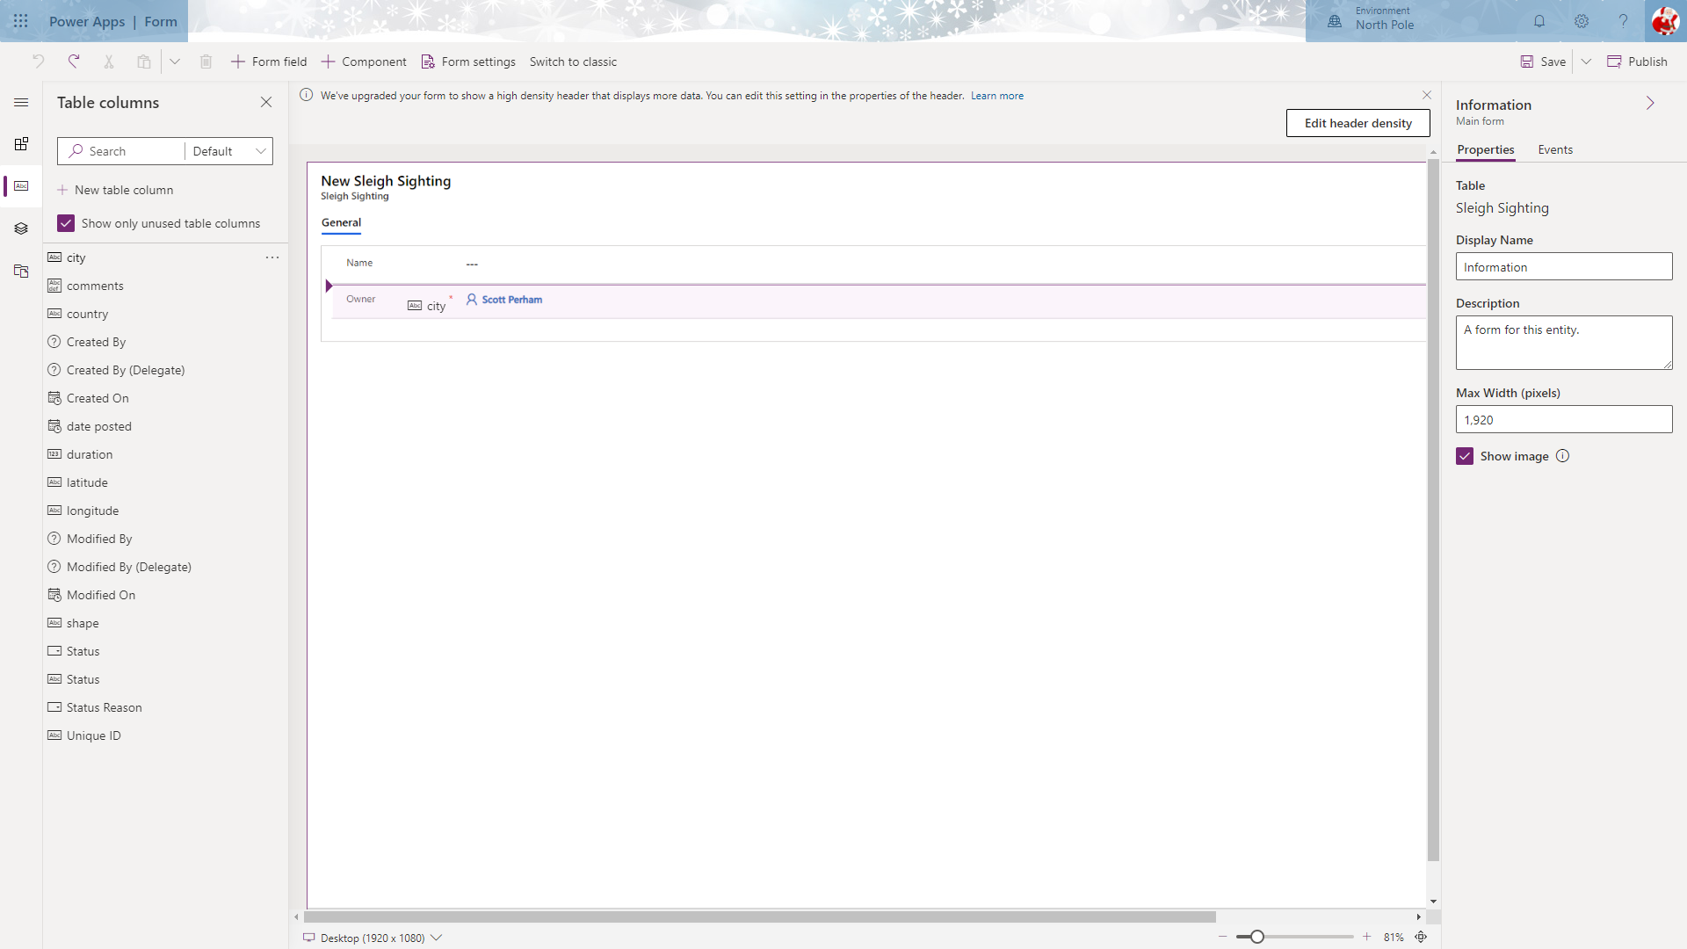

**Save** and **Publish** the form. You MUST do this before navigating back to the main Table screen.

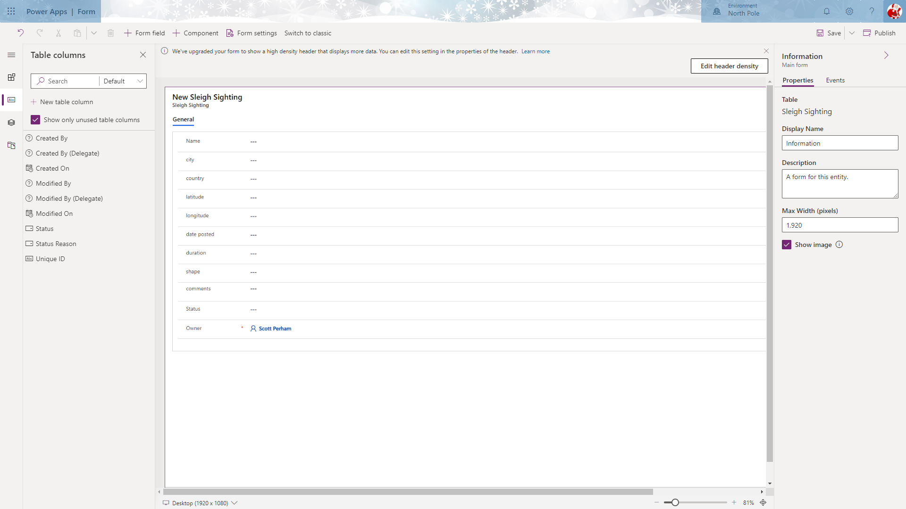

Click the Browser Back button to navigate to the main Table screen.

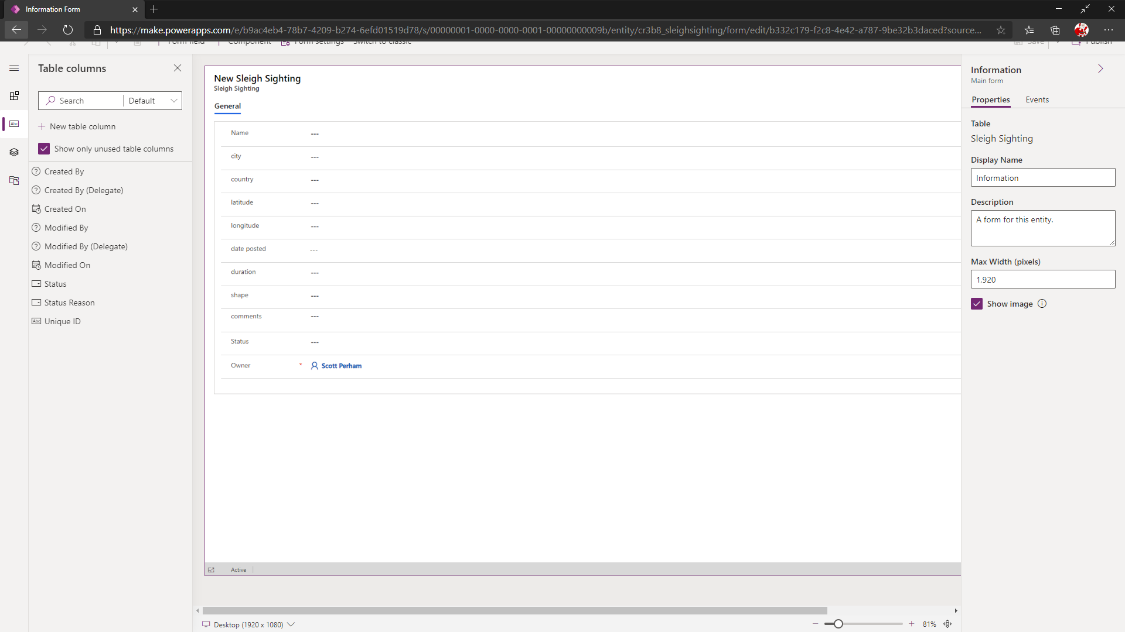

### View Configuration

Views are the mechanism used to view lists of data within all application types within the Power Platform.

Select the **Views** tab from the menu and click the view named “Active Sleigh Sightings”.

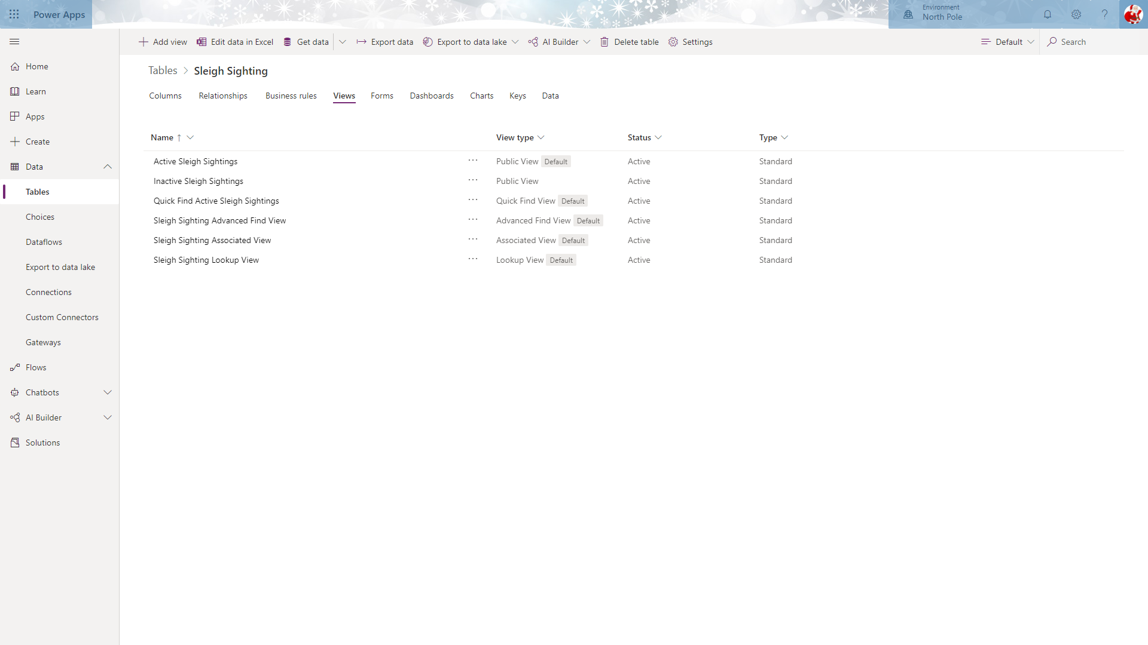

This will open the view editor with the default columns selected.

Drag and drop the following fields into the main view headers section.

1. City
2. Country
3. Duration
4. Date posted
5. Shape
6. Status

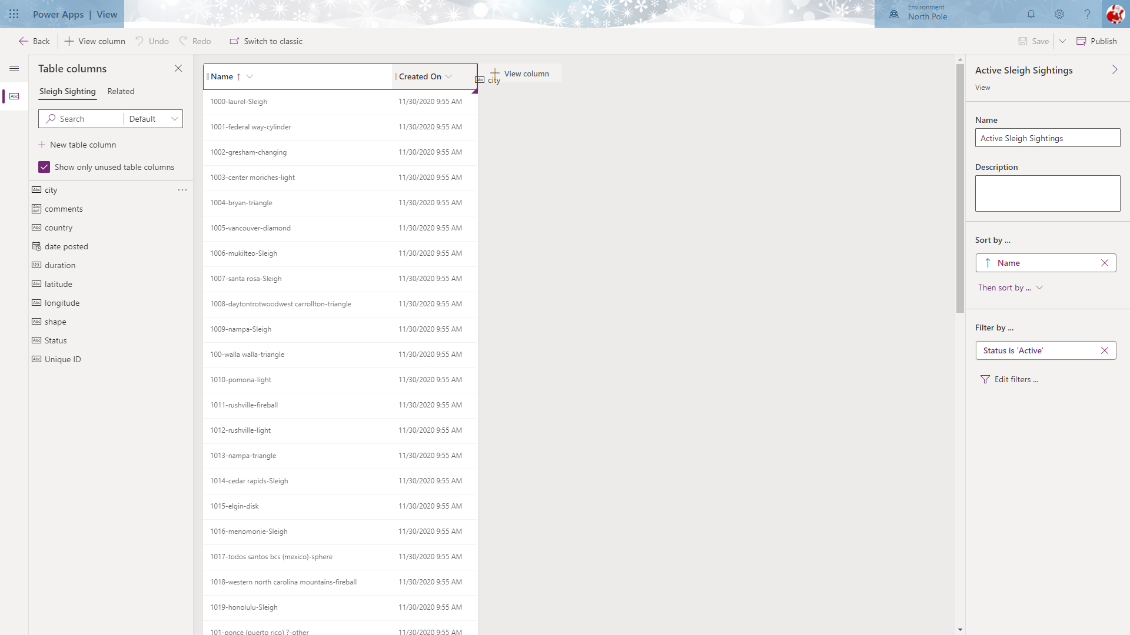

**Save** and **Publish** your changes to the “Active Sleigh Sightings” view. You MUST do this before you navigate back to the main Table screen.

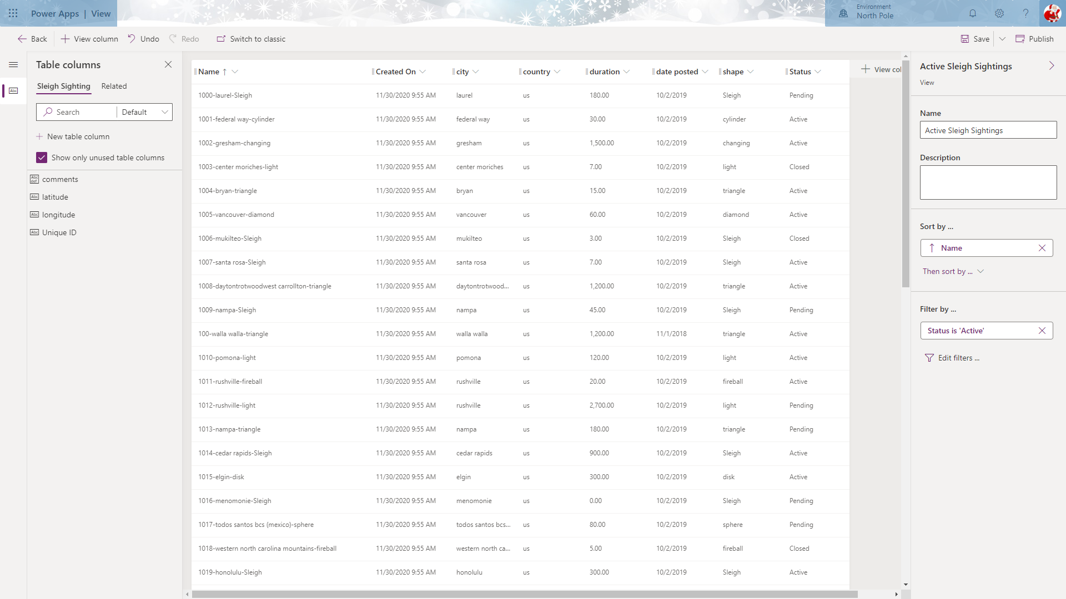

Once the view has been saved and published, use the **Back** button to navigate back to the Table screen.

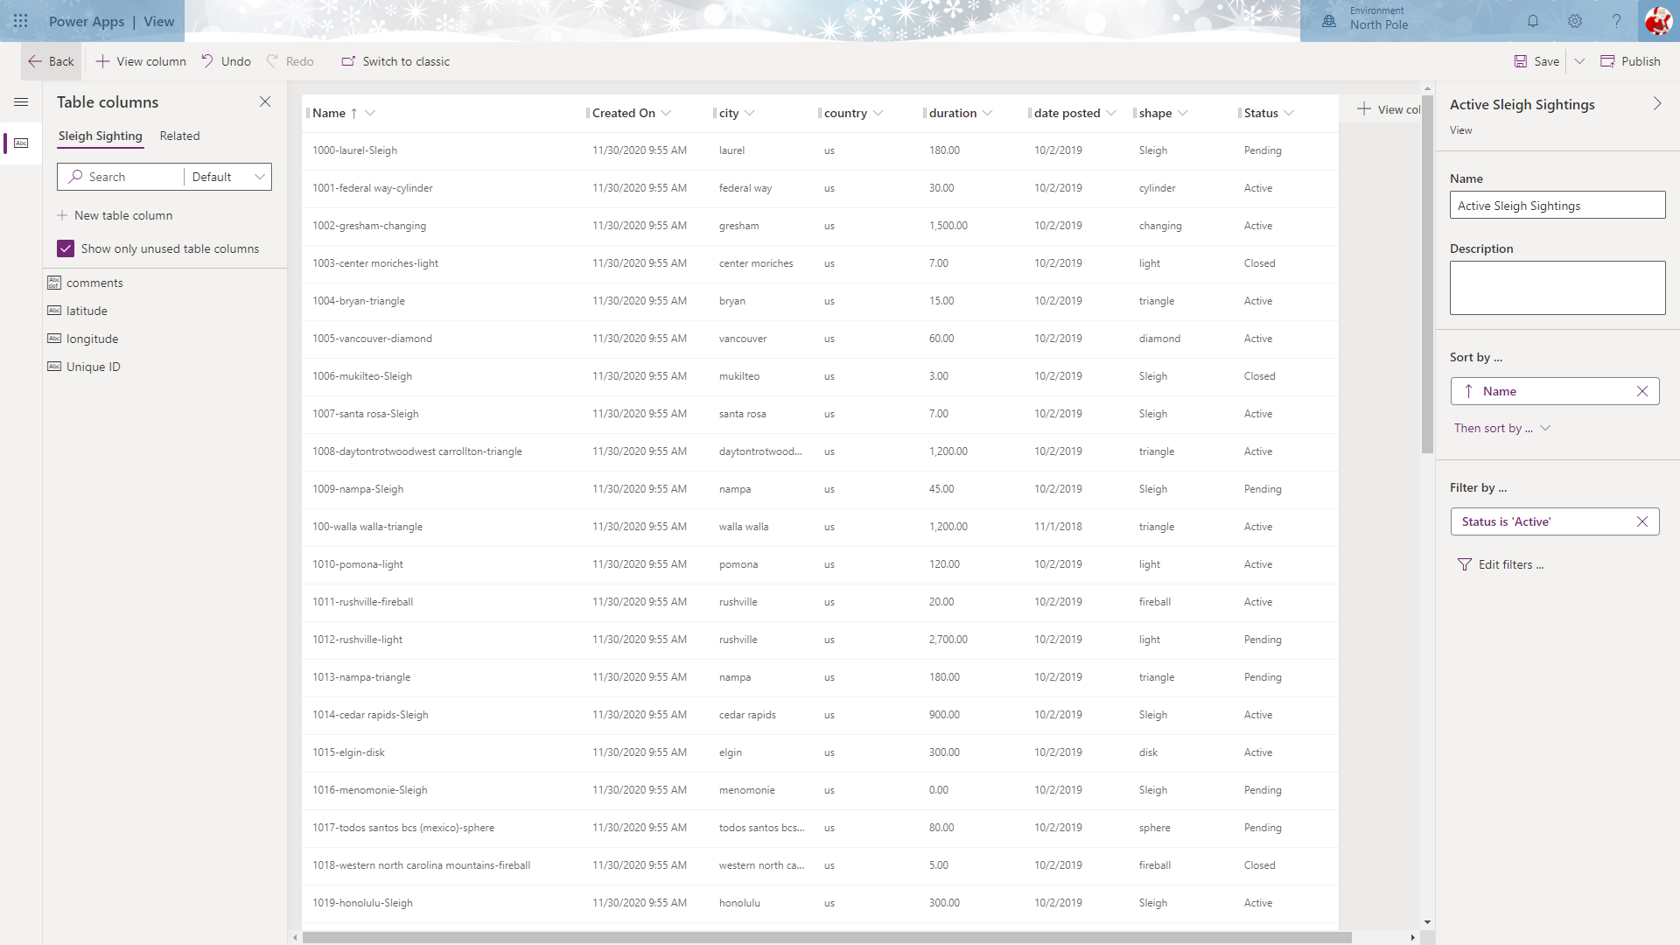

### Charts Configuration

Charts are a mechanism to enable users the ability to understand and interact with data in a more visual format.

Select the **Charts** tab from the menu.

You will see that there are currently no charts available within the table.

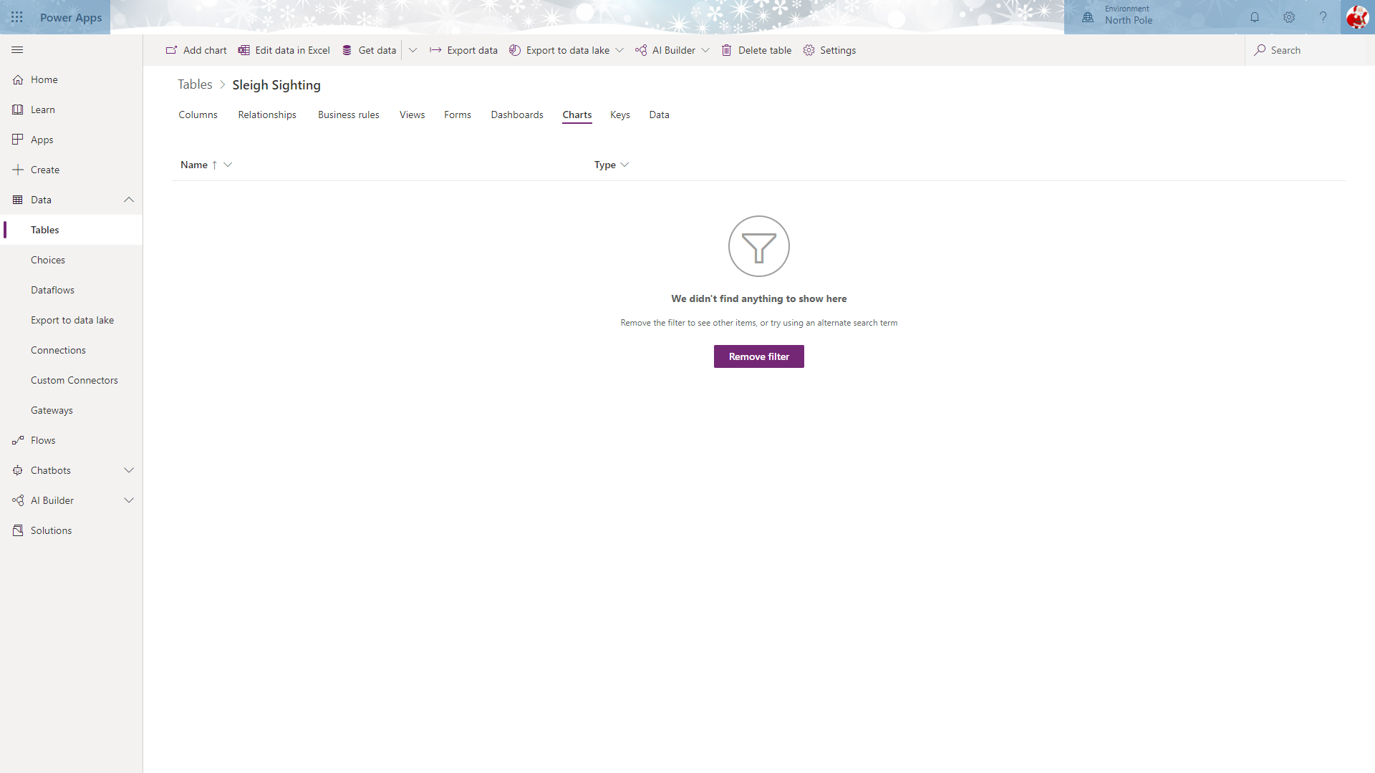

Create a new chart by clicking **Add chart**.

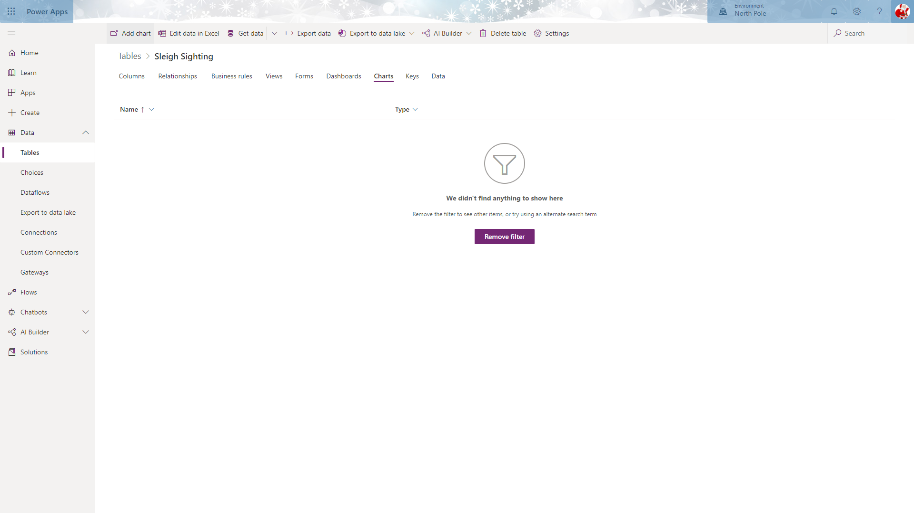

This will open the chart editor in a separate page.

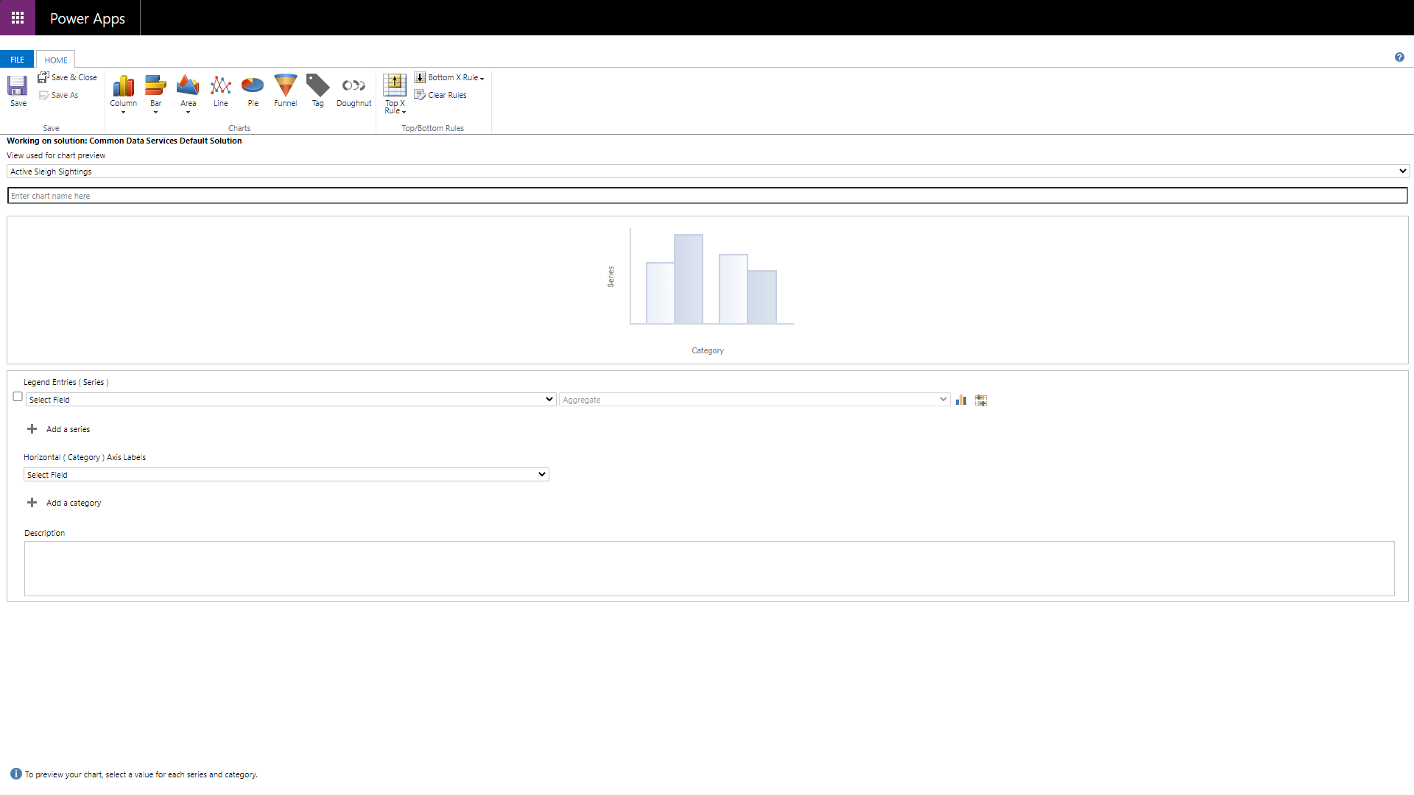

The first chart to create is the distribution of sleigh shapes that have been sighted.

Choose Pie chart from the toolbar and choose the following from the available options:

1. View: **Active Sleigh Sightings**
2. Legend Entries: **Unique ID**
3. Horizontal Axis Labels: **Shape**

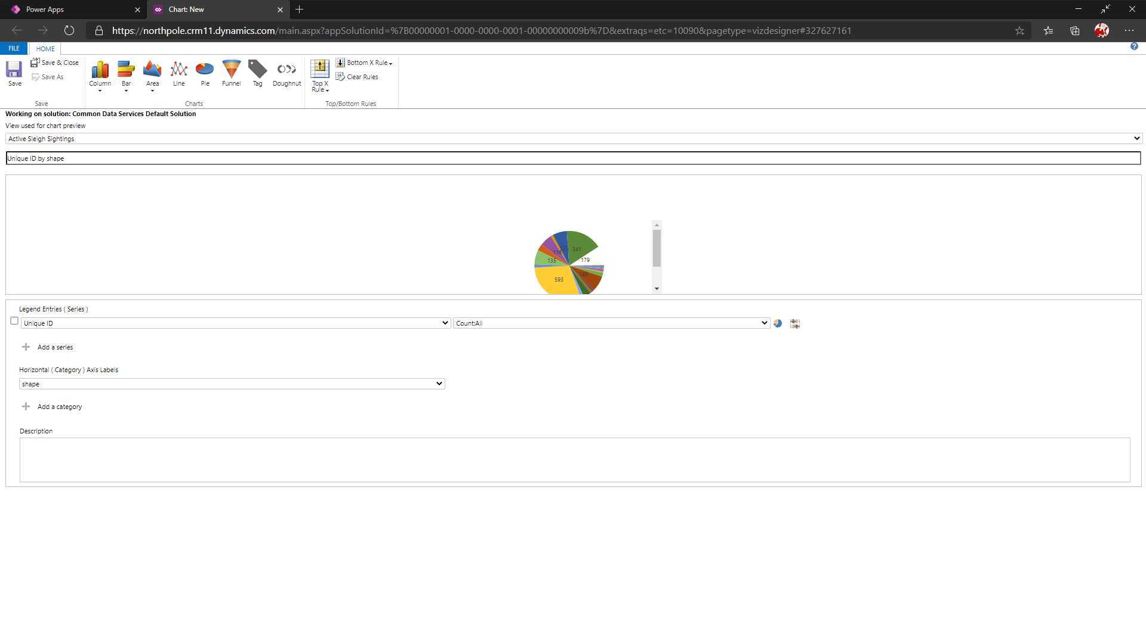

Click **Save & Close** to return to the charts list.

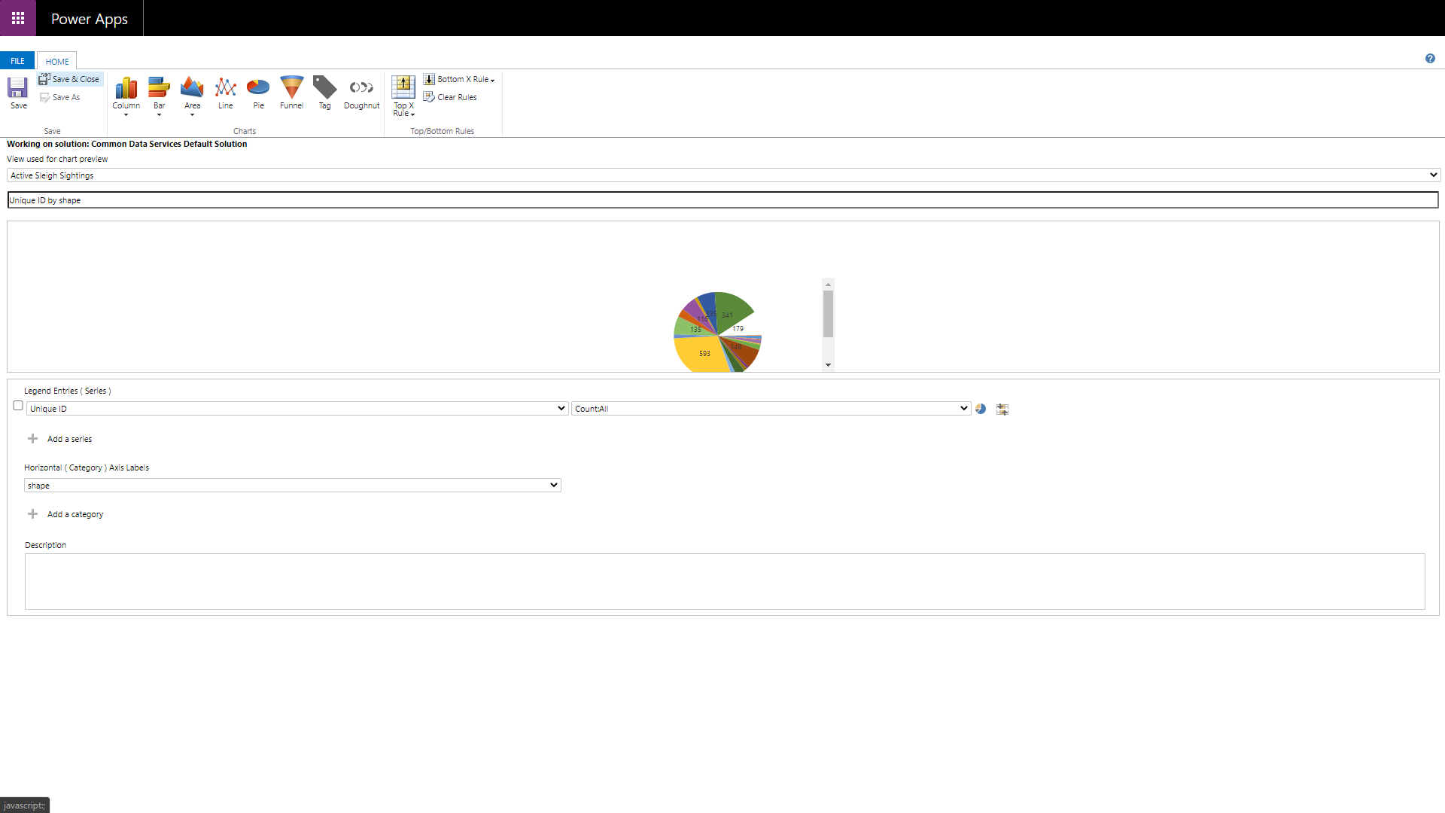

You will see the new chart displayed in the list of available charts.

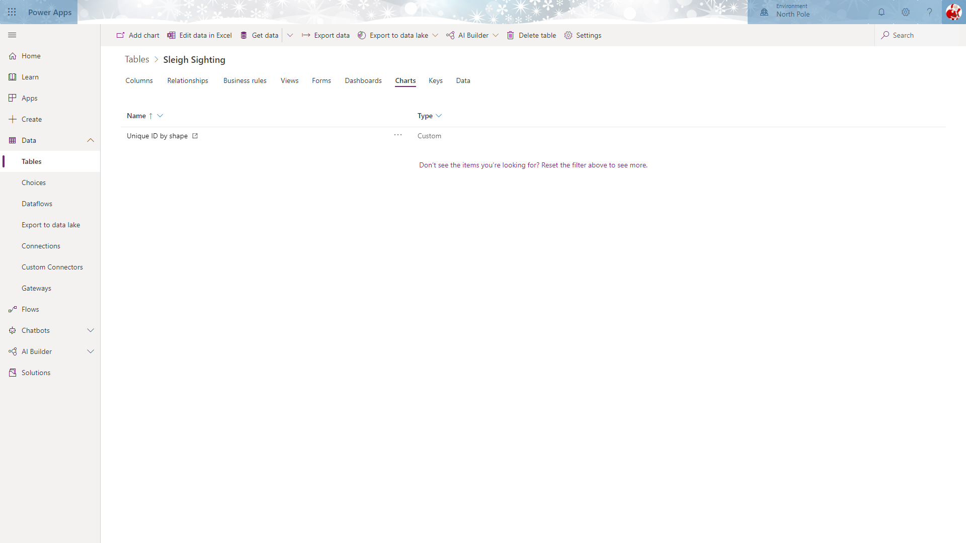

Create another chart using the following options:

1. Chart type: Column
2. View: **Active Sleigh Sightings**
3. Legend Entries: **Unique ID**
4. Horizontal Axis Labels: **Status**

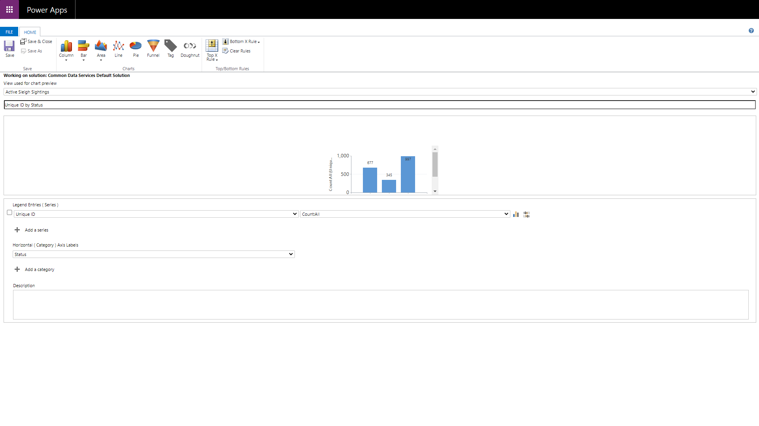

And a third using the following options:

1. Chart type: Area
2. View: **Active Sleigh Sightings**
3. Legend Entries: **Status**
4. Horizontal Axis Labels: **Date posted / year**

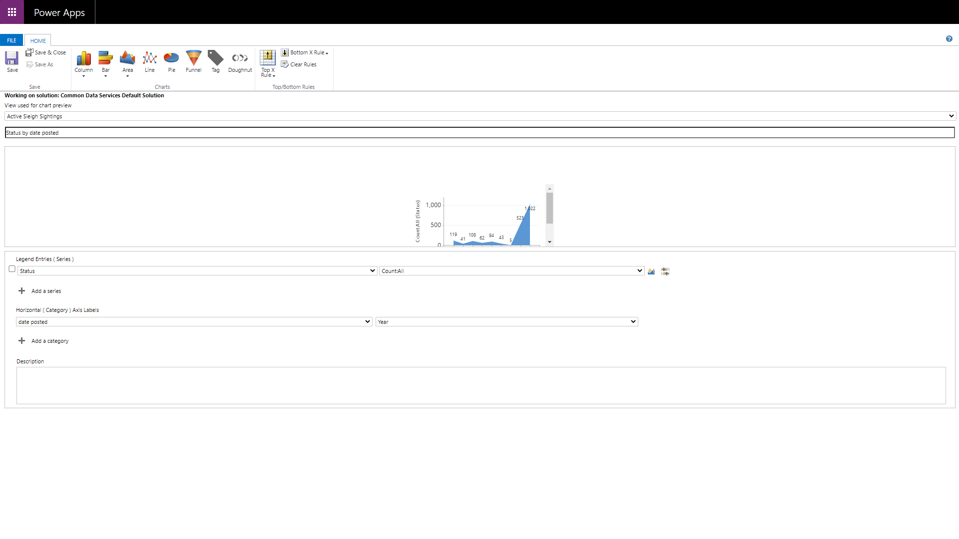

Once these charts have been created, they will be displayed in the list of available charts for the Sleigh Sightings table.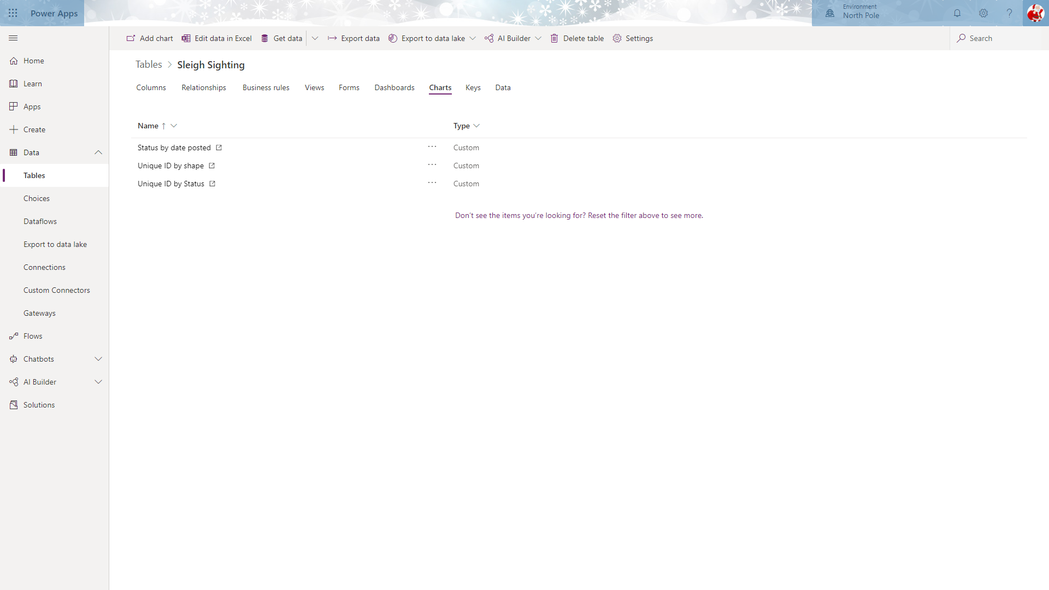

These charts will be added to a dashboard in a later lab.

# Lab 3: Configuring your Business Process Flow and Model Driven App experience

In this lab we will configure a Model Driven application for the mid office users who will be controlling the Sleigh Sightings process and managing the flow of information

***Please Note:***

***Many of the elements in this lab are is reliant on the completion of Lab number 2. If you do not complete Lab number 2, the forms, graphs and views will not work in the same way. This is especially relevant in the Dashboards section.***

## Solution Components

PowerApps (Model Driven Applications)

Microsoft Flow : Business Process Flow

PowerApps (Classic Dashboards)

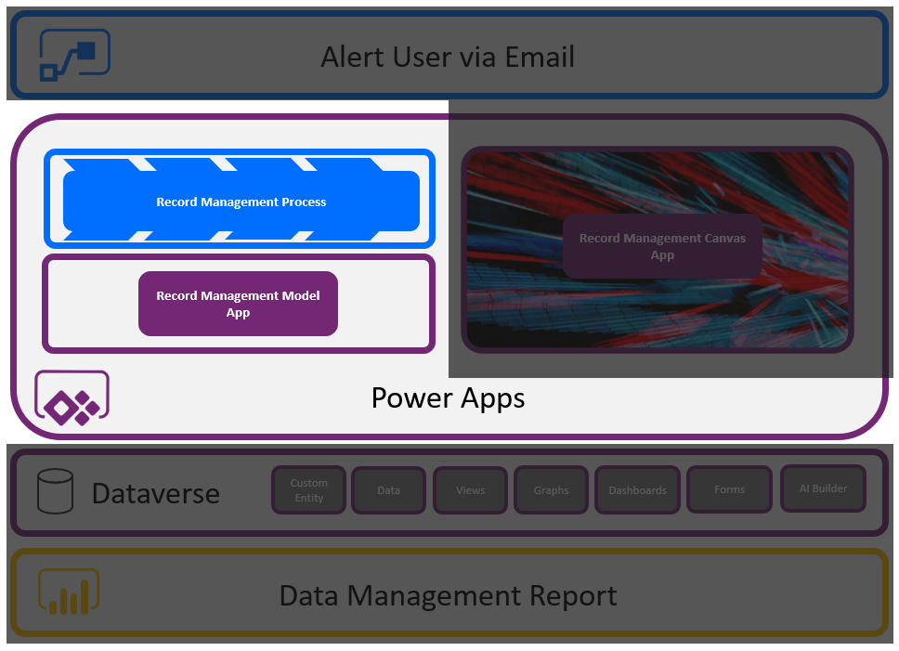

## Let’s Begin

### Business Process Flow

We will be creating a basic step-by-step process for the elves to follow when entering a new sleigh sighting.

Select **Flows** from the left menu and then the **Business process flows** tab.

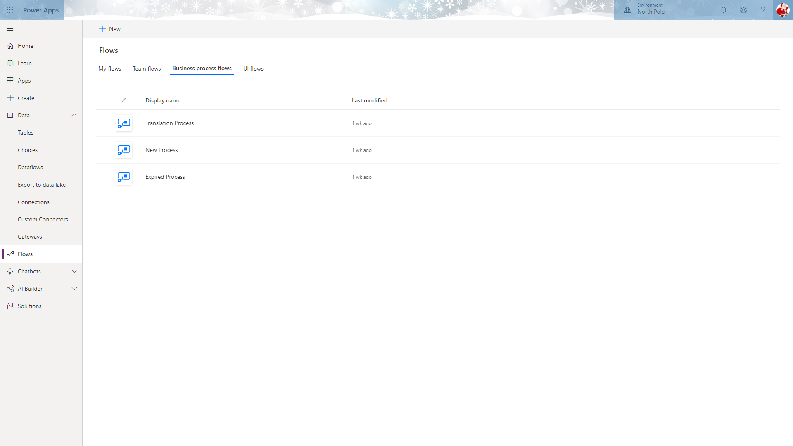

Click the **+ New** at the top of the page to create a new flow.

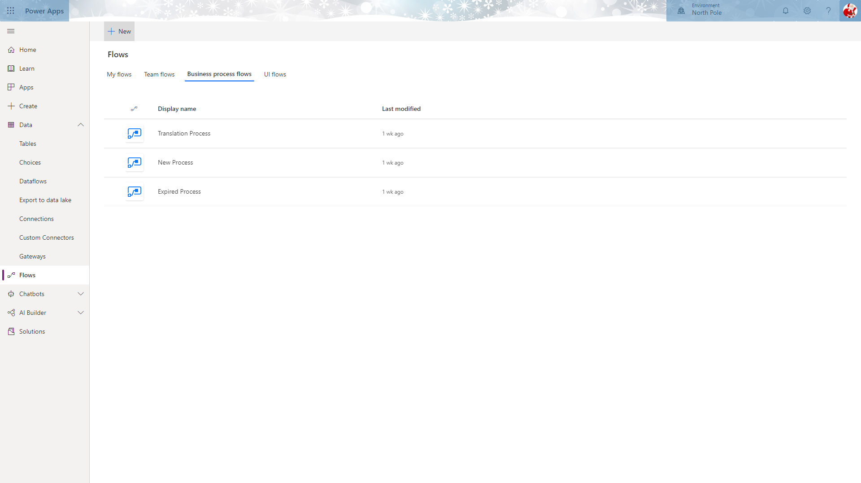

In the **Flow name** textbox, enter “Sleigh Sighting Management”, select “Sleigh Sightings” from the list of tables and click **Create**.

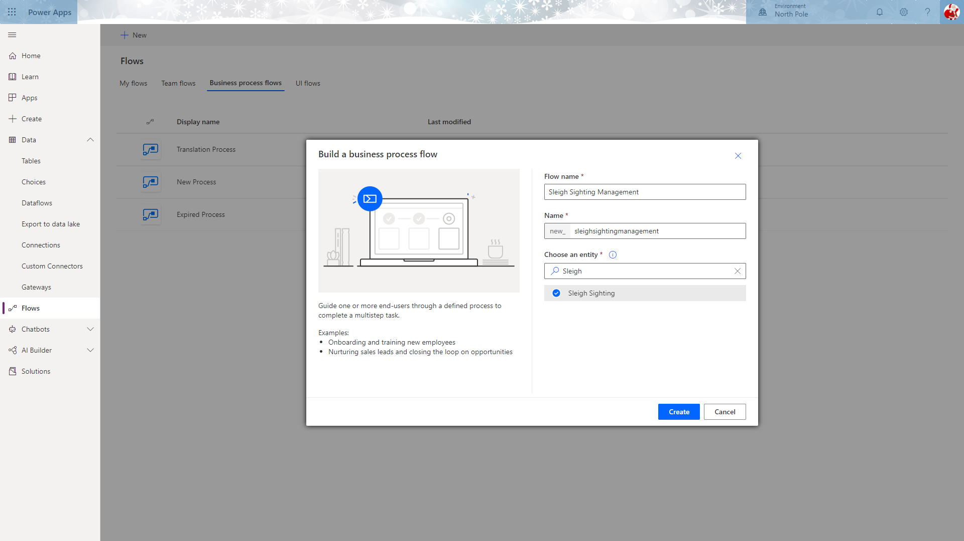

This will launch the flow designer with a default first stage already added to the flow.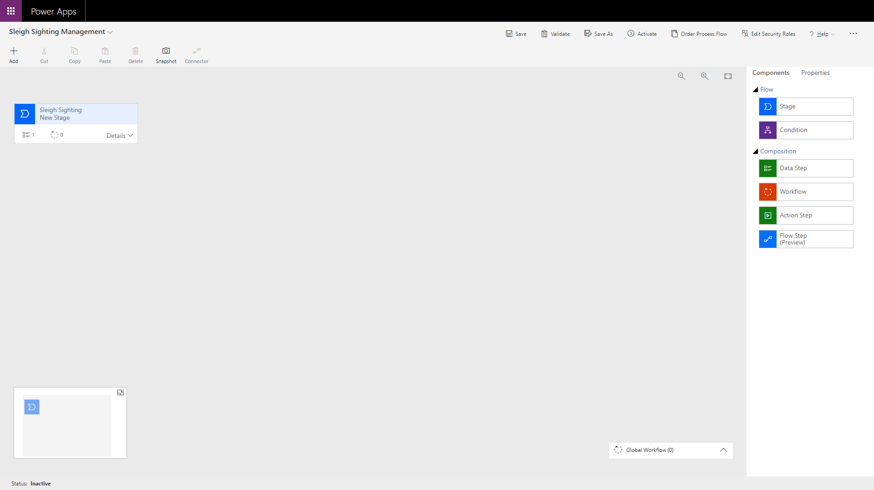

Rename this flow by selecting the stage and entering “Create Sighting” in the **Display Name** textbox and selecting “Qualify” from the **Category** dropdown.

Make sure you click **Apply** to commit the changes made.

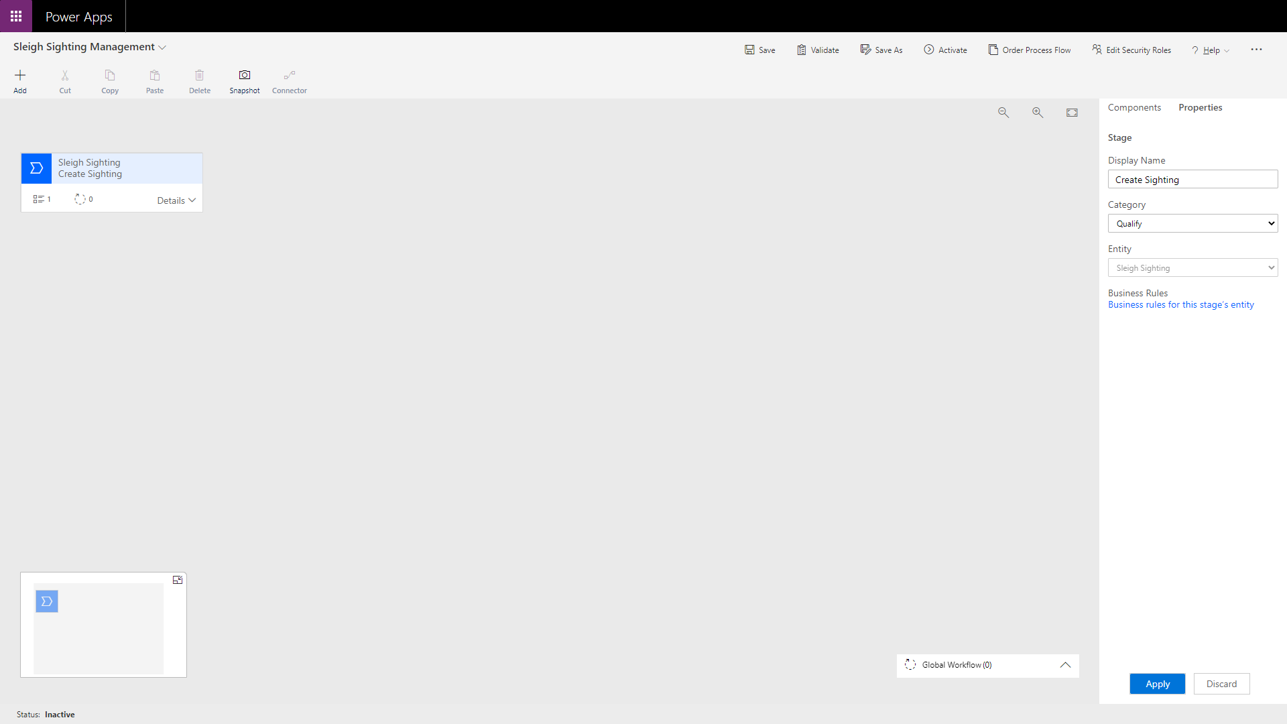

Expand the first stage’s **Details** section to view the Data Steps.

Select the first step to view the properties pane on the right. 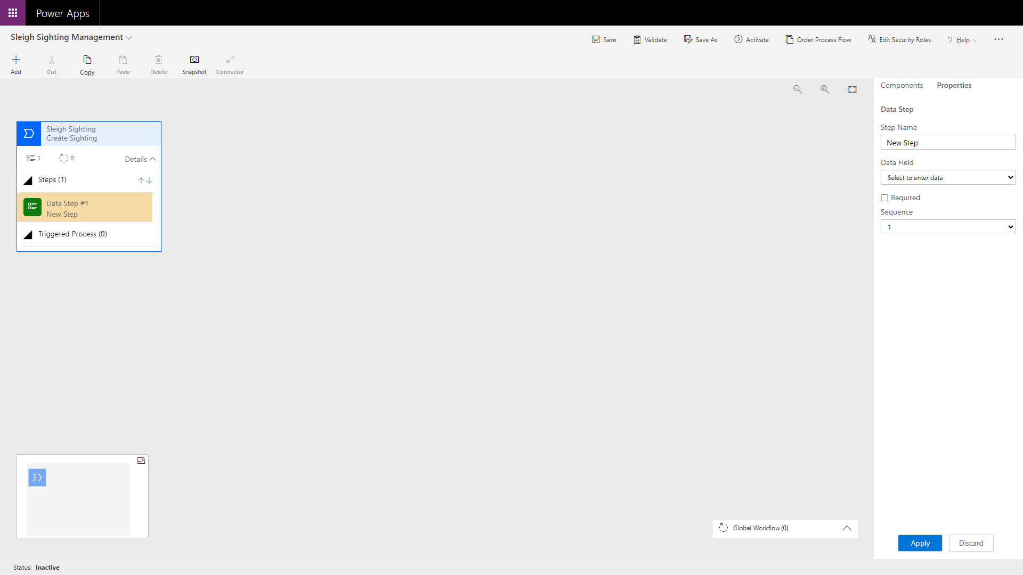

From the **Data Field** dropdown select the “date posted” field.

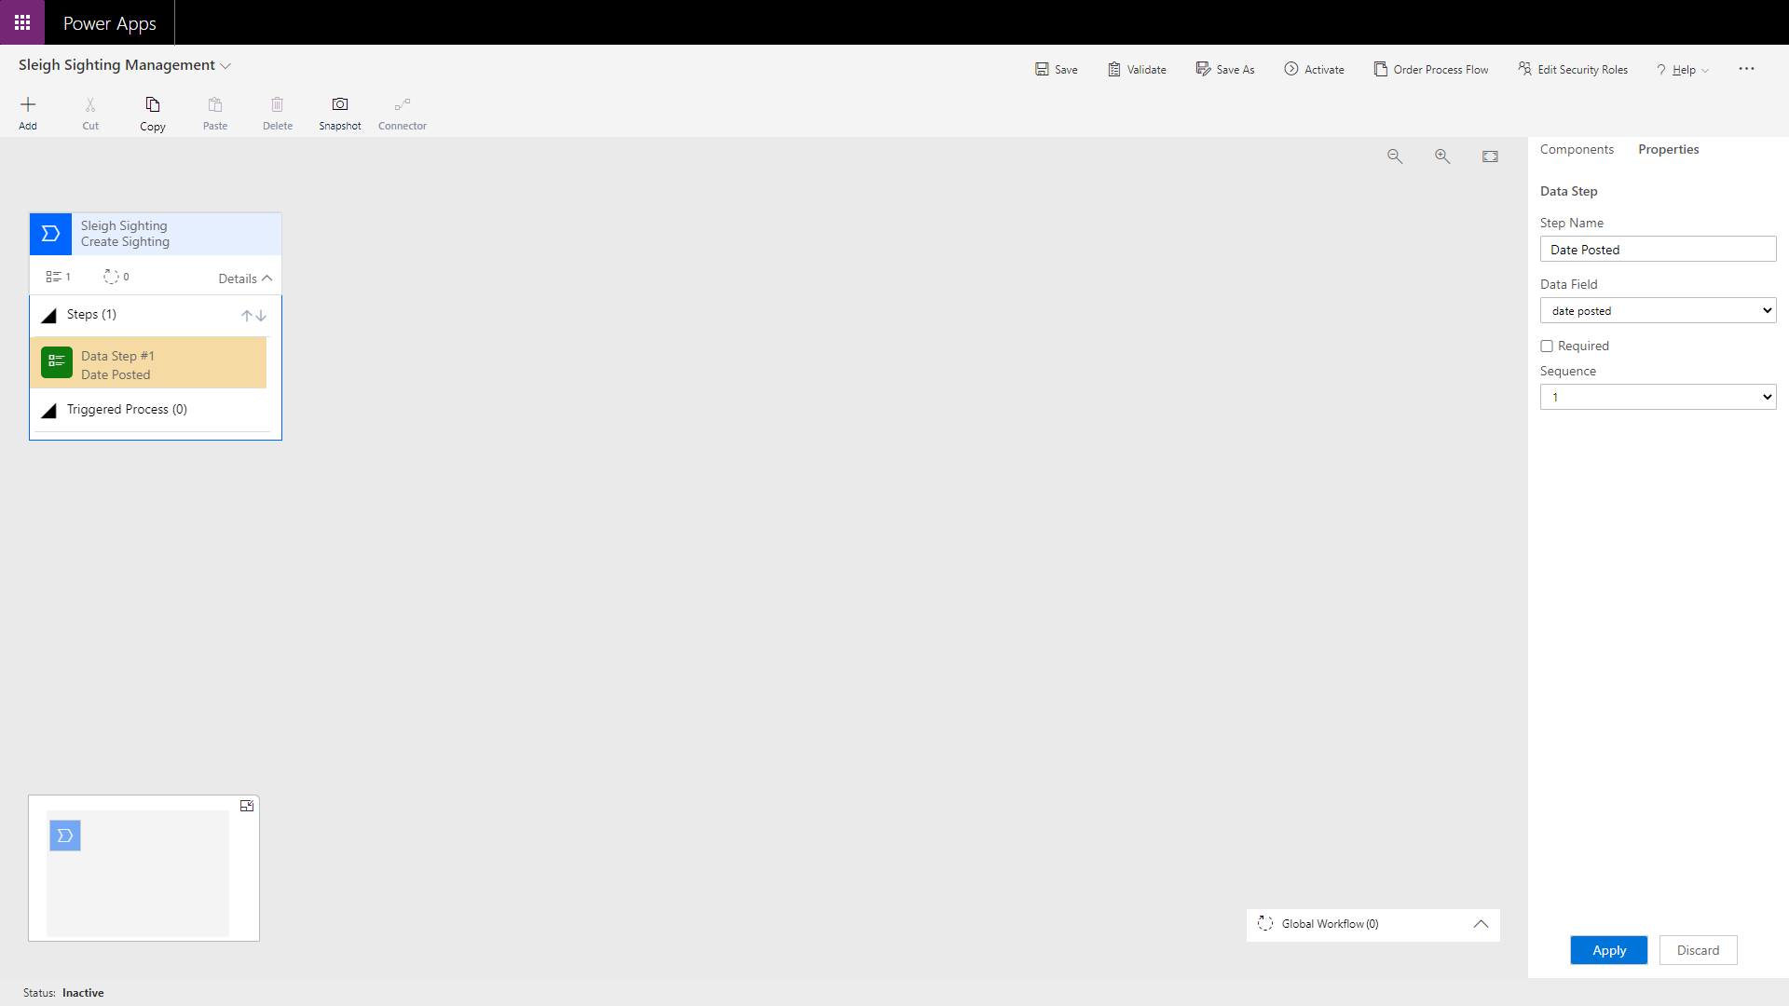

To add additional steps, select the **Components** tab from the pane on the right and drag a **Data Step** to the + symbol below the existing step.

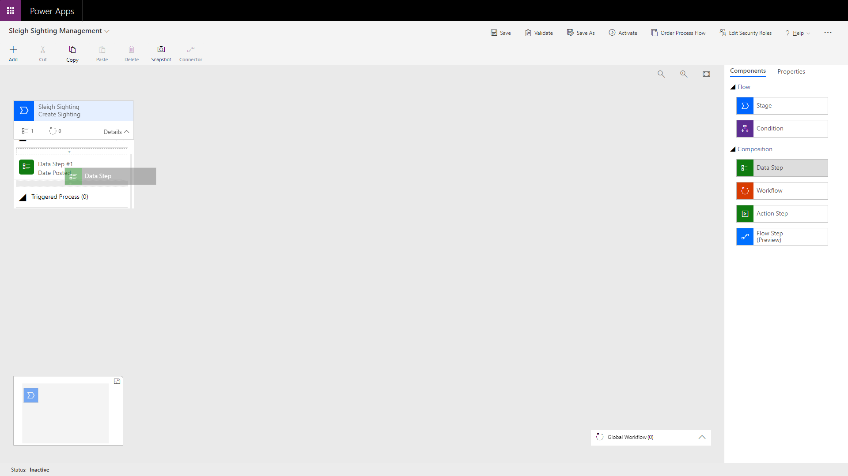 

From the Data Field dropdown, select the “Name” field.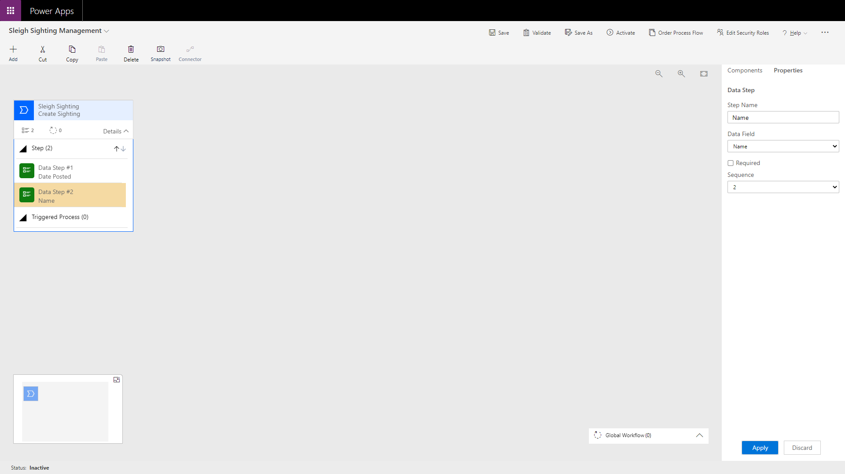

Repeat these steps for the “city” and “country” fields.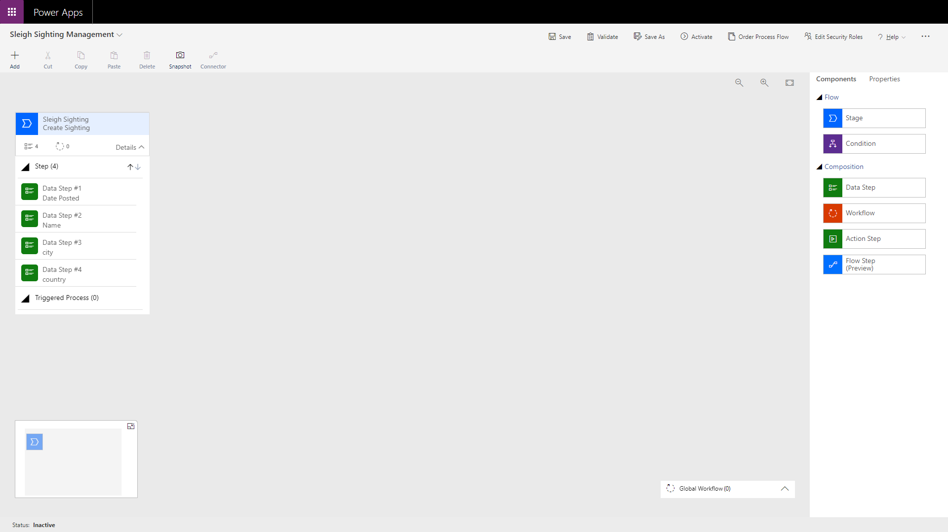

Next, we should add another stage. To do this, from the **Components** list on the right, drag a new **Stage** element over the + symbol to the right of the existing step.

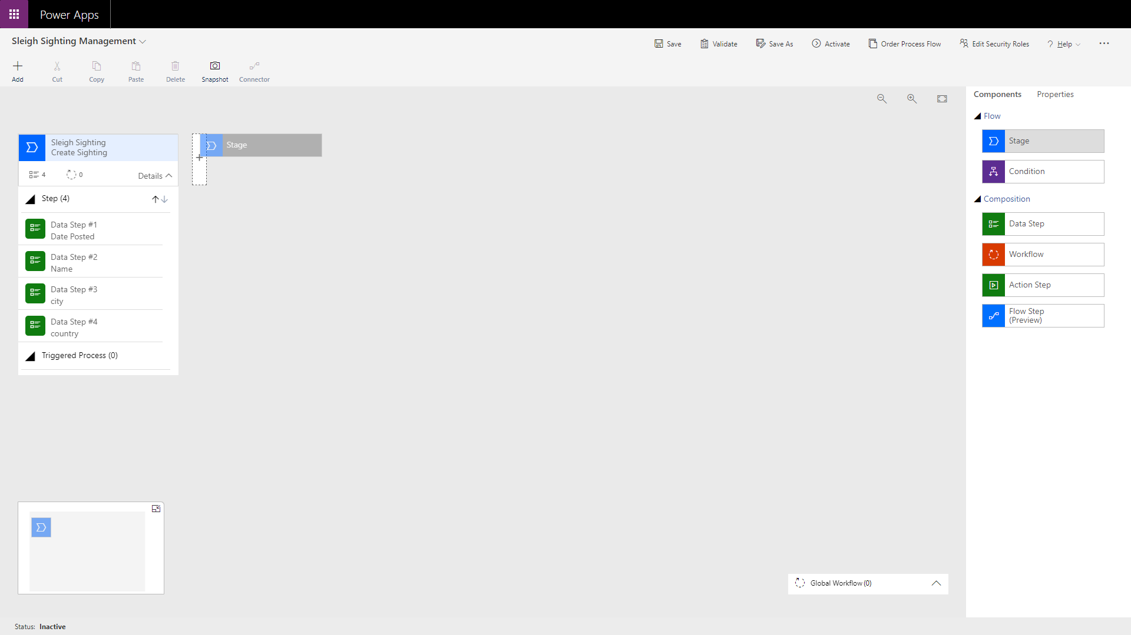 

After placing the step, set the **Display Name** to “Review Sighting” and choose “Identity” from the **Category** dropdown. Ensure that “Sleigh Sighting” is selected in the **Entity** dropdown.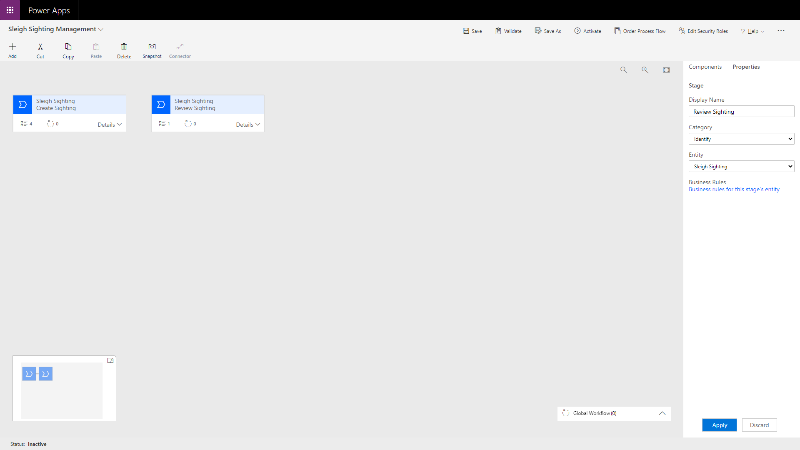

Next, add a new step as before and select the “comments” field from the **Data Field** dropdown.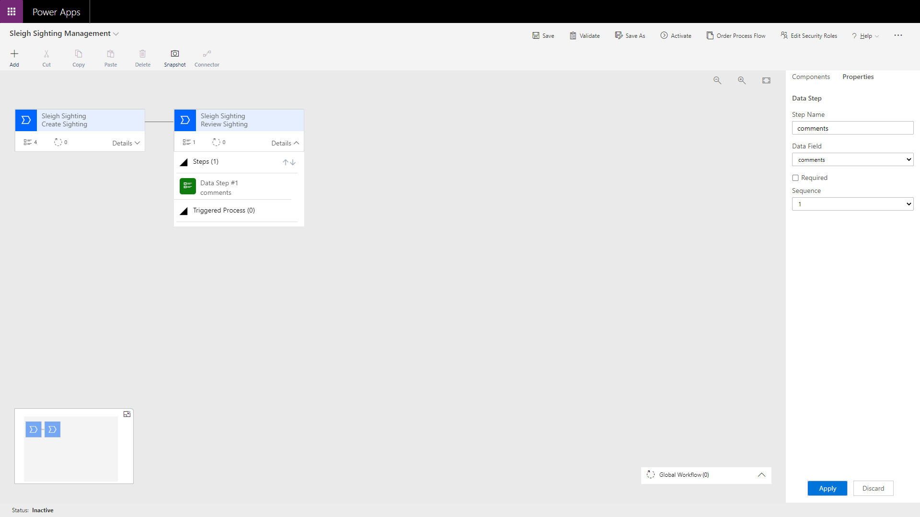

Add a new stage with the **Display Name** “Resolve Sighting” and a **Category** of “Resolve” ensuring that “Sleigh Sighting” is selected in the **Entity** dropdown. To this stage, add a **Data Step** selecting the “Status” field.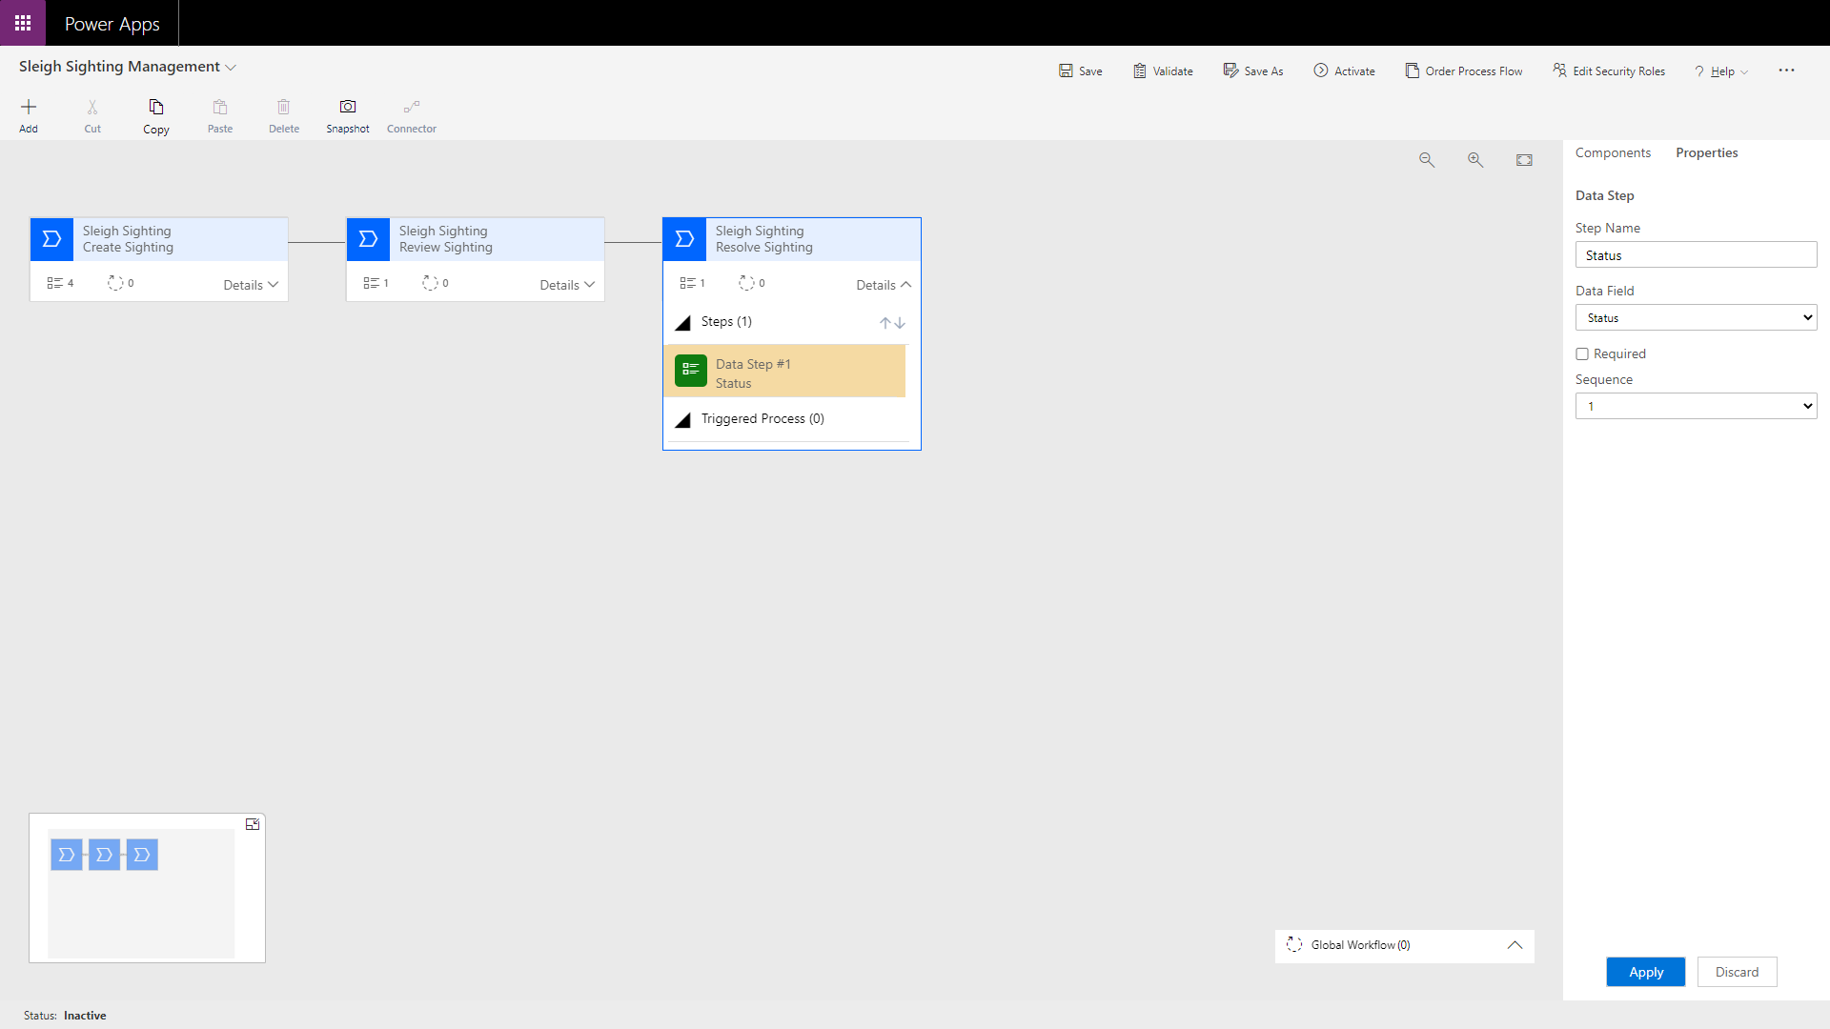

This completes the Business Process Flow so click the **Save** button at the top of the page.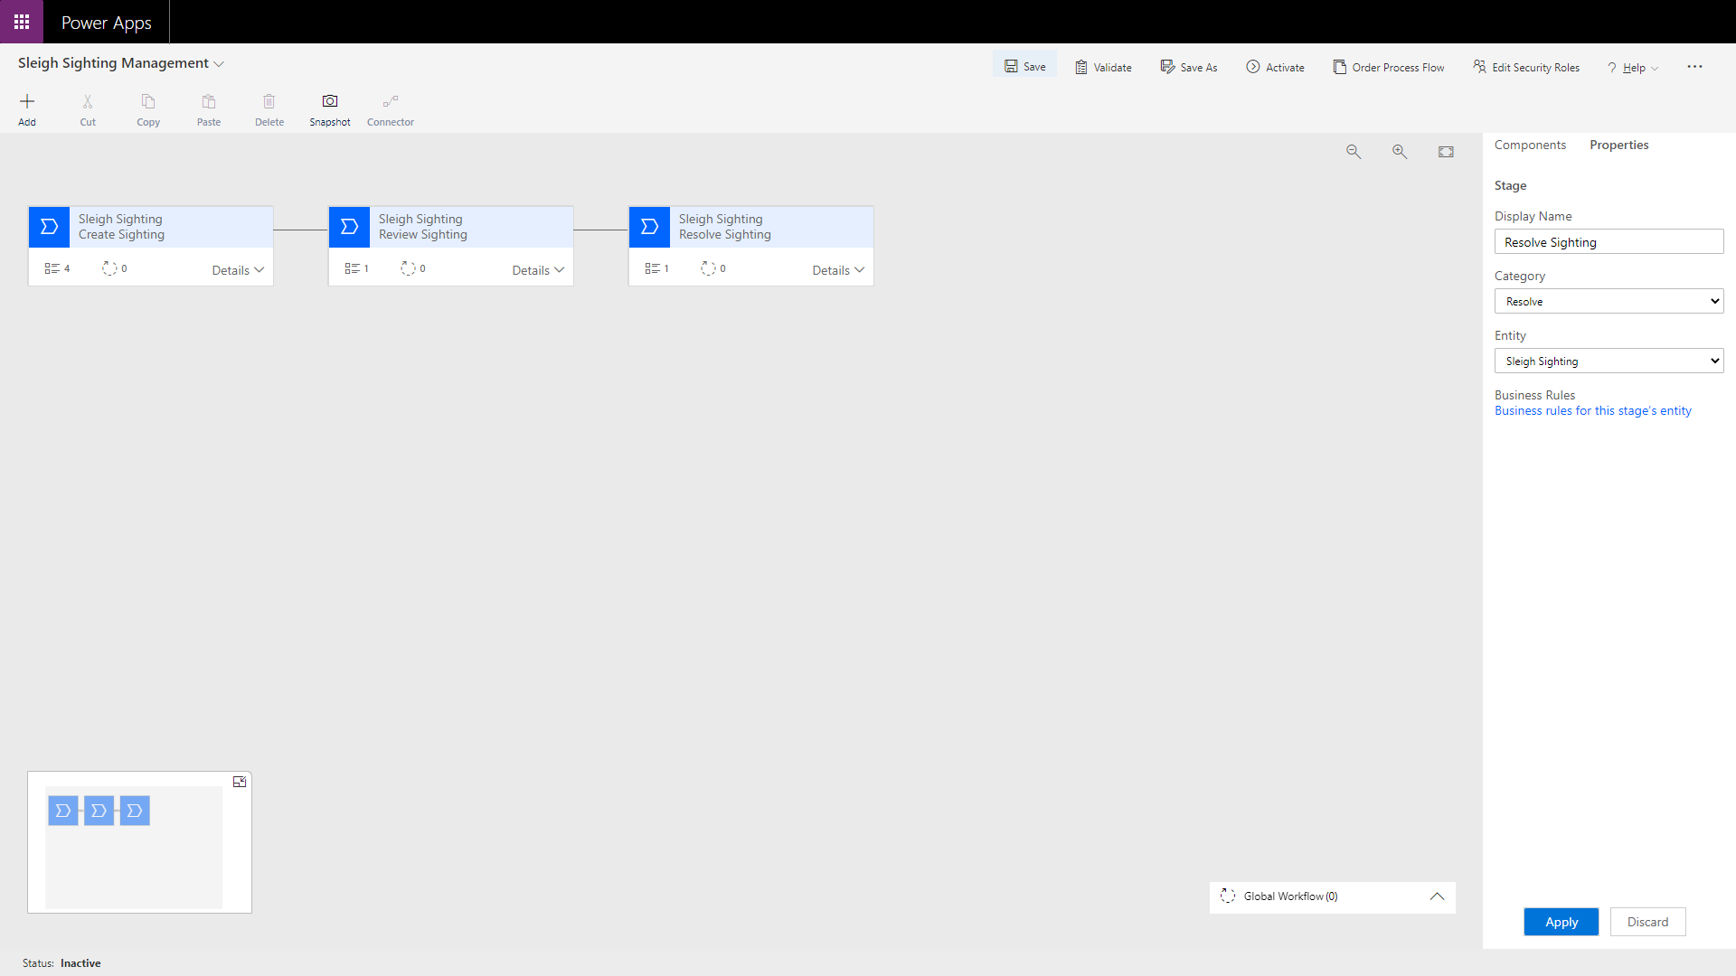

Then click **Activate** to activate the flow followed by the **Activate** button on the displayed dialog.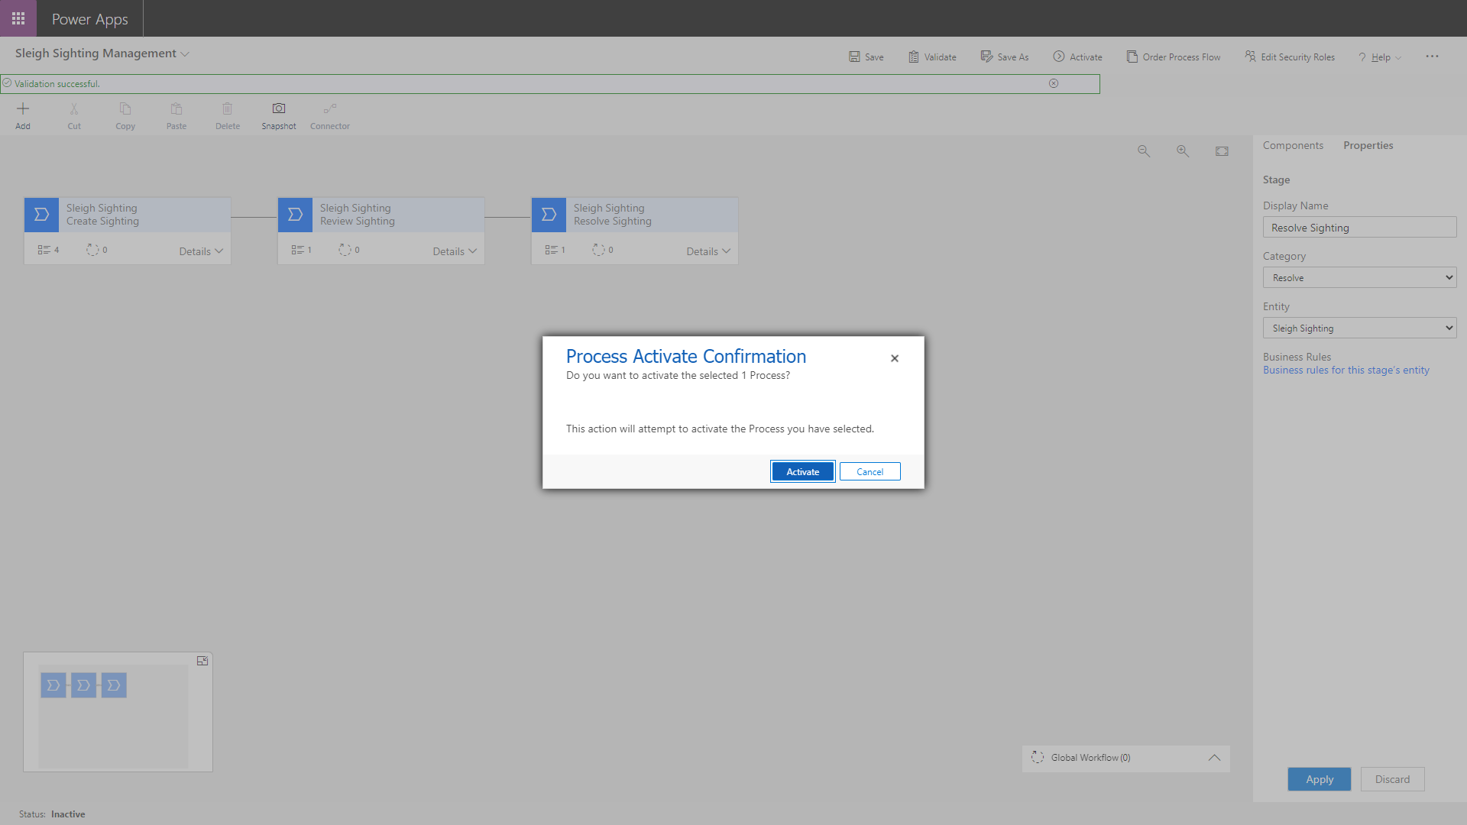

This will display a progress bar dialog and may take a little time to complete.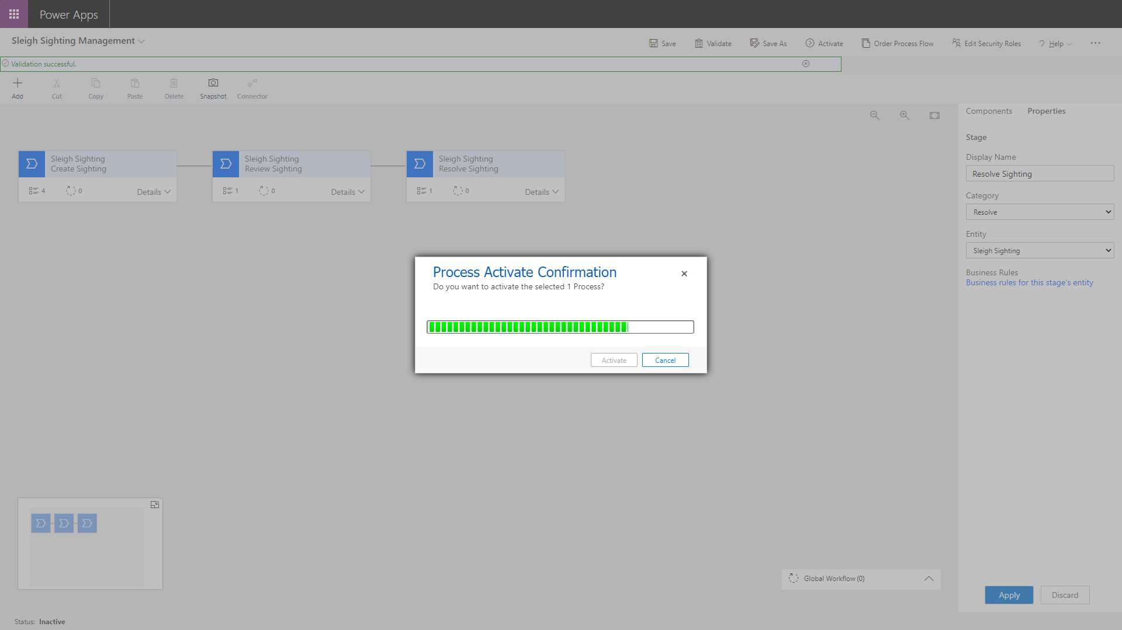

Once the progress bar dialog has disappeared, confirm that the activation was successful by checking that **Deactivate** button now exists (don’t click it!).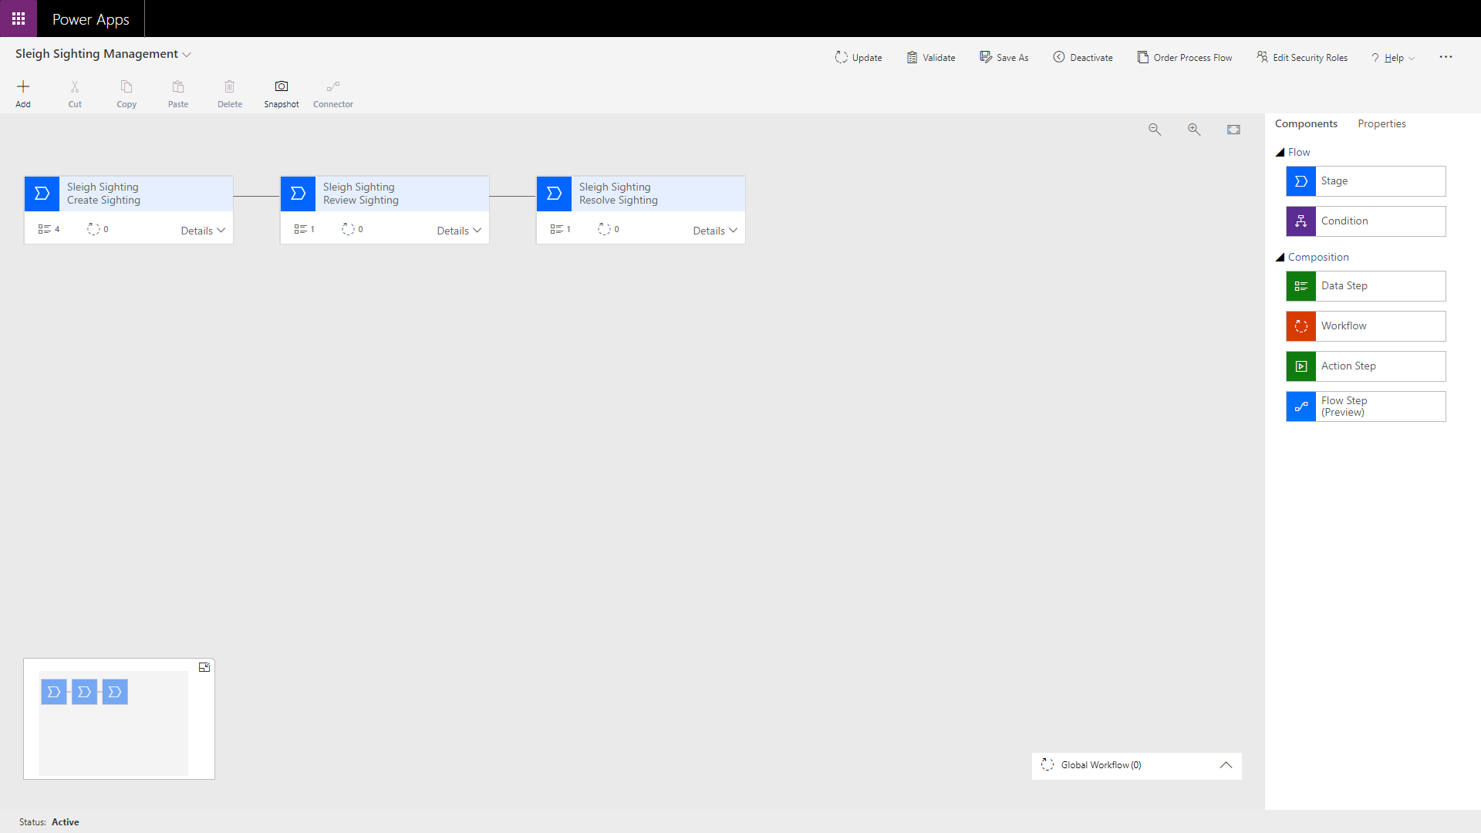

Finally, close the page to return to the Power App maker portal and you should see your new flow listed under the **Business process flows** tab.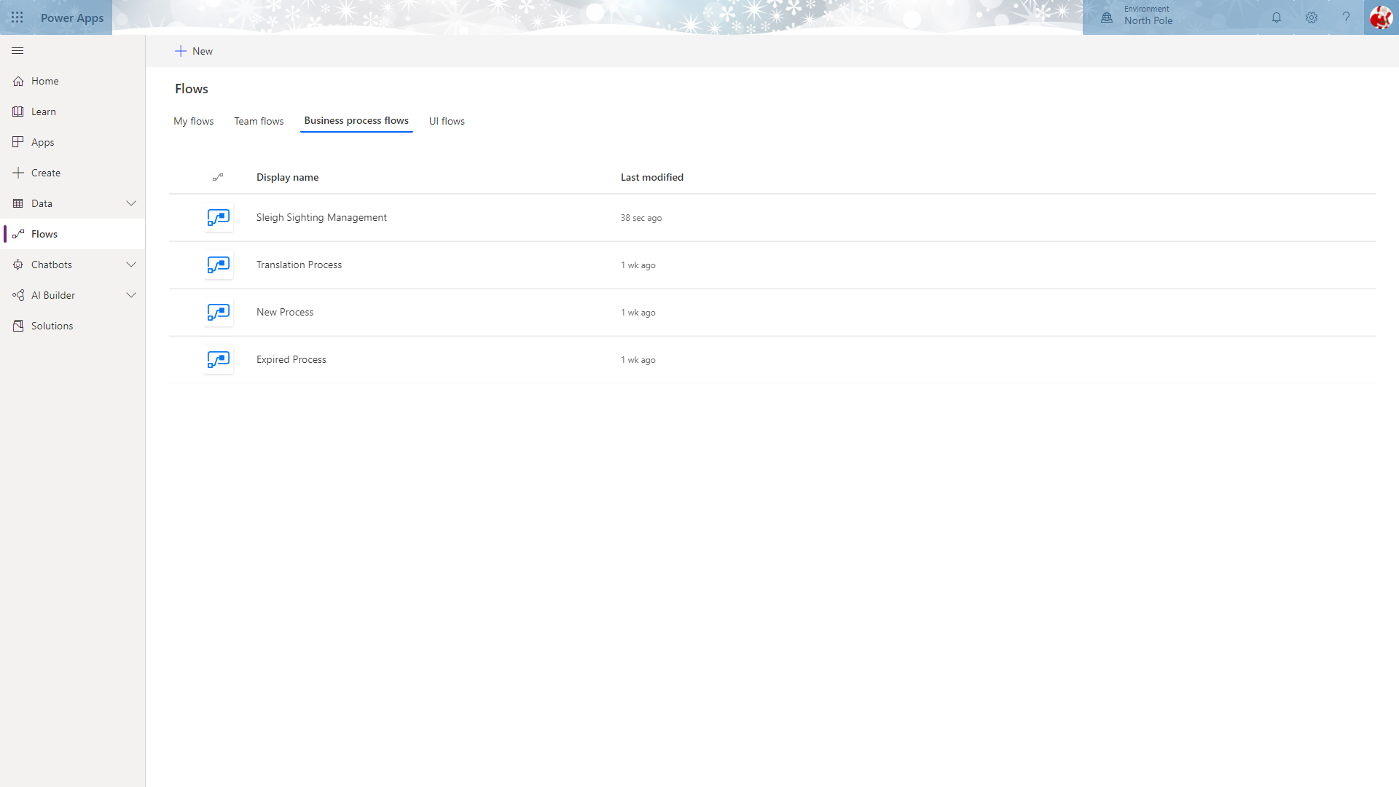

### Model Driven Application

Now that we have created the Business Process Flow, we need to configure our Model Driven Application that will display this to the elves responsible for managing sleigh sightings.

From within the app maker experience (<https://make.powerapps.com>), click **Apps** on the left menu to display the available applications.

You should see an app named “SS Management”. This is the application we will configure.

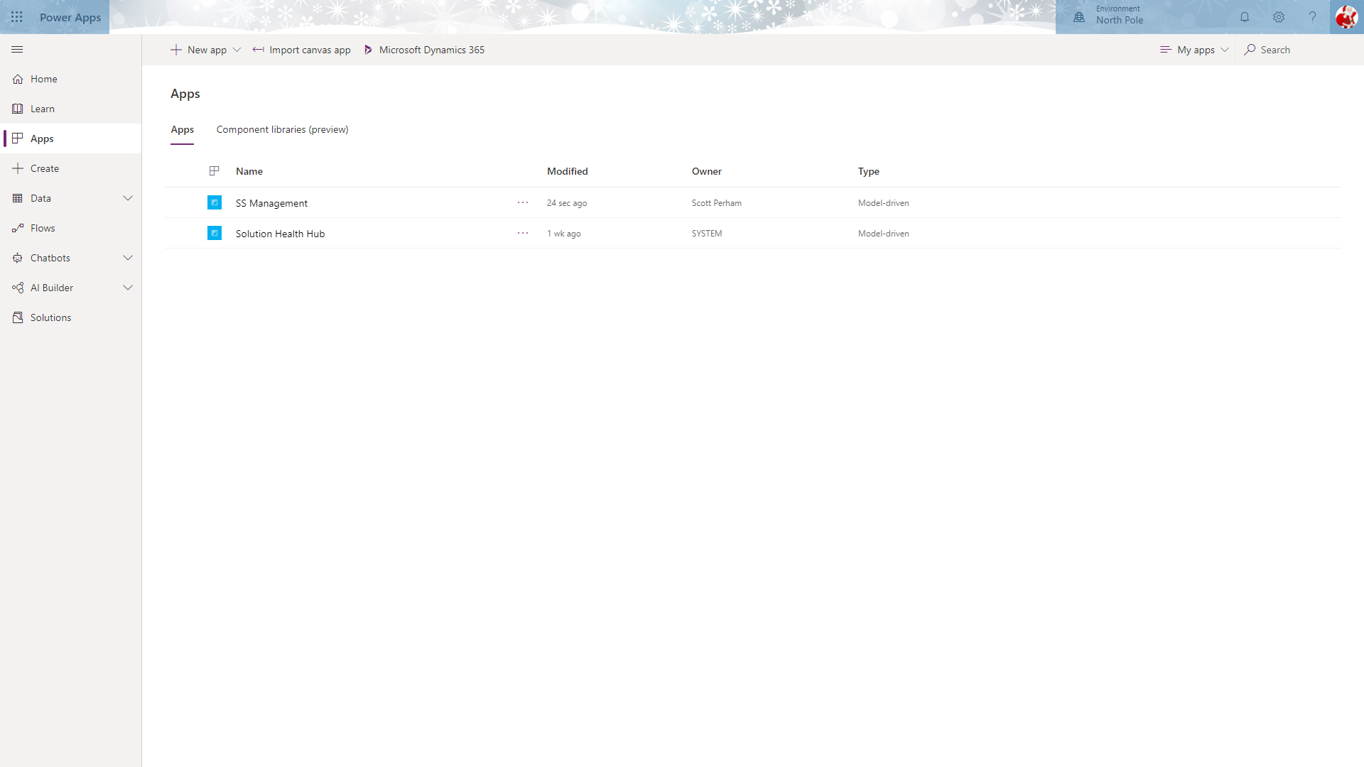

To edit the application, select SS Management by clicking the circle to the left (only appears when you move the mouse over the name), then click **Edit** from the toolbar.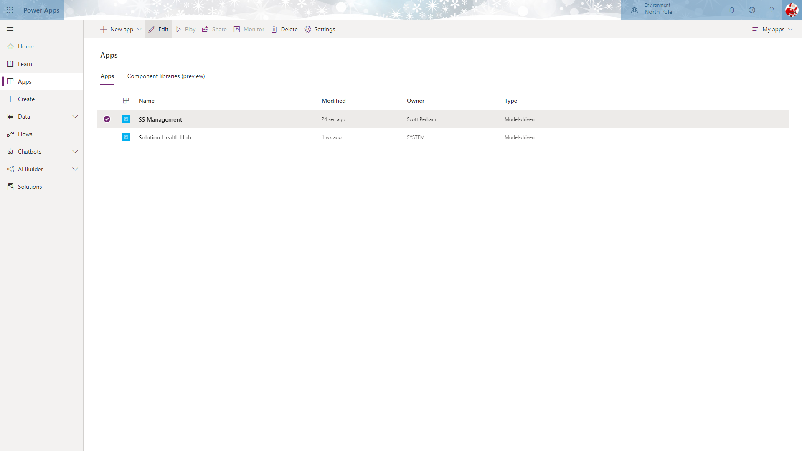

This will launch the Model Driven Application maker experience.

The first thing you will notice is that the **Site Map** element is displaying a warning that there is important configuration missing. Let’s fix this by clicking the pencil icon on the **Site Map** element.

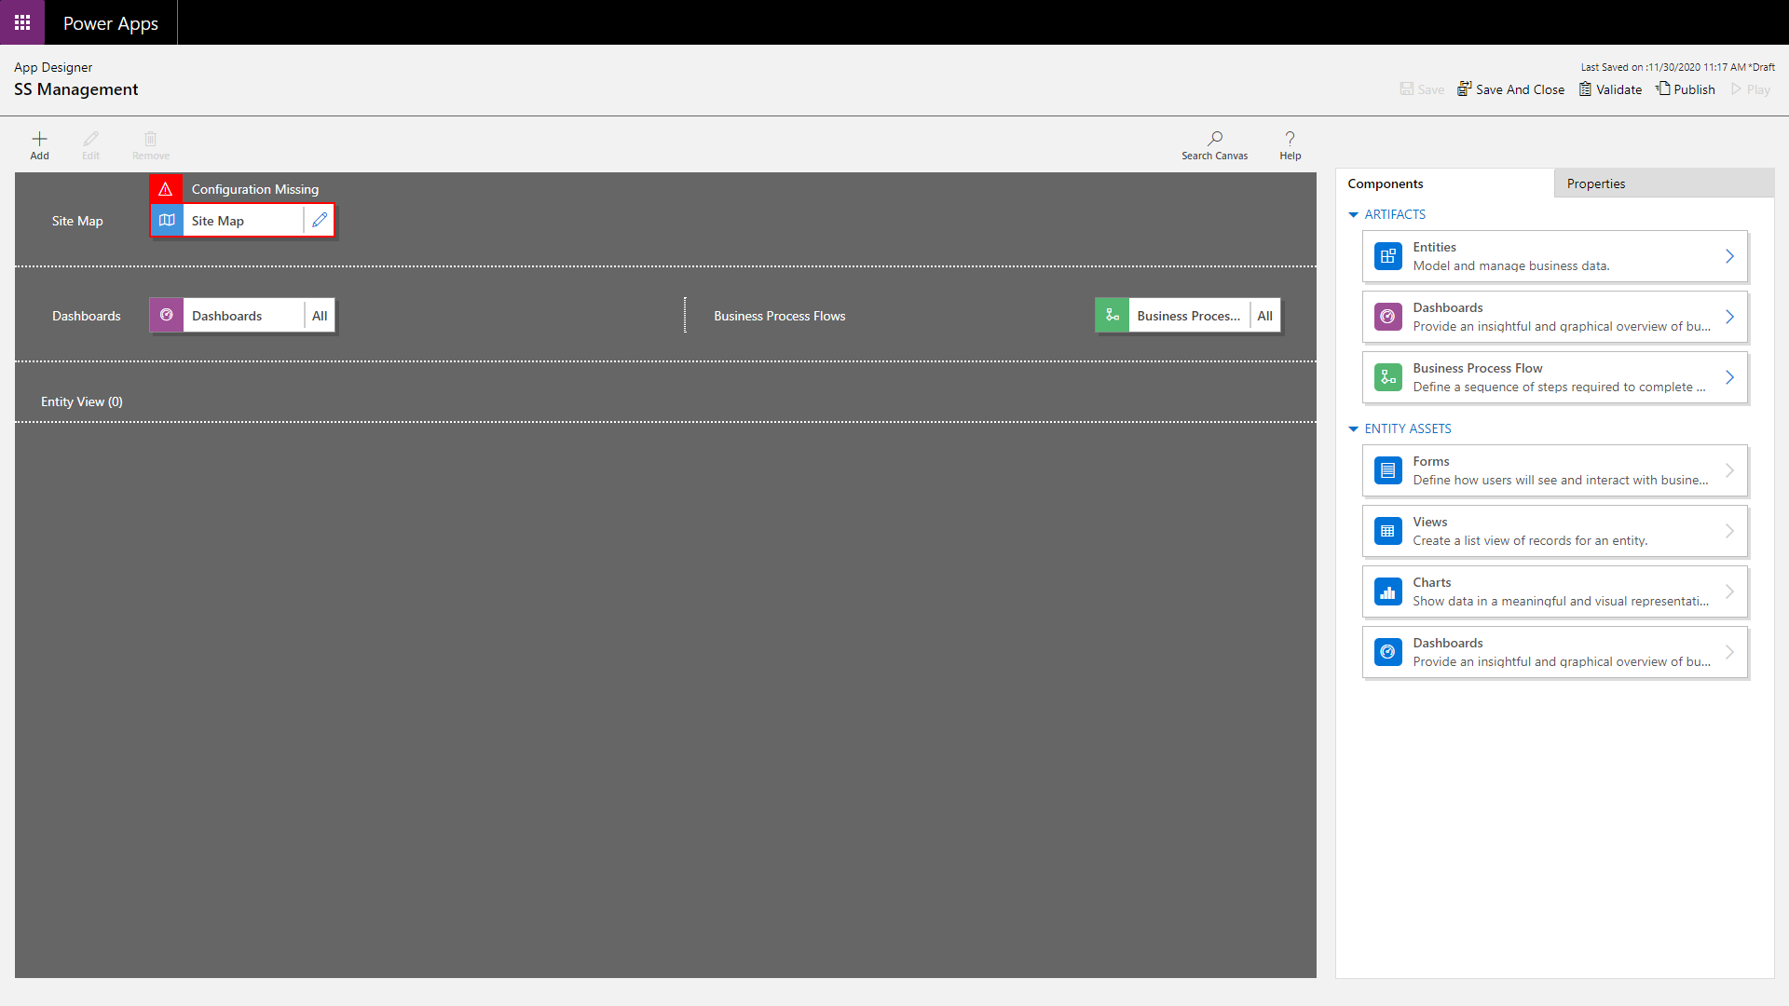

This will launch the site map editor.

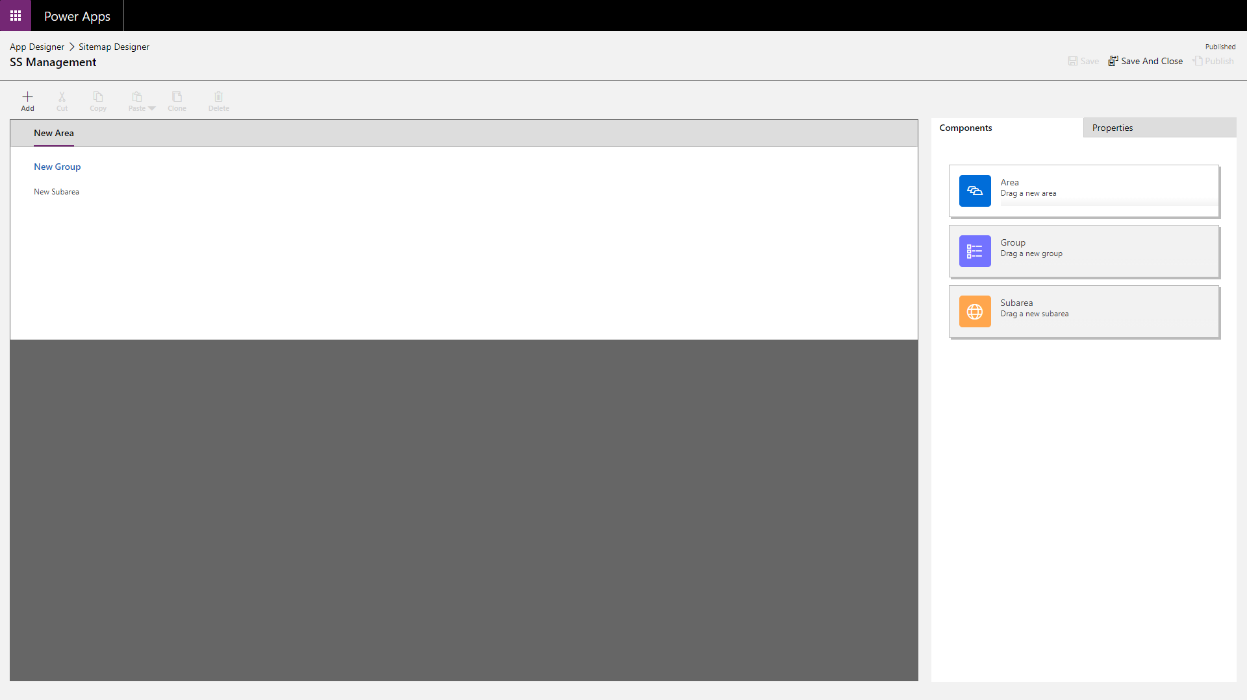

Edit the default Area component by click on the text “New Area”. This will display the properties pane on the right.

Enter “SS Management” in the **Title** textbox.

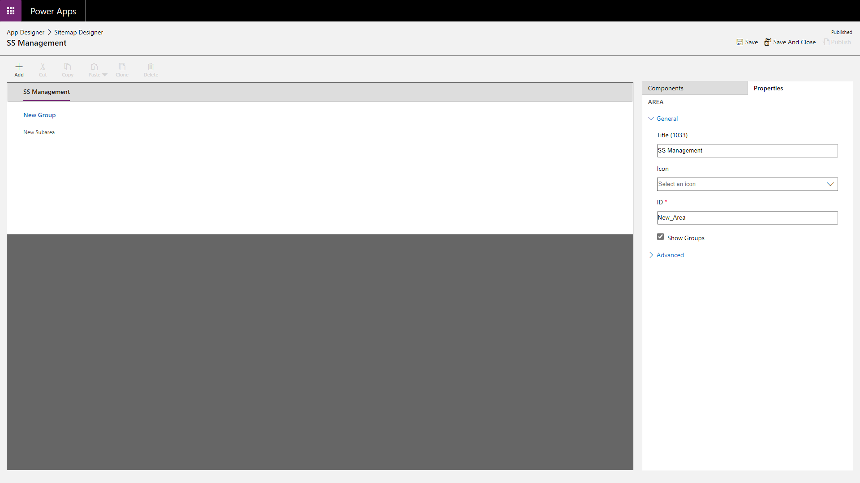

Next, click the “New Group” text on the left to display the properties pane for the group.

Here, enter “Management” into the **Title** textbox.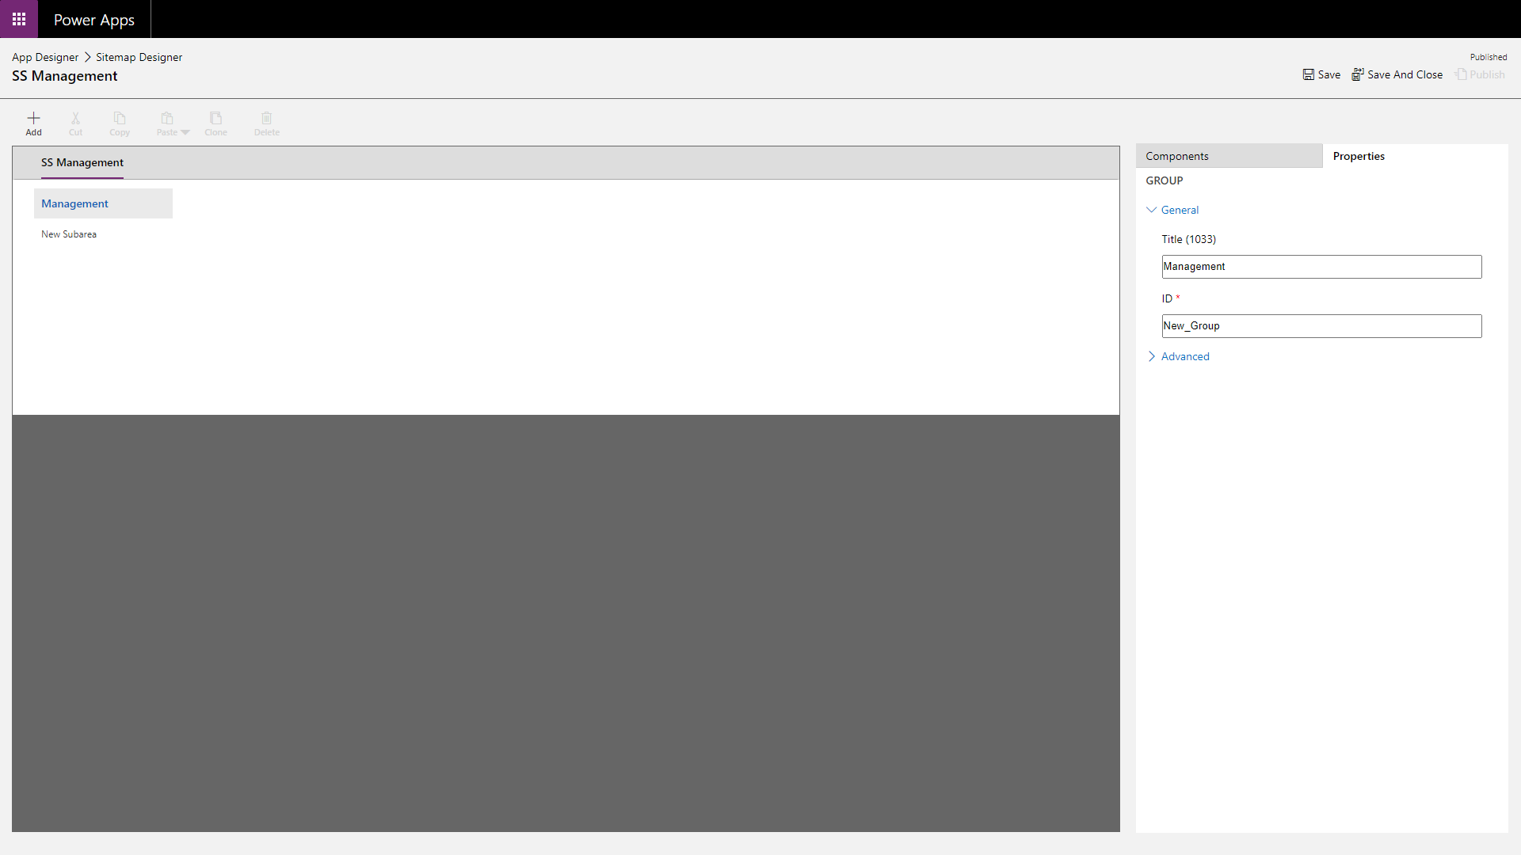

Finally, edit the existing subarea but clicking the “New Subarea” text on the left which will display the subarea properties pane on the right.

This pane requires either an Entity (renamed to Table in Dataverse) to display a list of or a URL to navigate to. 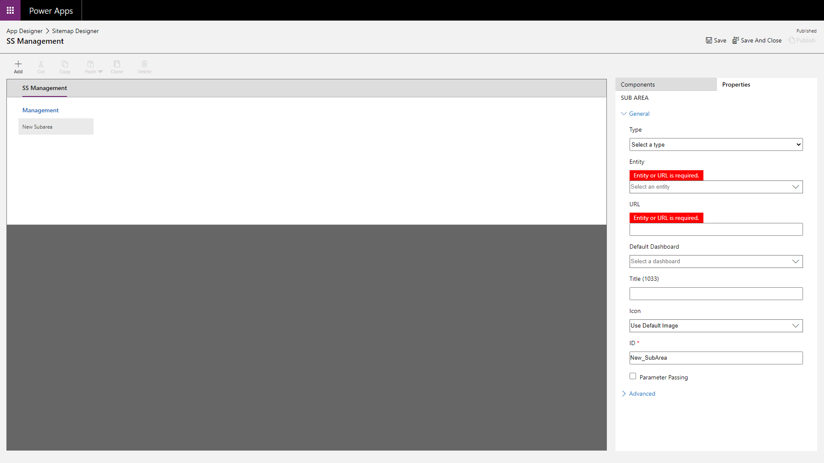

We would like to display the list of existing sleigh sightings so select the “Sleigh Sighting” table from the **Entity** dropdown.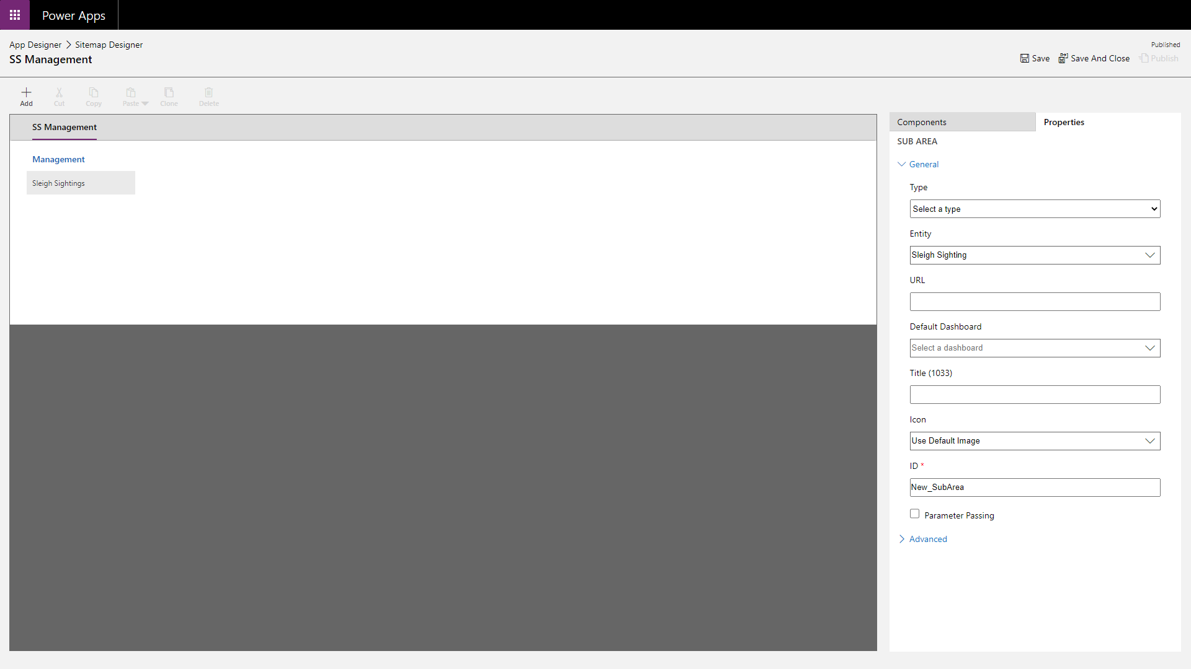

Next, we want to add a new subarea that will allow us to display a dashboard with the charts we created earlier.

To do this, select the “Sleigh Sightings” subarea on the left and select **Components** tab on the right to list the available components.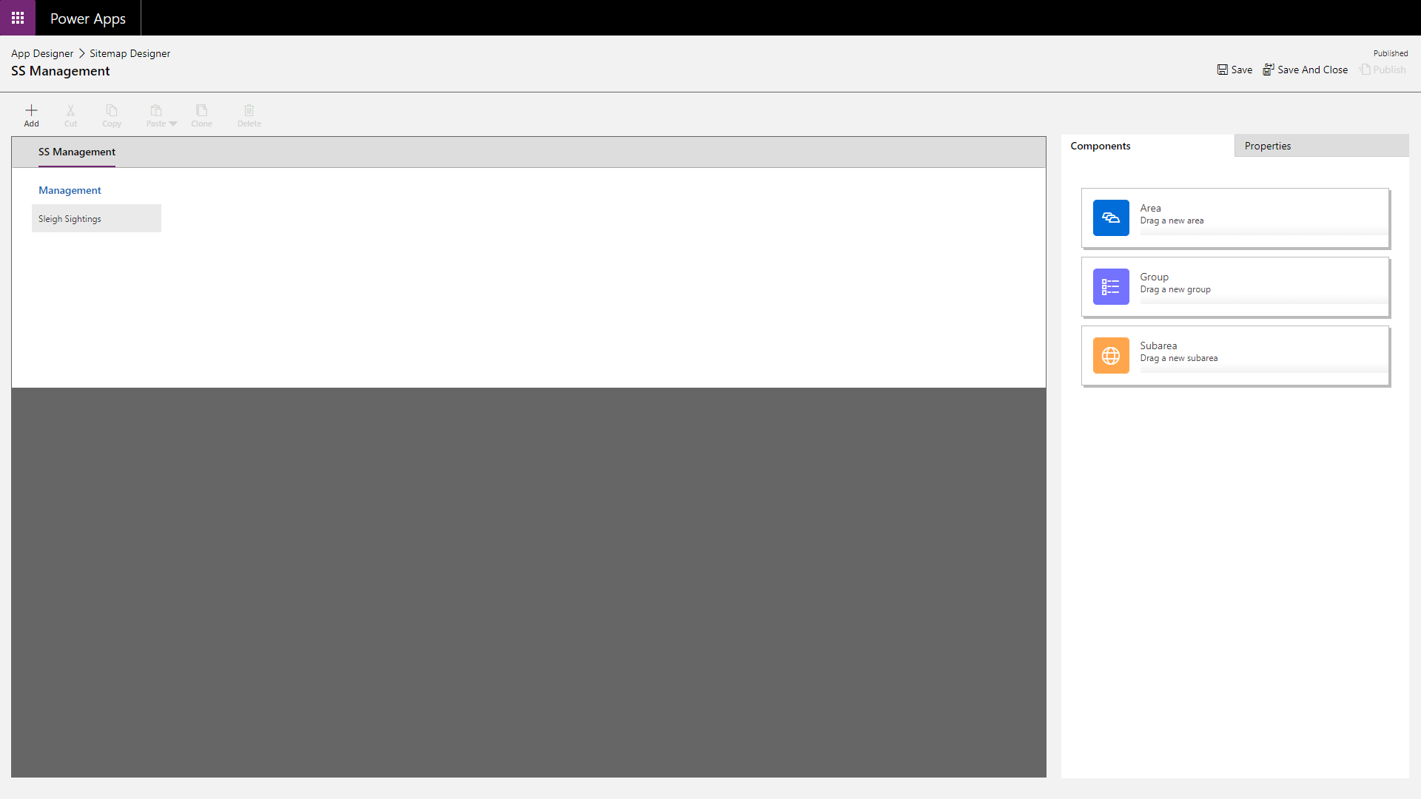

From this list, drag a new Subarea underneath the existing “Sleigh Sightings” subarea on the left.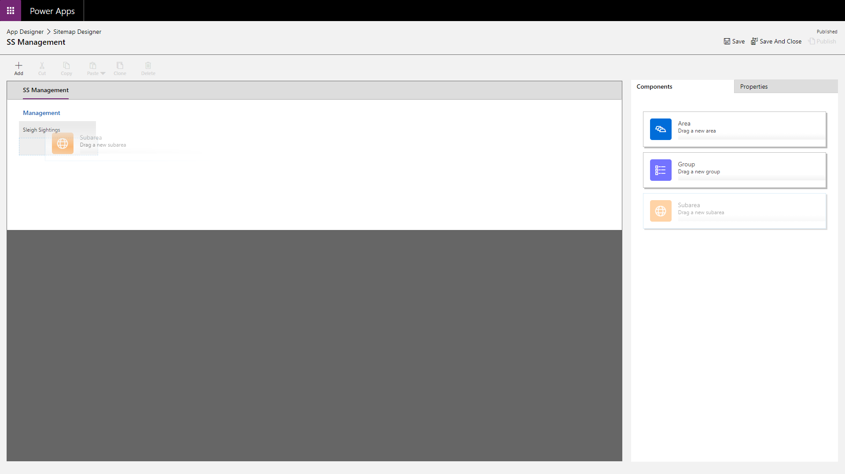

Select the new subarea, ensure the properties pane is selected and choose “Dashboard” from the **Type** dropdown. (We will come back and select the dashboard later)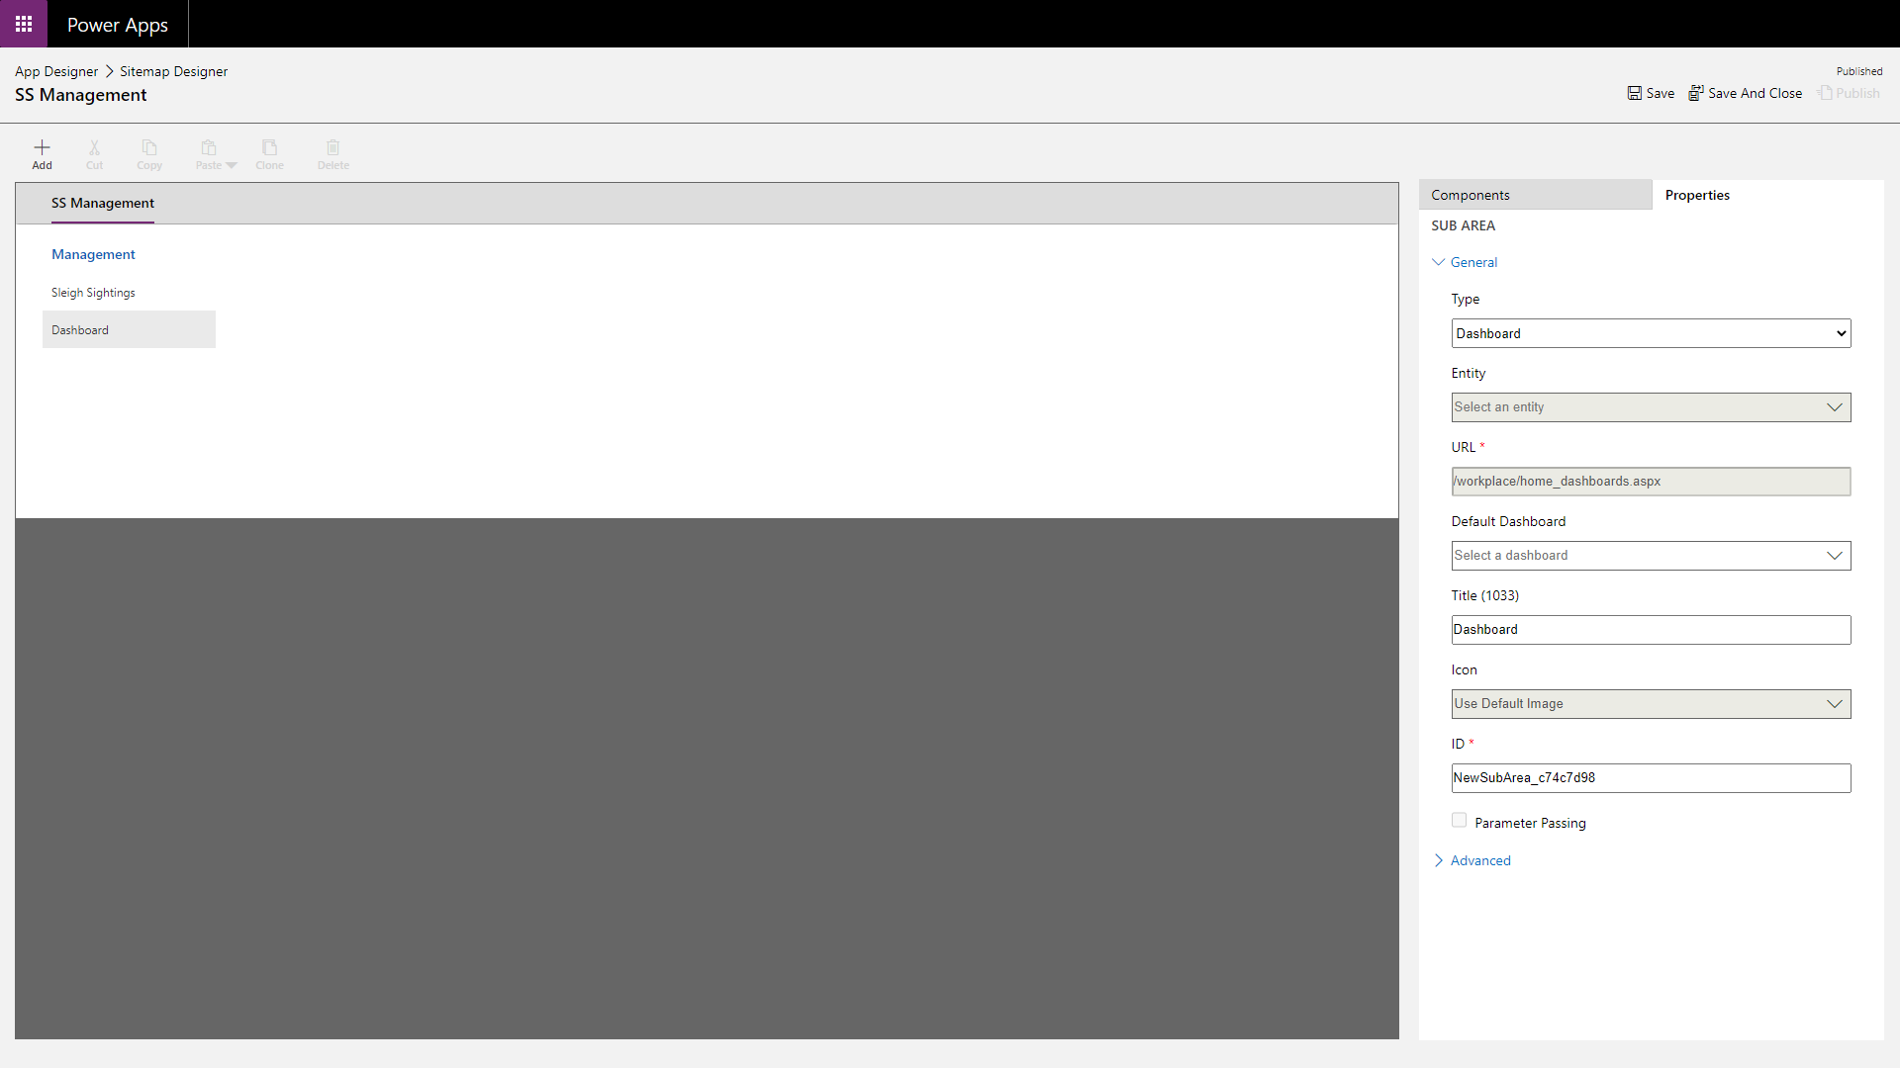

Click **Save** followed by **Publish** to commit the changes made and finally click **Save And Close** to return to the Entity Driven Application maker experience.

You will see that a new row has been added under **Entity View**. 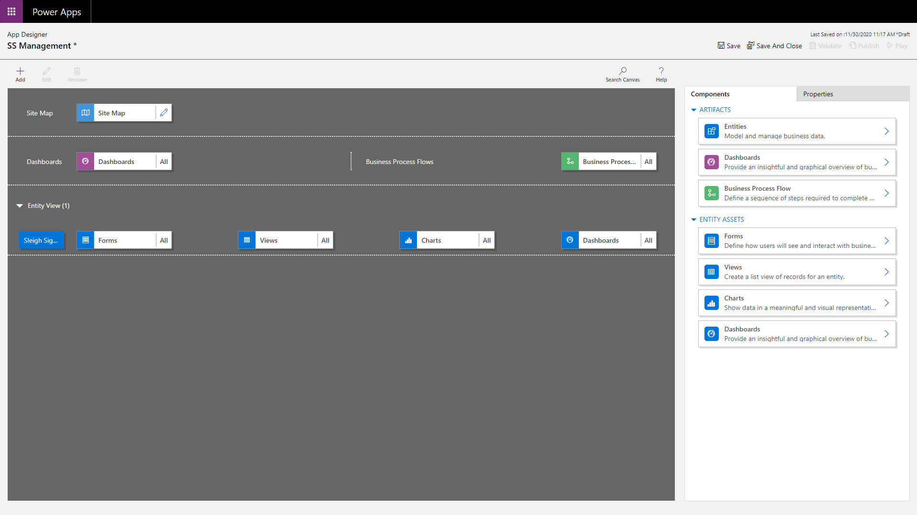

Next, we want to create a dashboad and add it to the application.

Begin by selecting the **Dashboards** element in the main area to open the dashboard properties pane.

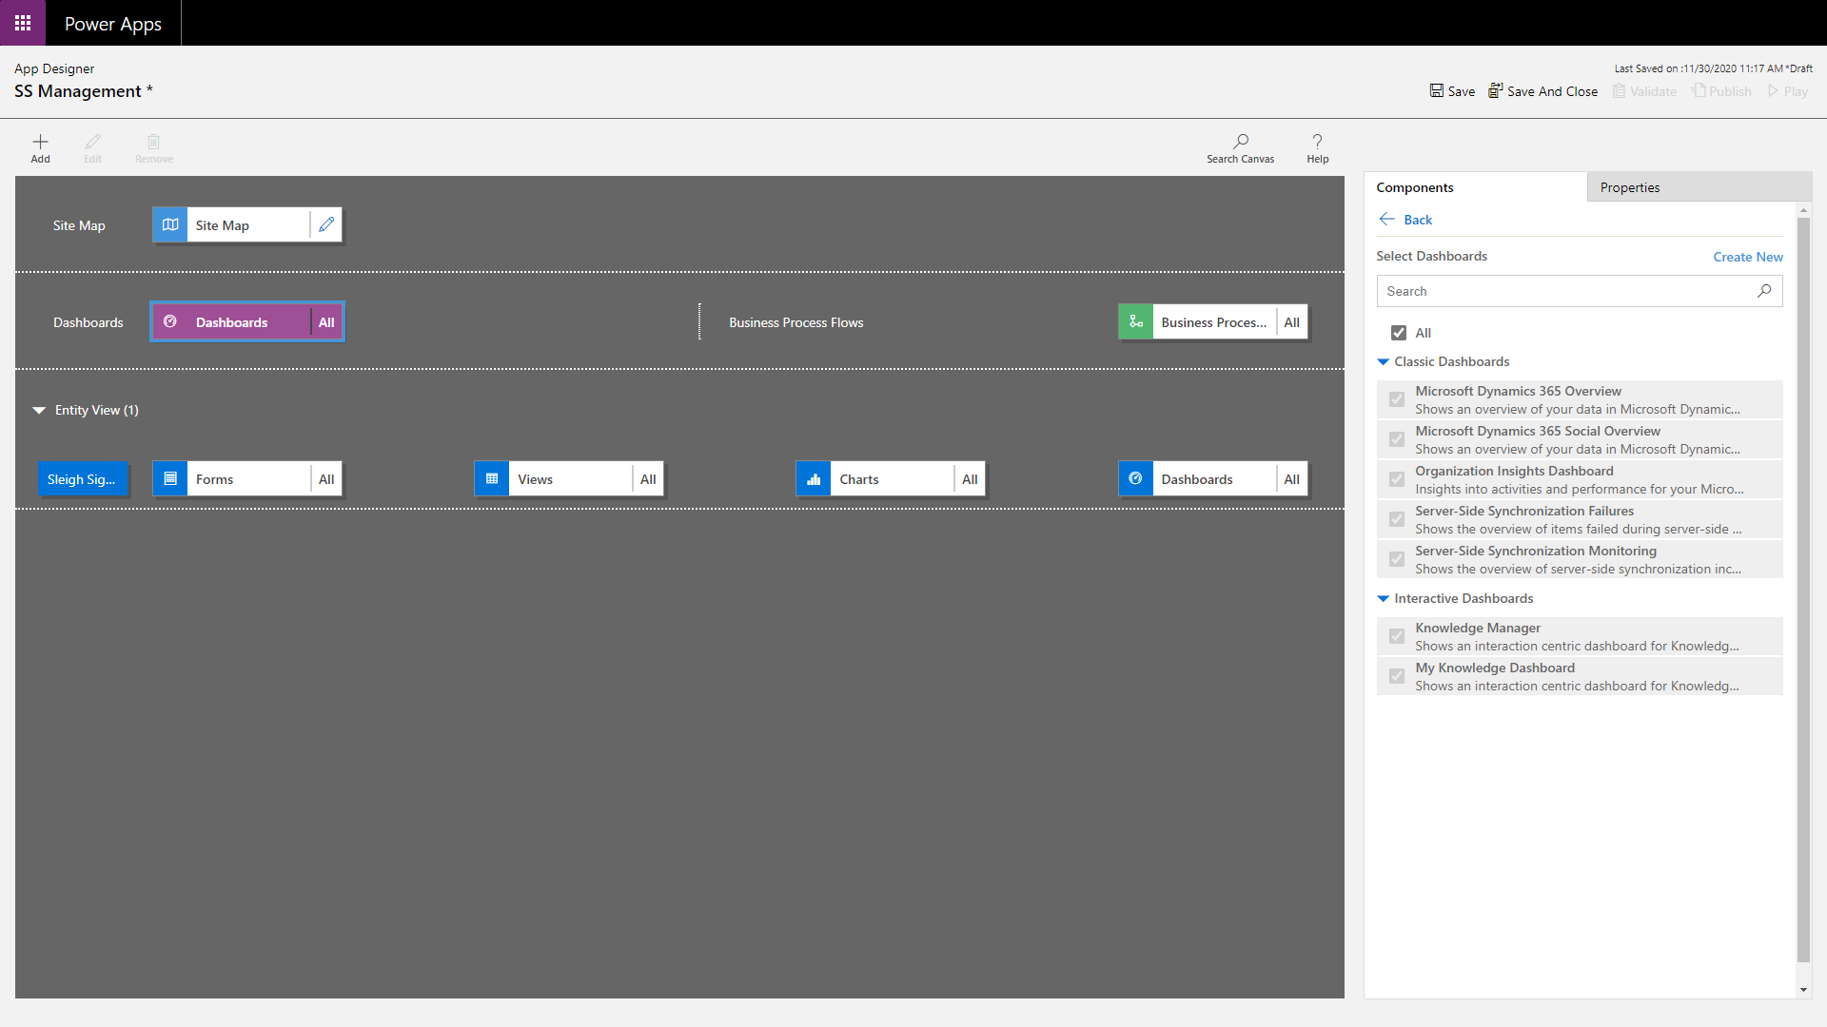

From here, click the **Create New** link and select **Classic Dashboards**. 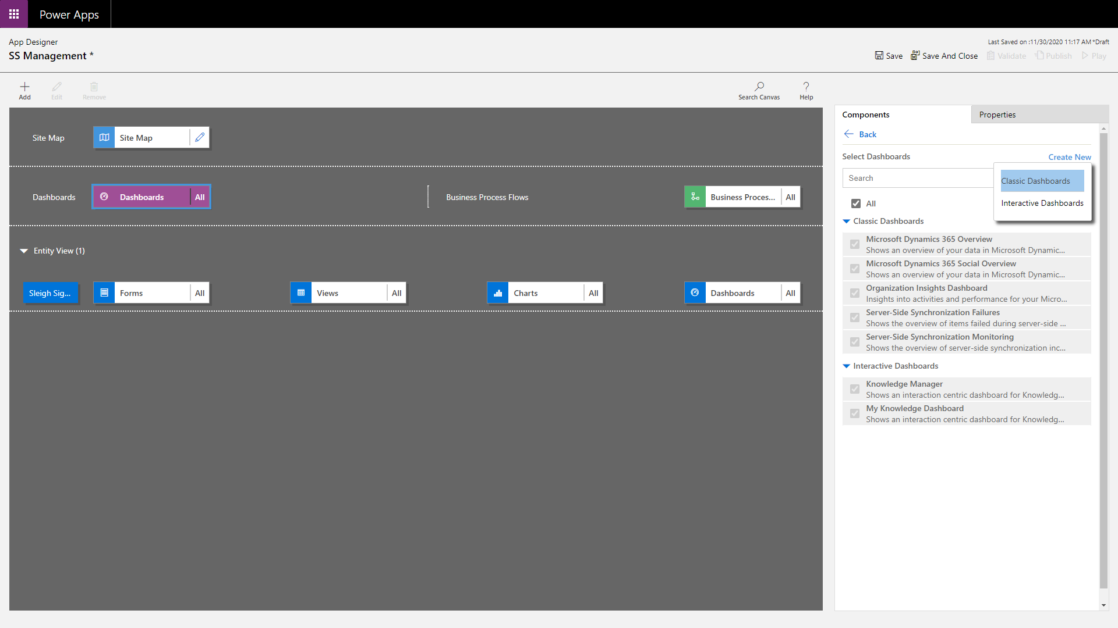

From the displayed dialog, choose **2-column Regular Dashboard** and click **Create**.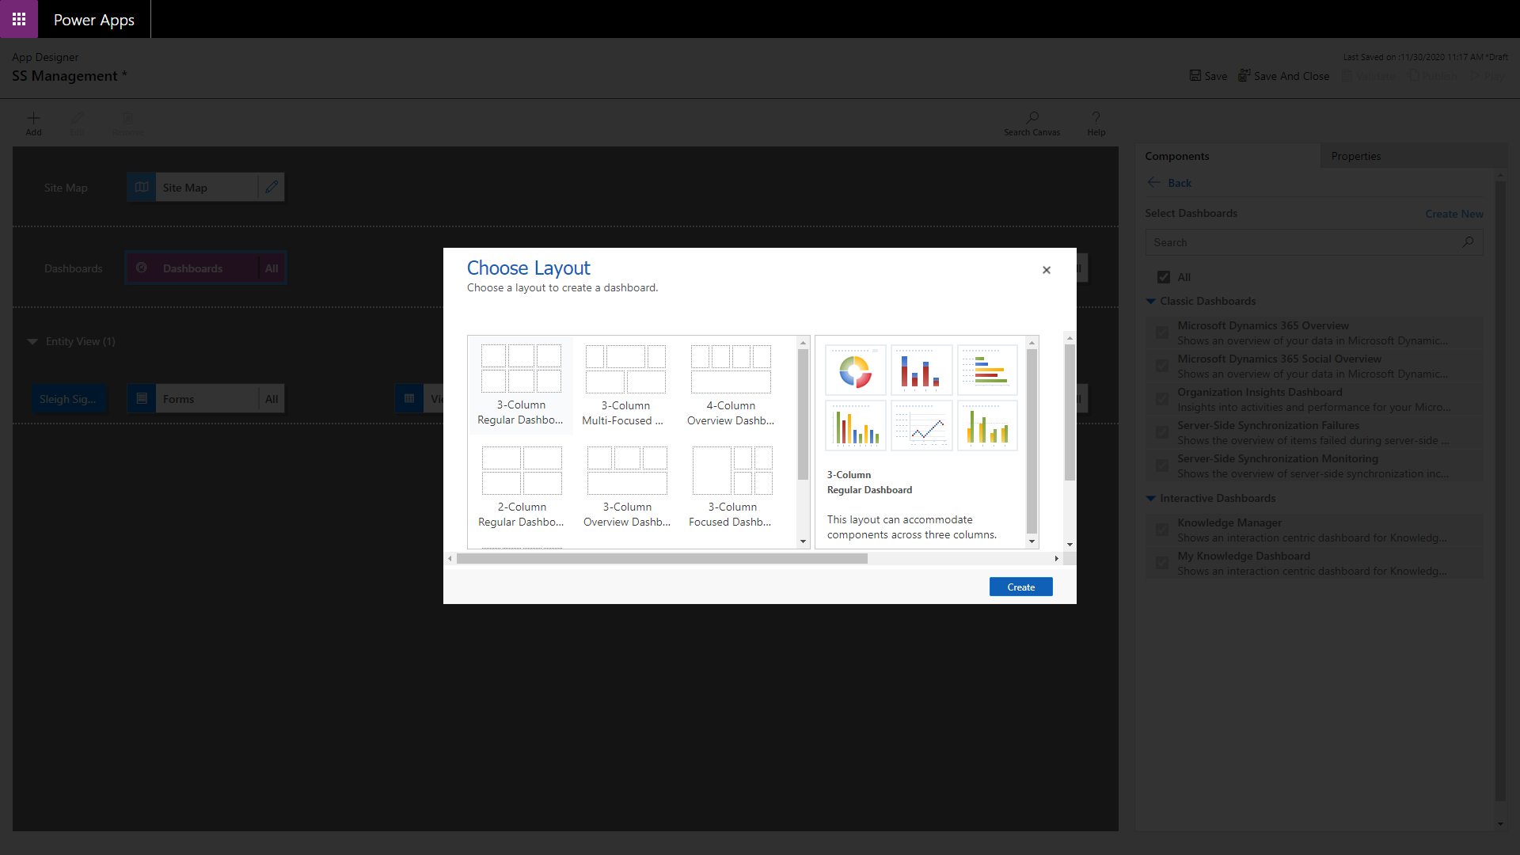

The dashboard editor will load displaying 4 empty areas. 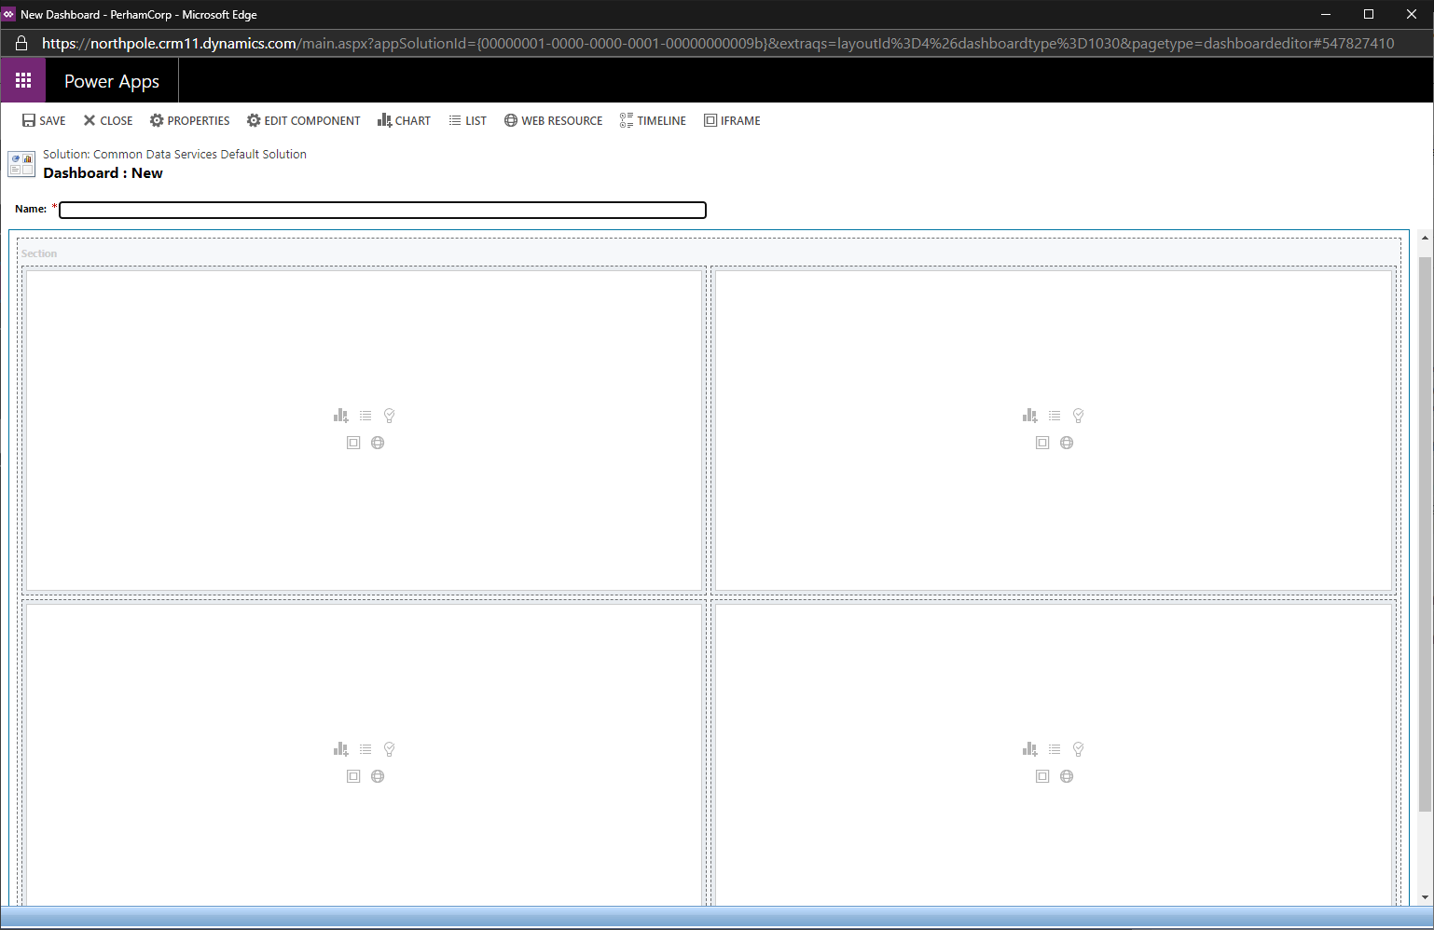

In the area on the top-left, select the list icon () and from the display that is displayed, choose “Sleigh Sightings” from the **Record Type** dropdown and “Active Sleigh Sightings” from the **View** dropdown.

Click **Add** to add this list to the dashboard.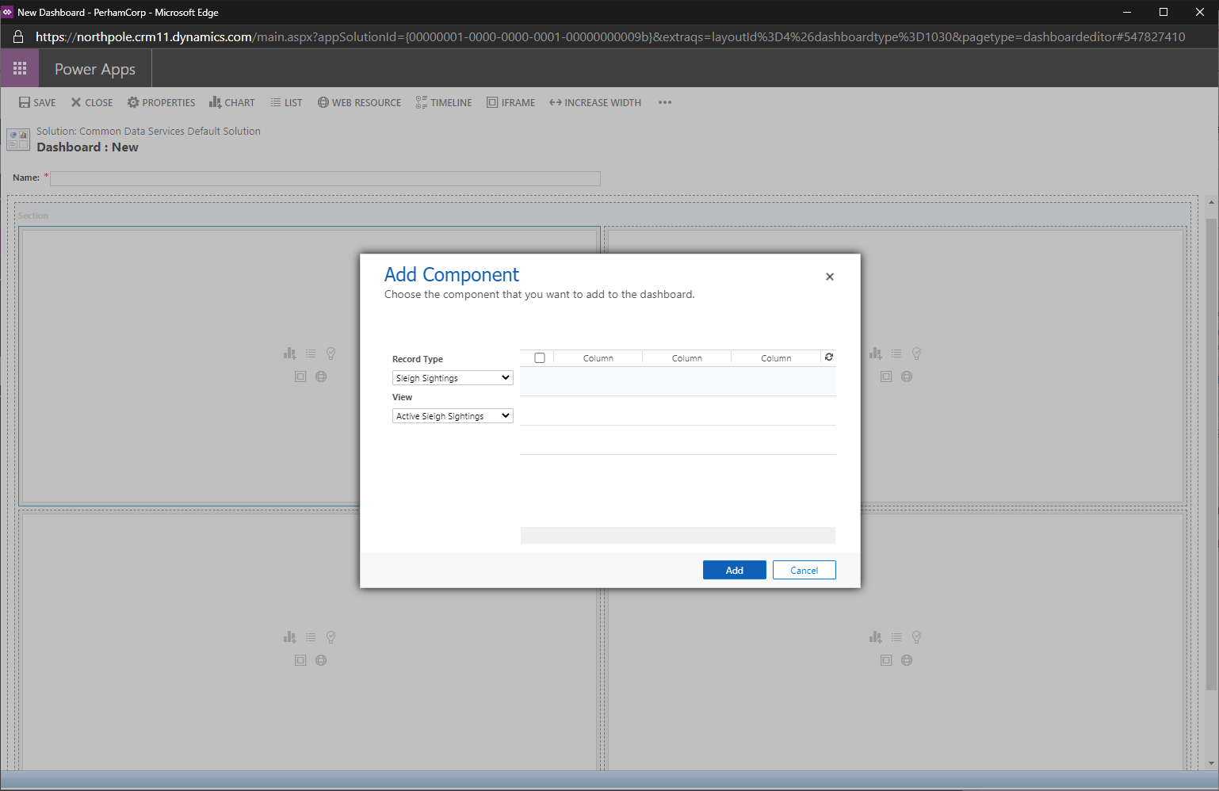

Next, click the chart icon () in the top-right panel and in the chart selection dialog, for **Record Type** choose “Sleigh Sighting”, **View** choose “Active Sleigh Sightings” and **Chart** choose “Unique ID by shape” to display the pie chart created earlier.

Click **Add** to add this chart to the dashboard.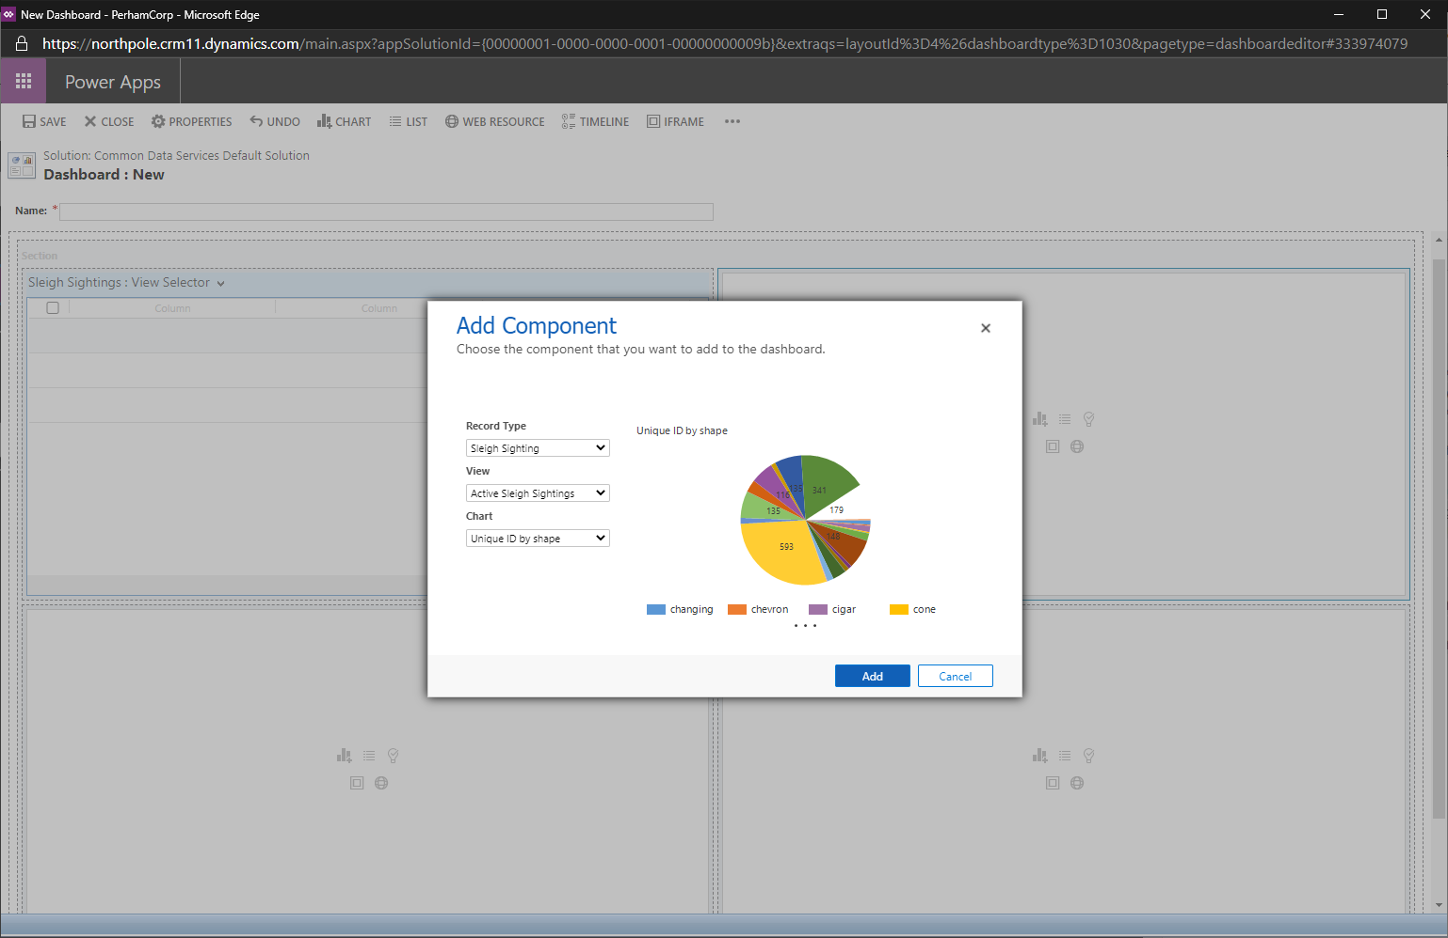

Next, click the chart icon () in the bottom-left panel and in the chart selection dialog, for **Record Type** choose “Sleigh Sighting”, **View** choose “Active Sleigh Sightings” and **Chart** choose “Unique ID by status” to display the column chart created earlier.

Click **Add** to add this chart to the dashboard.

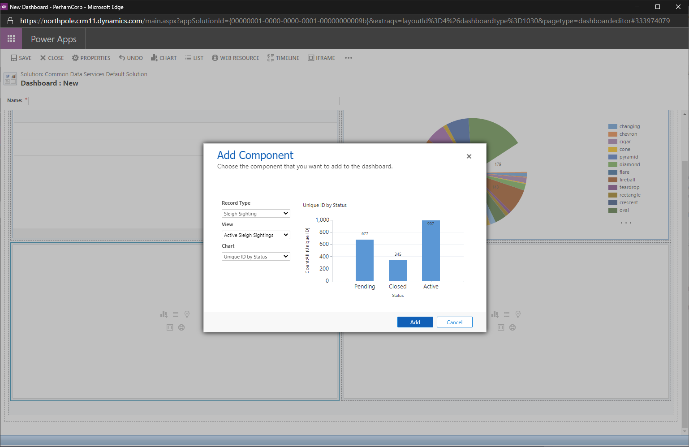

Finally, click the chart icon () in the bottom-right panel and in the chart selection dialog, for **Record Type** choose “Sleigh Sighting”, **View** choose “Active Sleigh Sightings” and **Chart** choose “status by date posted” to display the area chart created earlier.

Click **Add** to add this chart to the dashboard.

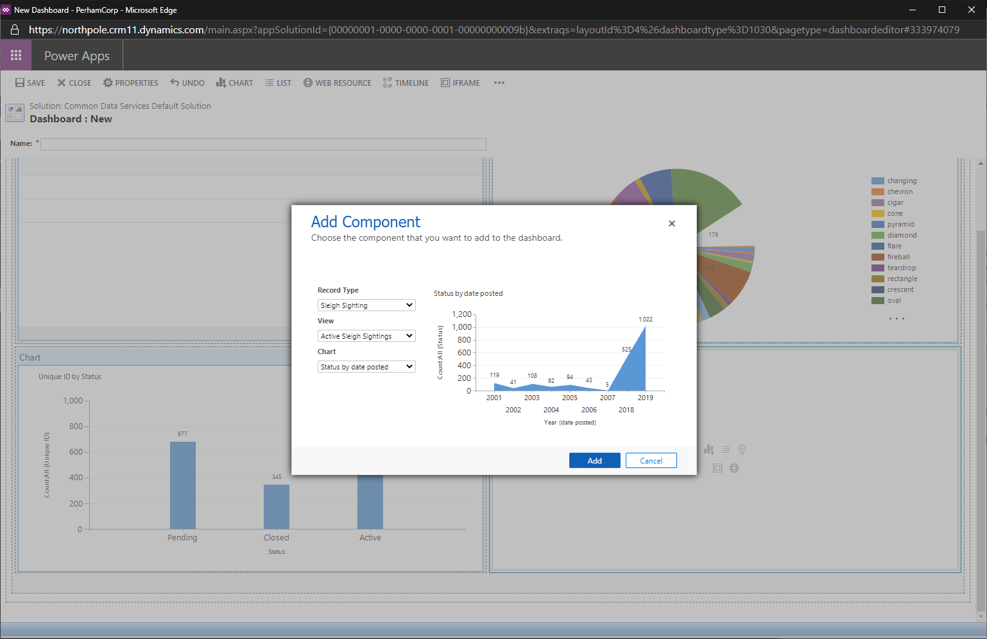

After adding the elements to the dashboard, enter “Sleigh Sightings Dashboard” in the **Name** textbox and click **Save**.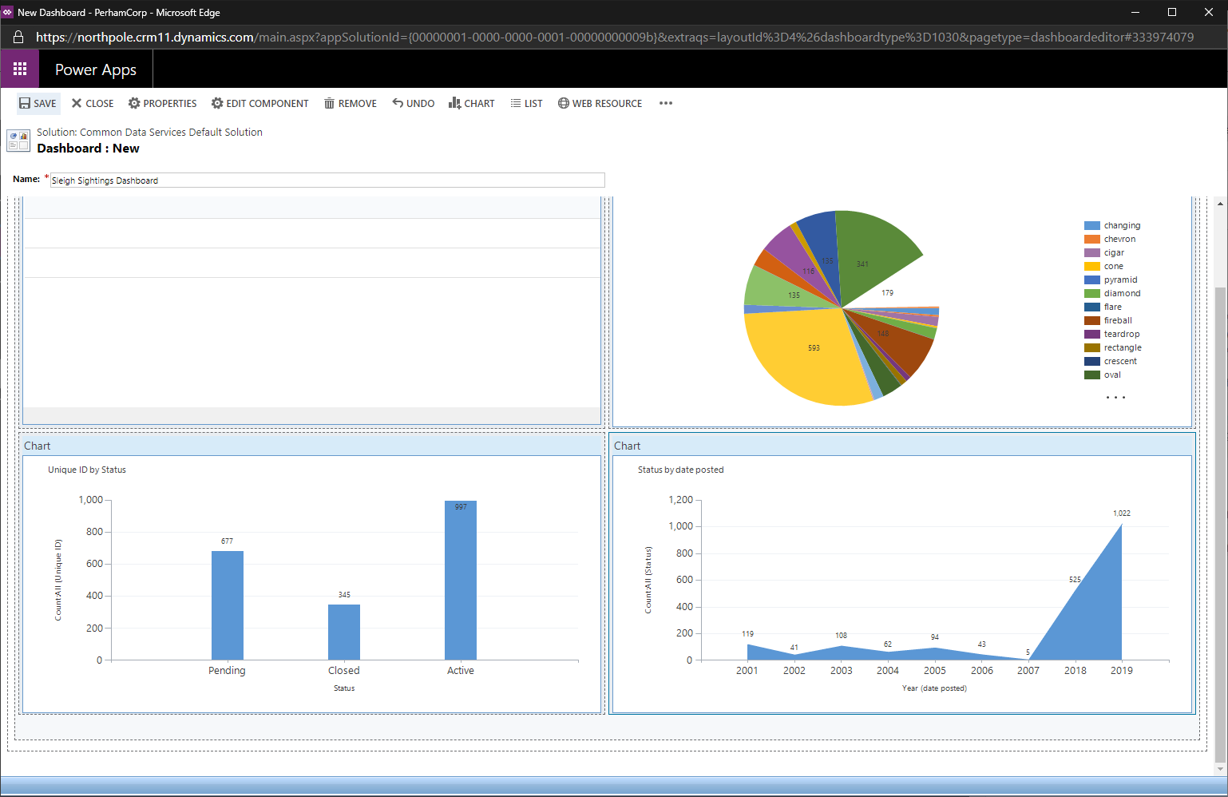

Finally, click **Close** to return to the Entity Driven Application maker experience.

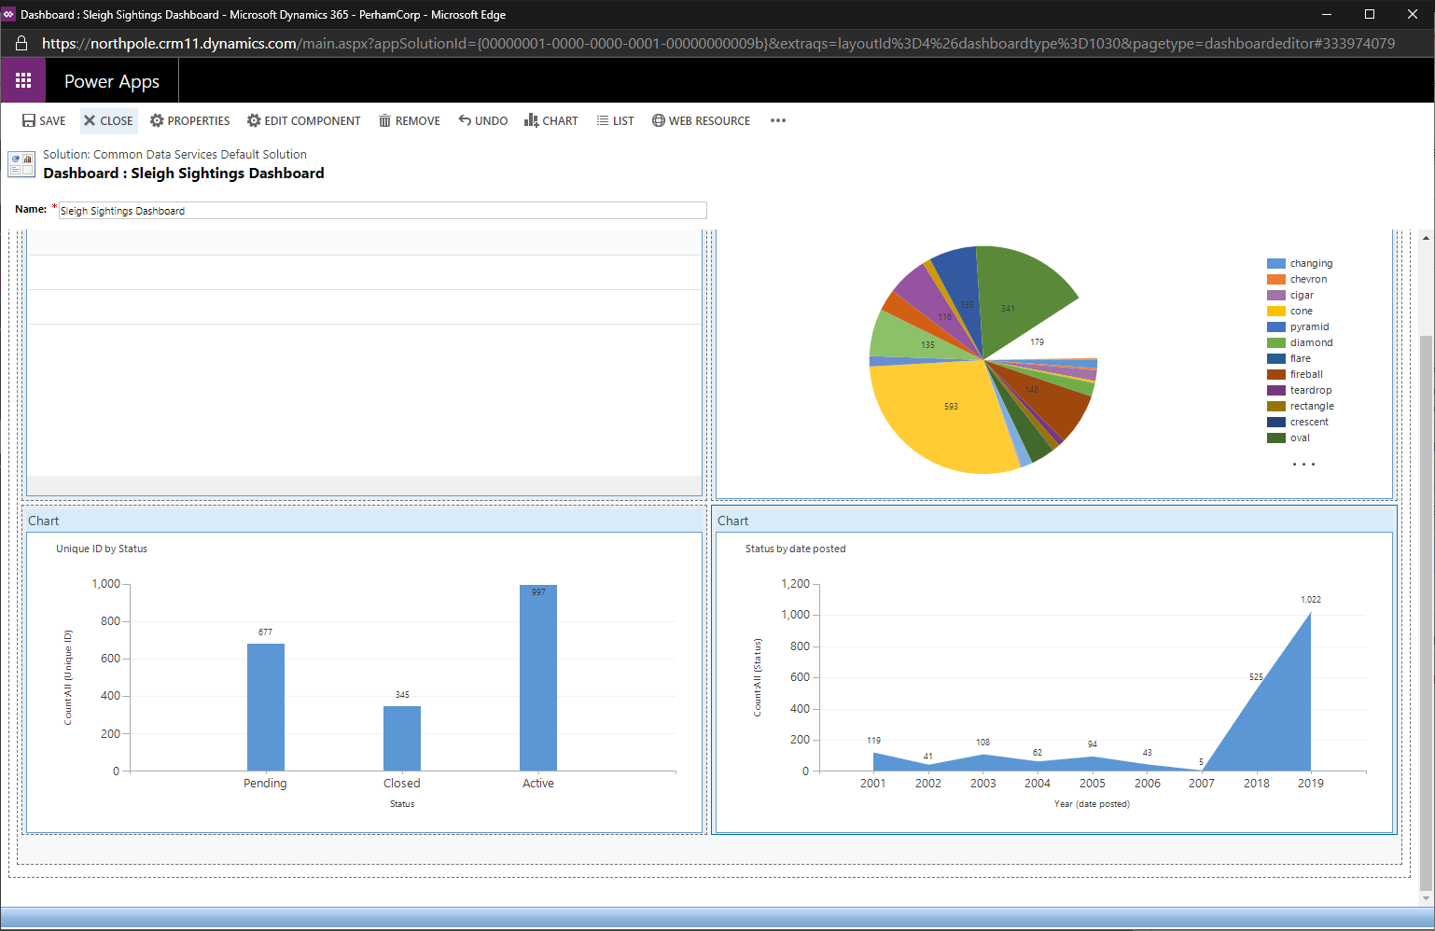

The new dashboard should now appear in the list under Classic Dashboards. Ensure that the **All** checkbox is *unchecked* and check only “Sleigh Sightings Dashboard”.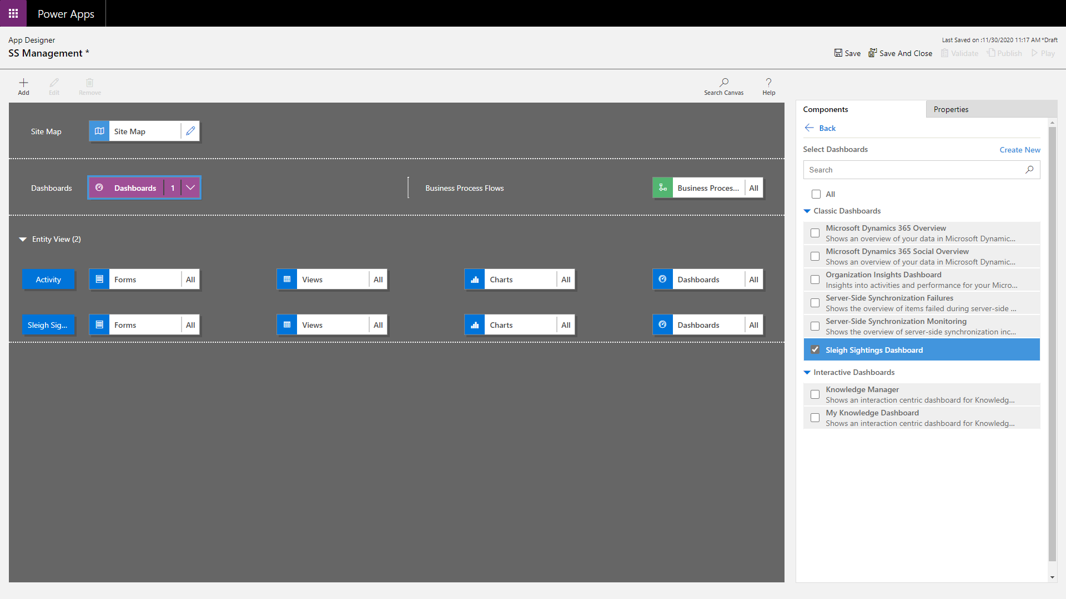

Now the dashboard has been created, it can be added to the sitemap subarea that was created earlier. To do this, click on the pencil icon next to the **Site Map** element.

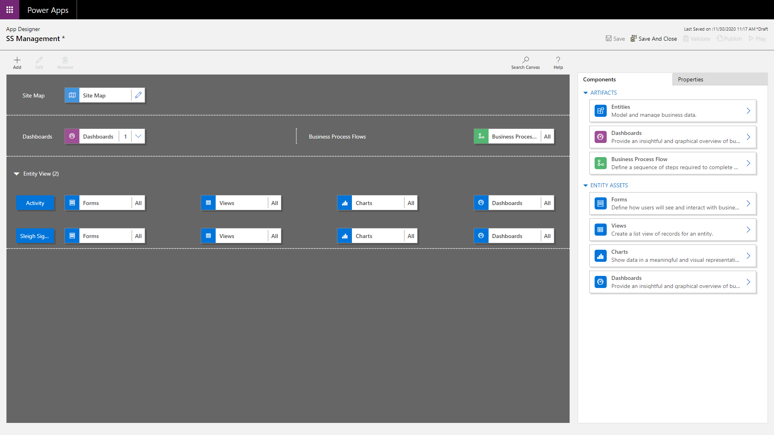 Select the Dashboard subarea on the left and ensure that the properies pane is displayed on the right.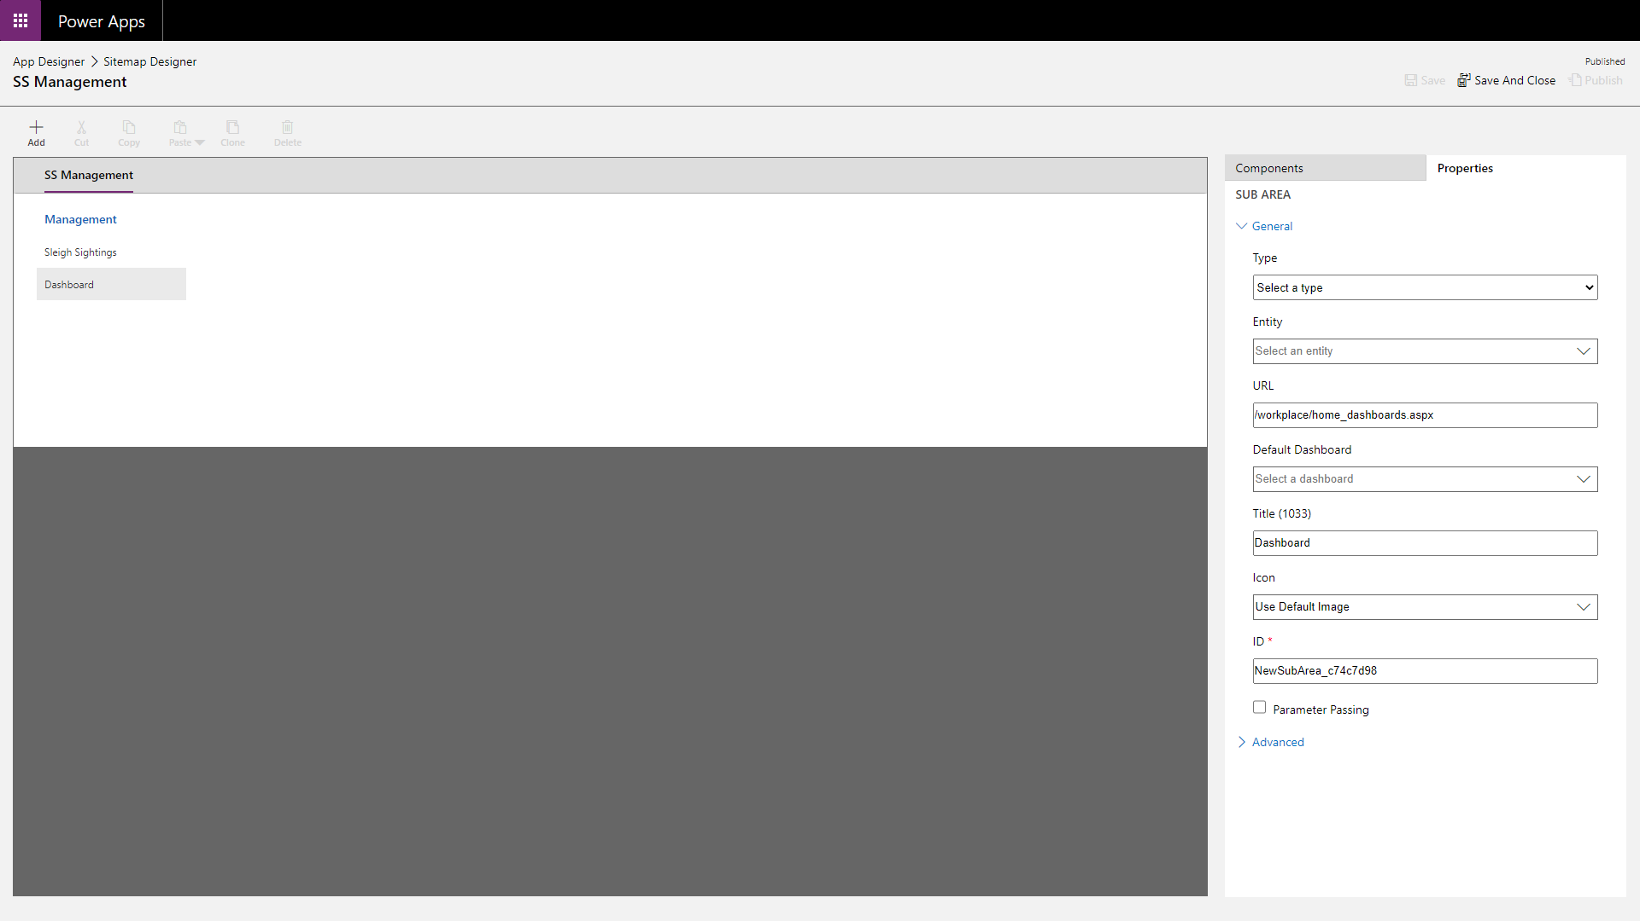

Choose “Sleigh Sightings Dashboard” from the **Default Dashboard** dropdown.

Click **Save**, **Publish** and then **Save And Close** to return to the application overview screen.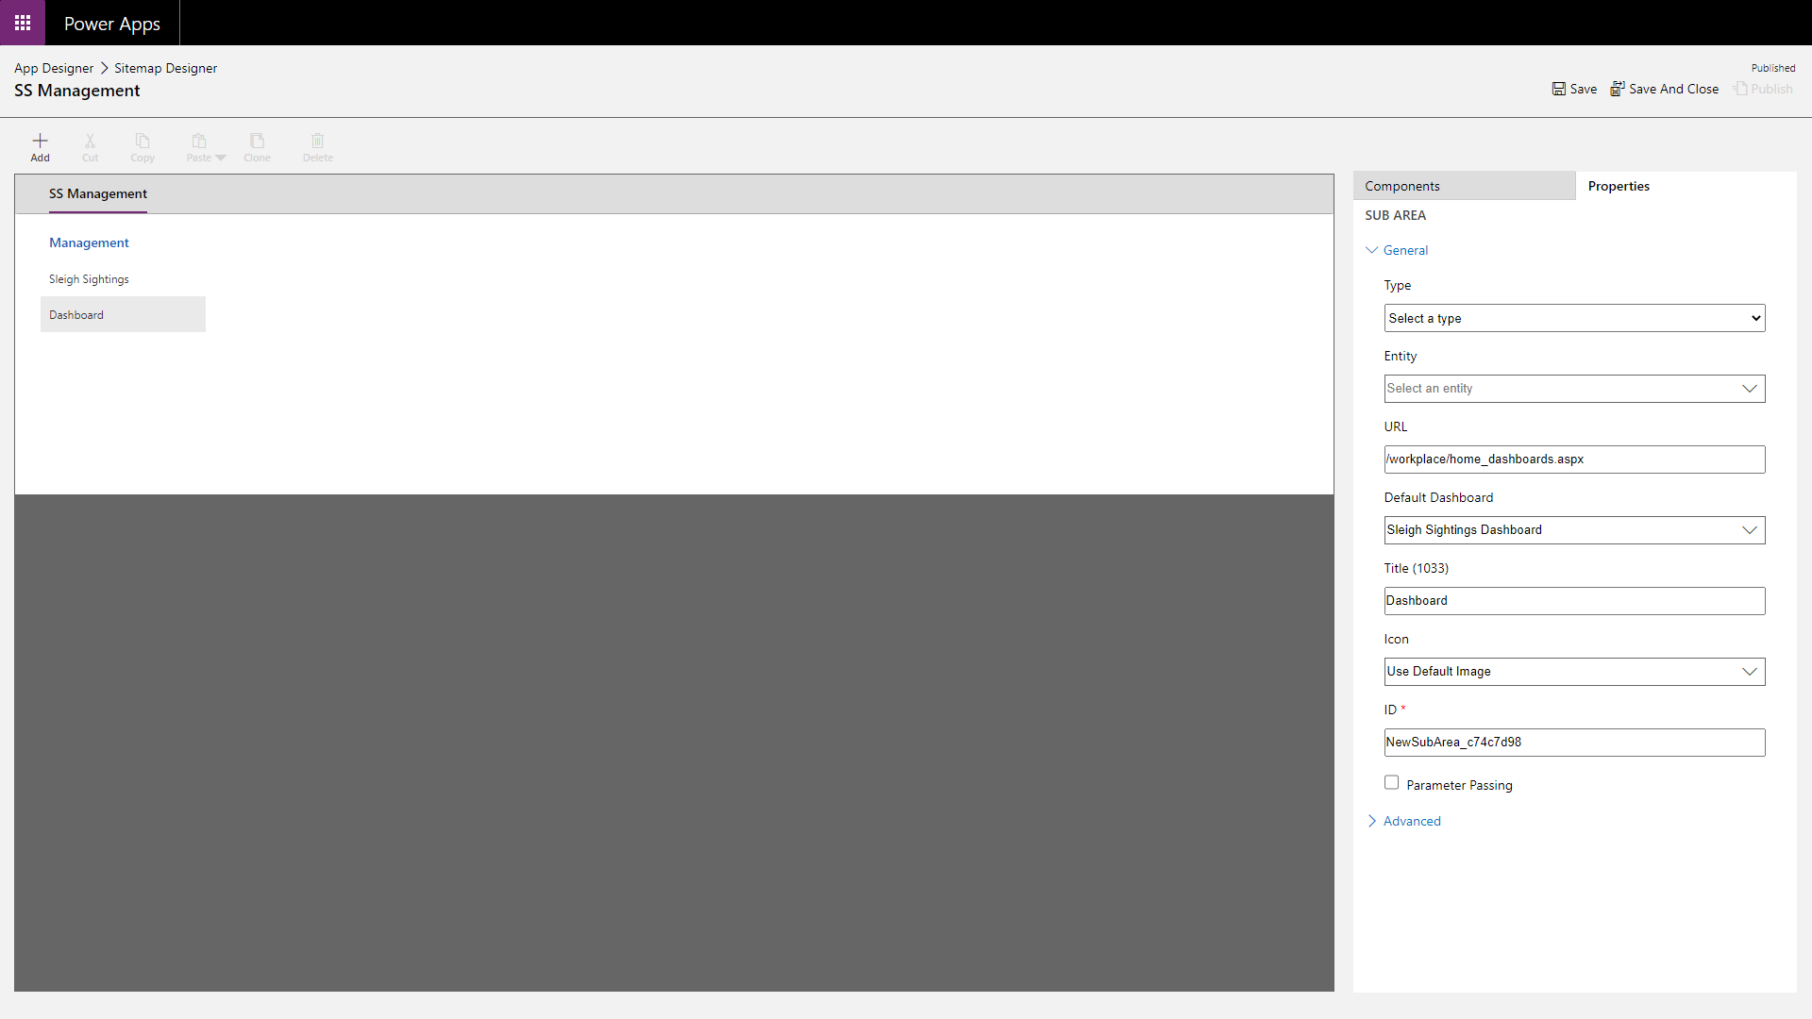

The final step in creating the application is to click Save and then Publish on the App Designer screen. This will make the new sitemap and dashboard available as part of the application.

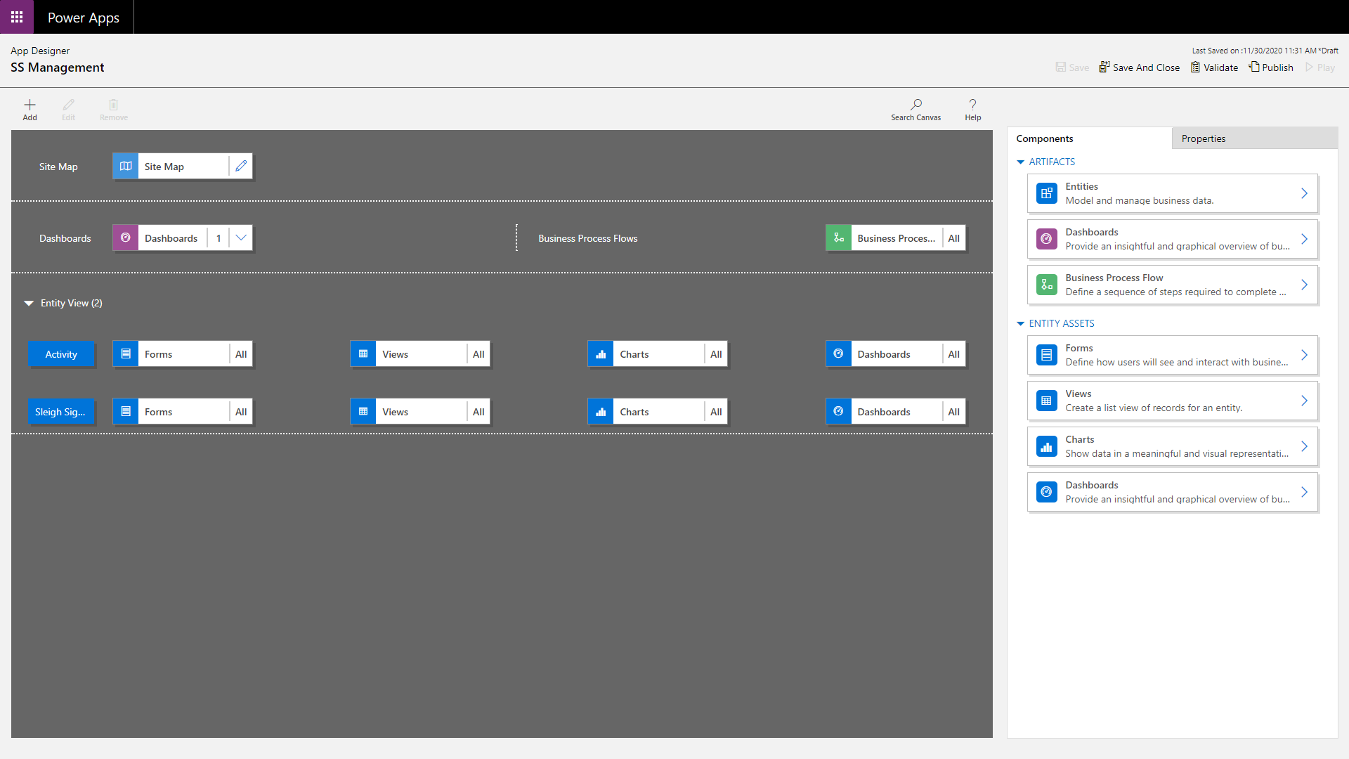

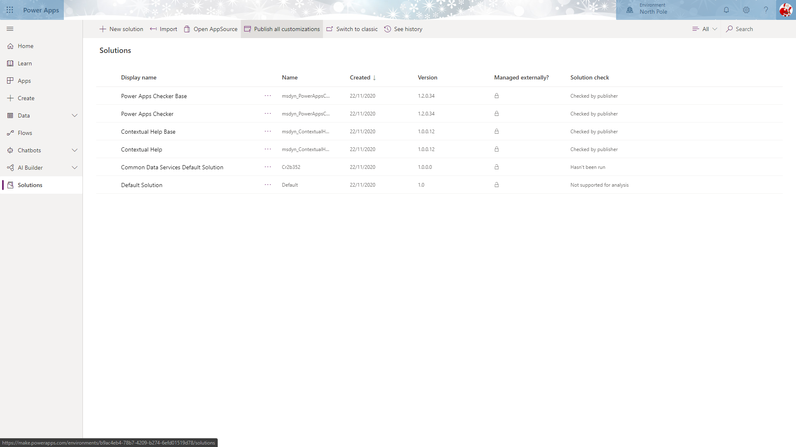

To test the application, navigate to **Apps** from the left menu, select “SS Management” and click the **Play** button on the toolbar.

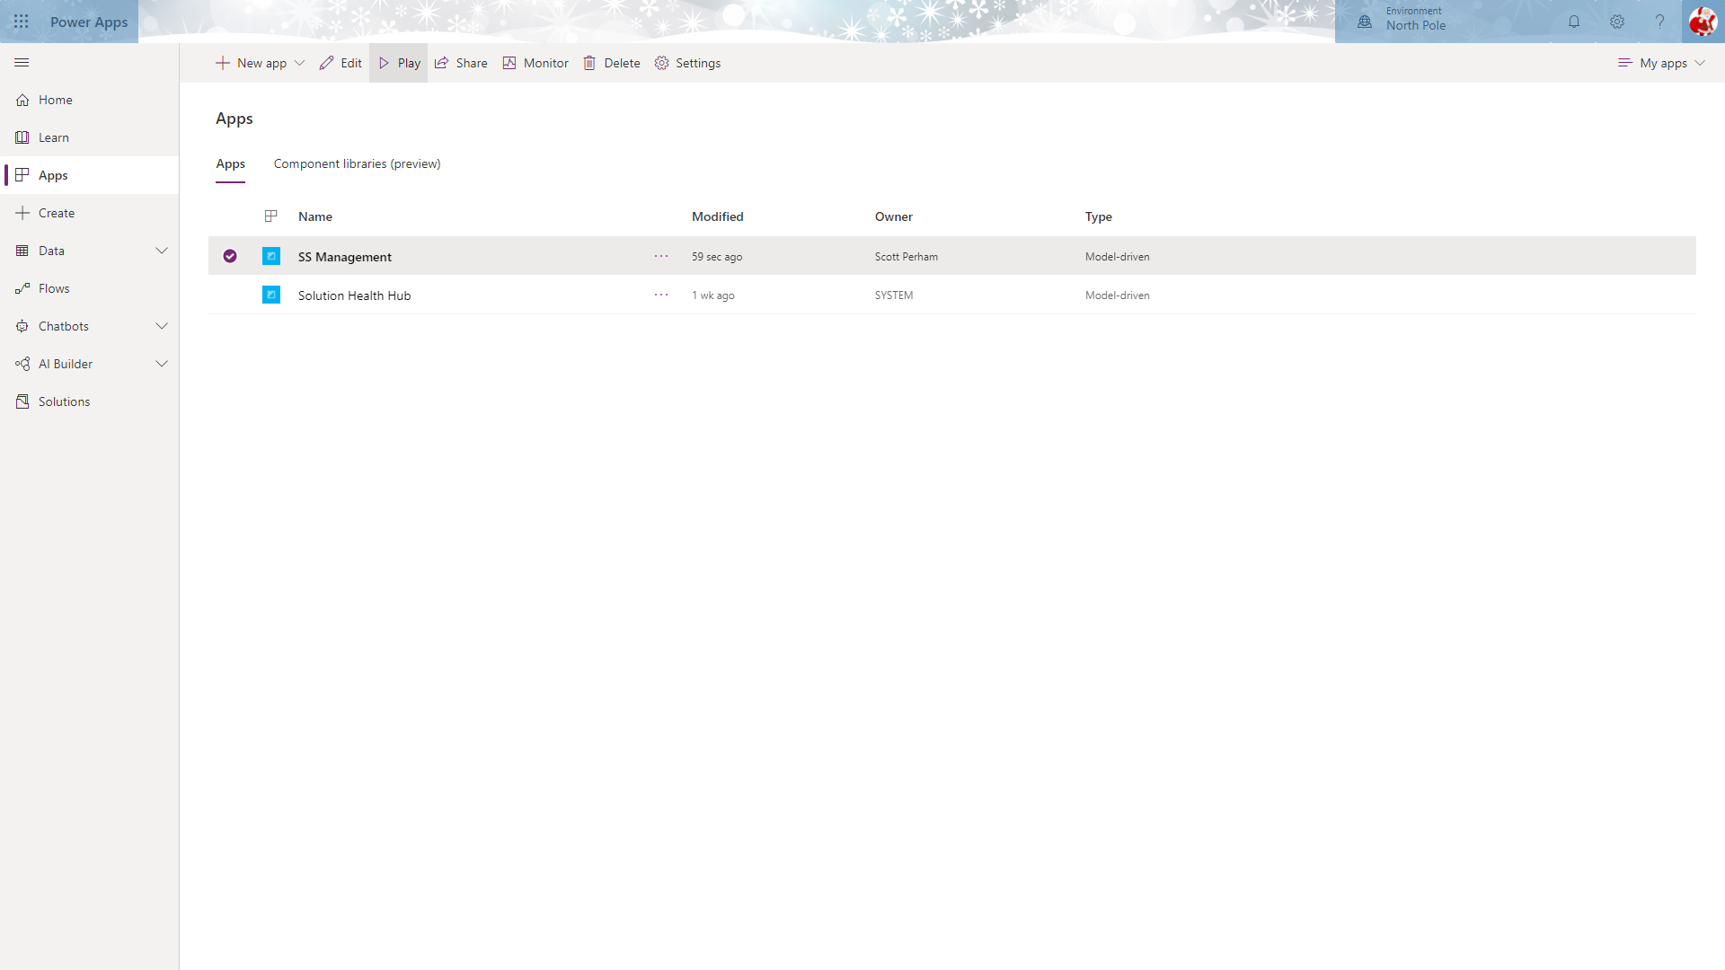

This will launch your application.

The first, default page will be the list of active sleigh sightings.

Clicking the **+ New** button will take you to the form to add a new sighting that you configured earlier.

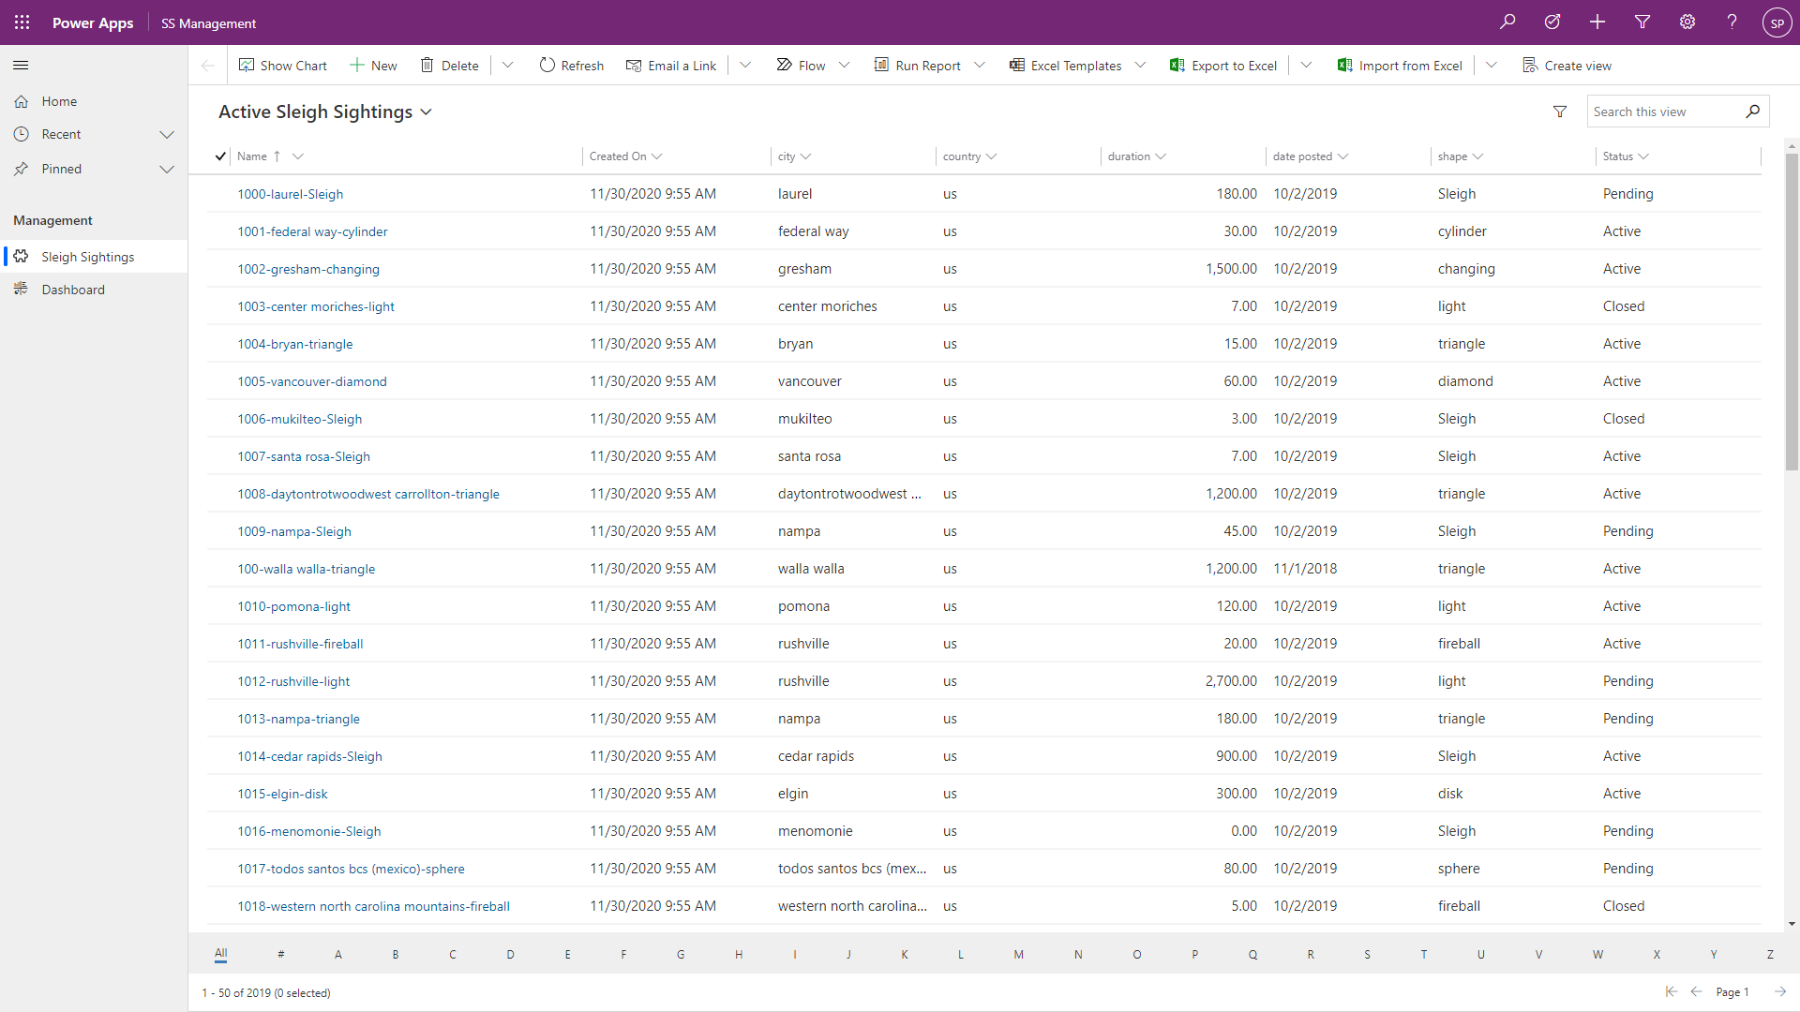

This form has the fields that you dragged onto the main form for the Sleigh Sighting table and also display the Business Process Flow at the top.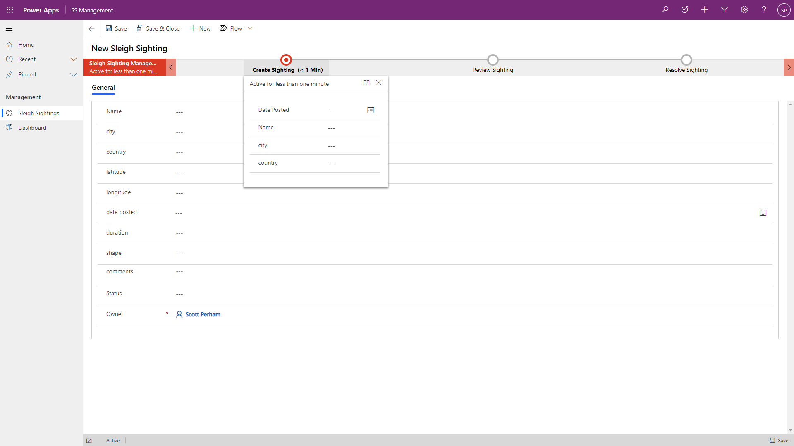

Finally, navigate to the dashboard by clicking **Dashboard** on the left menu.

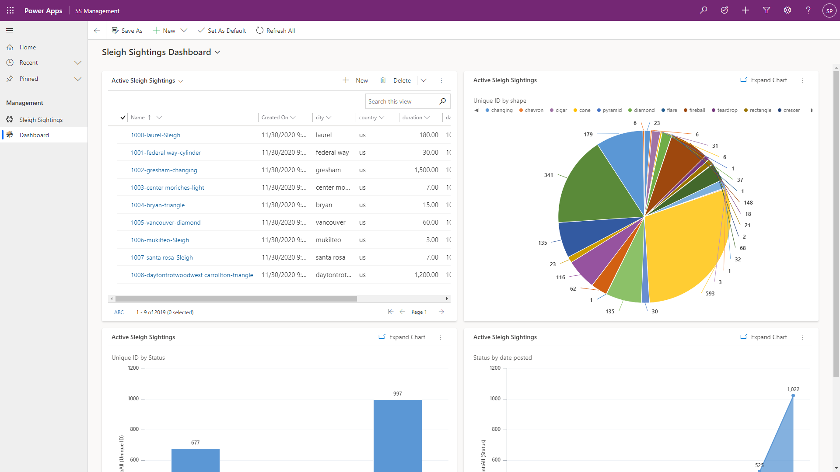

# Lab 4: Configuring your Microsoft Flow Notifications

In this lab we will configure an Automated Flow to alert the captured Sleigh sighting record that their information has been captured and that they are being taken through the sleigh sighting process.

***Please Note:***

***This lab can be completed independently, with only Lab 1 being and no support of the other labs.***

## Solution Components

Microsoft Flow

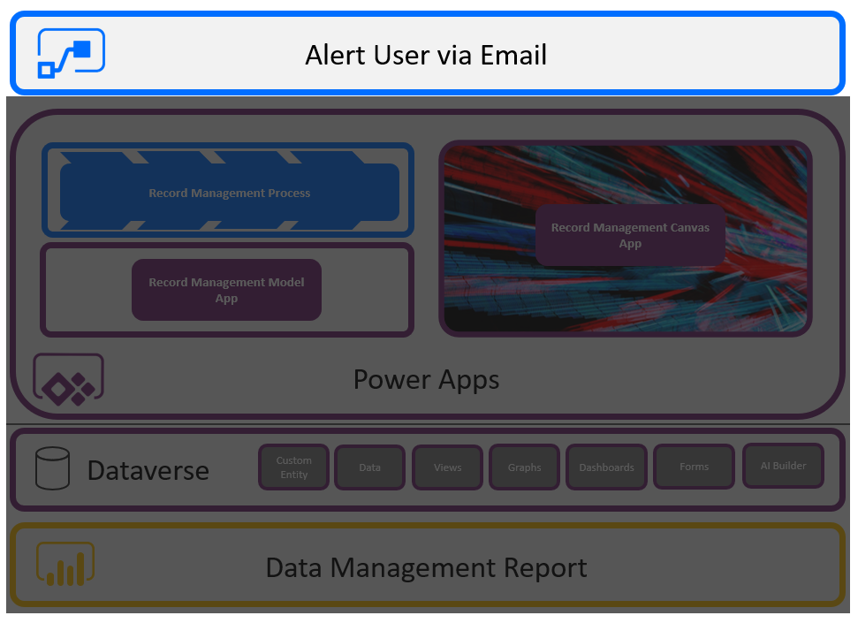

## Let’s Begin

### Flow

Navigate to the make experience (<https://make.powerapps.com>) and select **Flows** from the menu on the left.

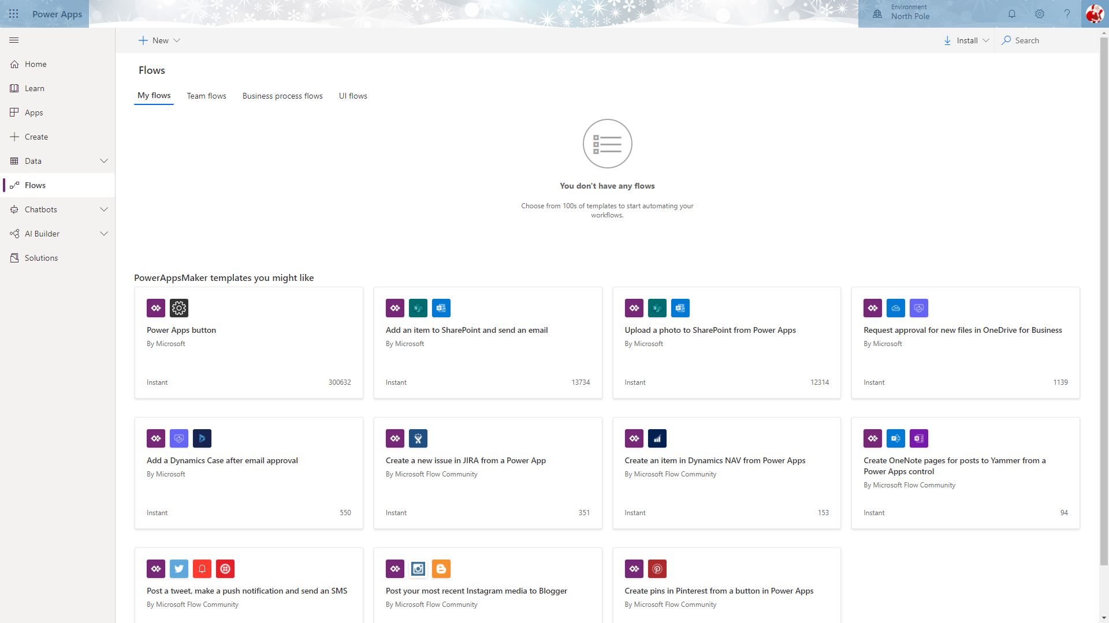

Click the **+ New** button at the top of the page and slect **Automated – from blank**.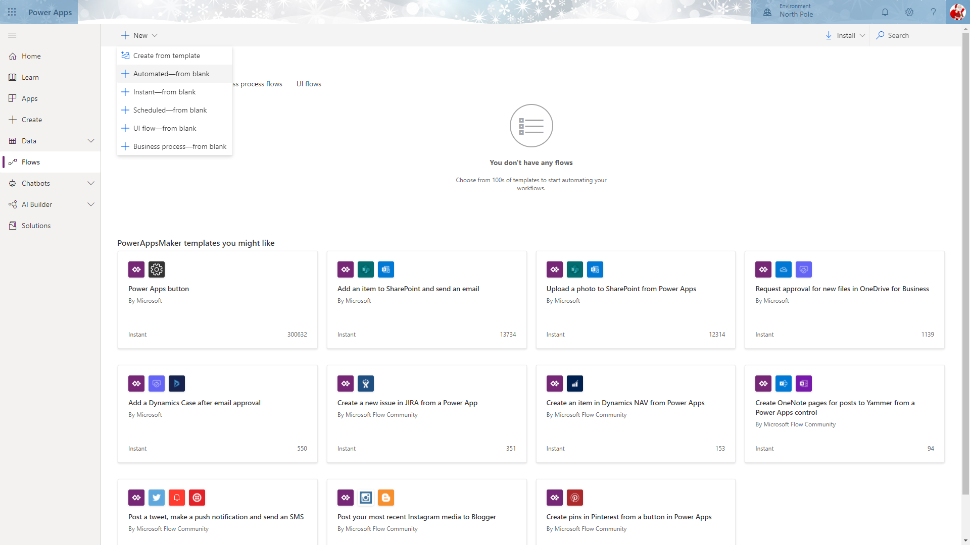

This will display the following dialog, asking for the name of the flow and the trigger to get it started.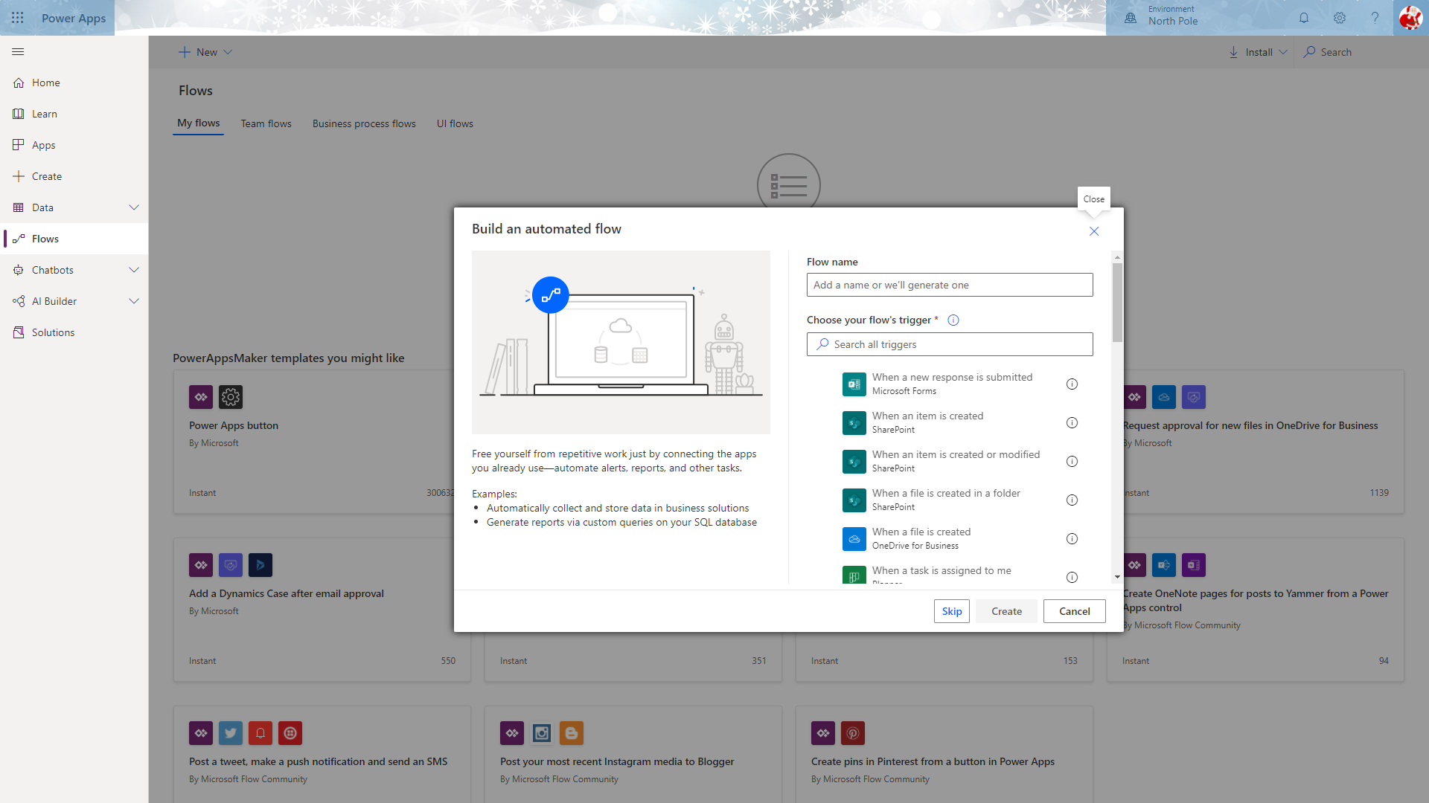

For the **Flow Name** enter “Alert Elves”. Enter “Common” into the search box below **Choose your flow’s trigger** and select **When a record is created**. Then click **Create**.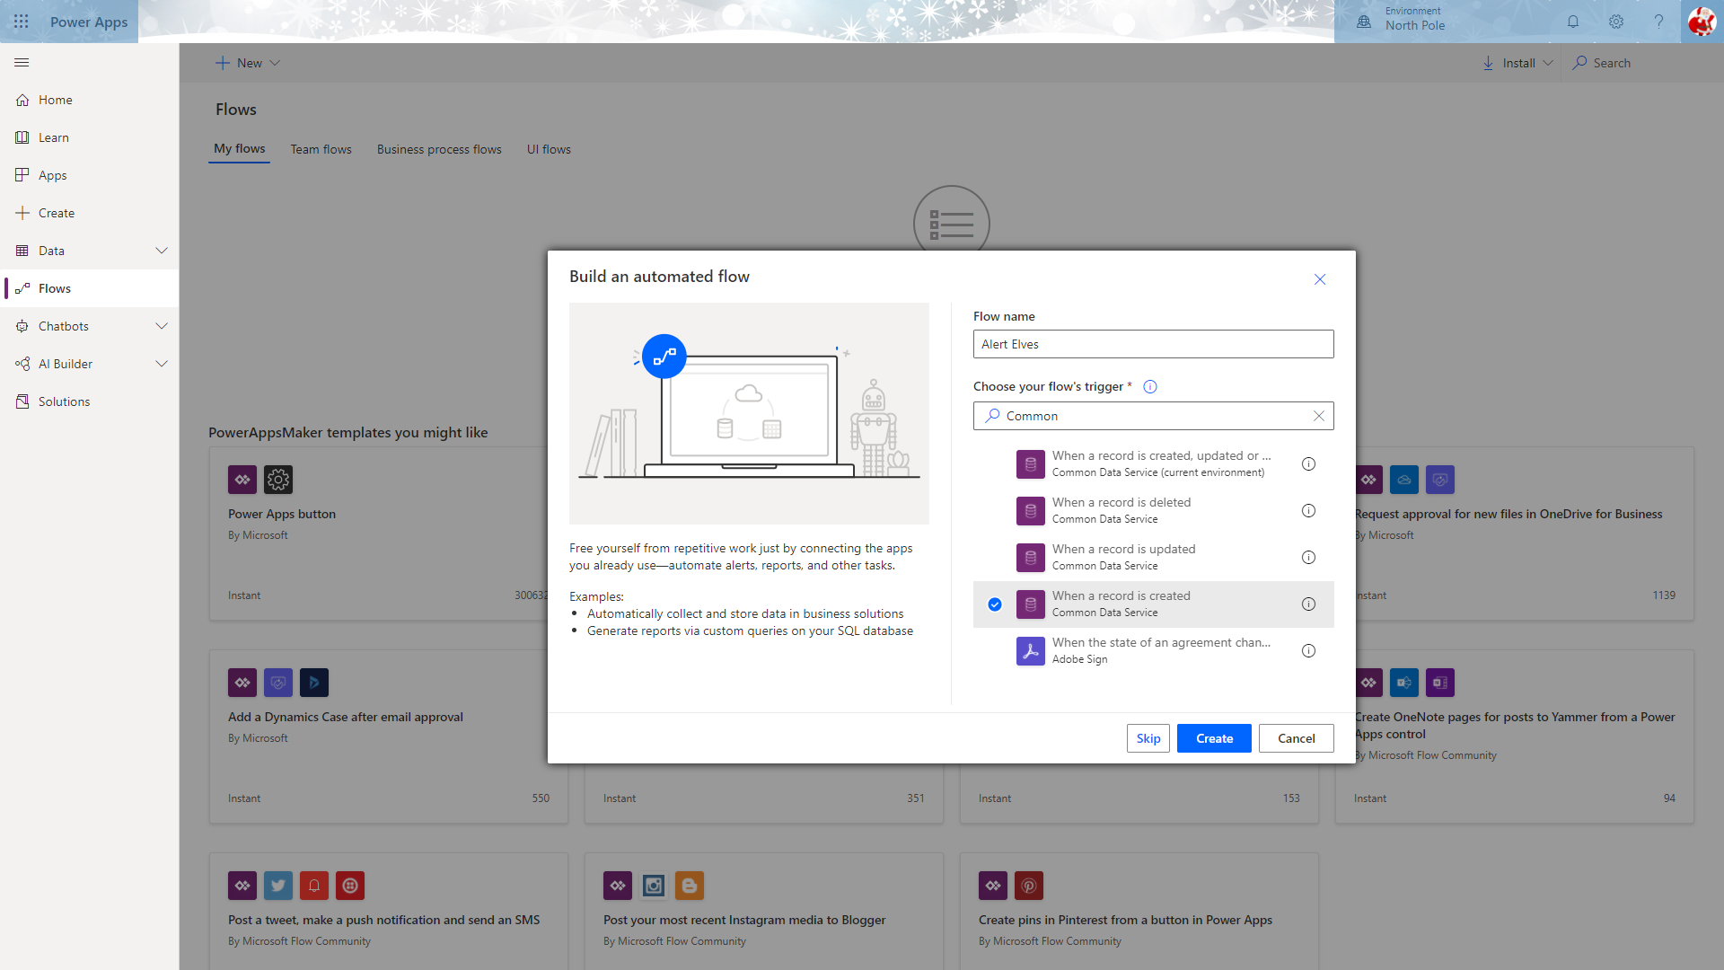

This will launch the flow designer with the trigger step in place. To configure this, choose your environment from the **Environment** dropdown, “Sleigh Sightings” from the **Entity name** dropdown and “Organization” from the **Scope** dropdown.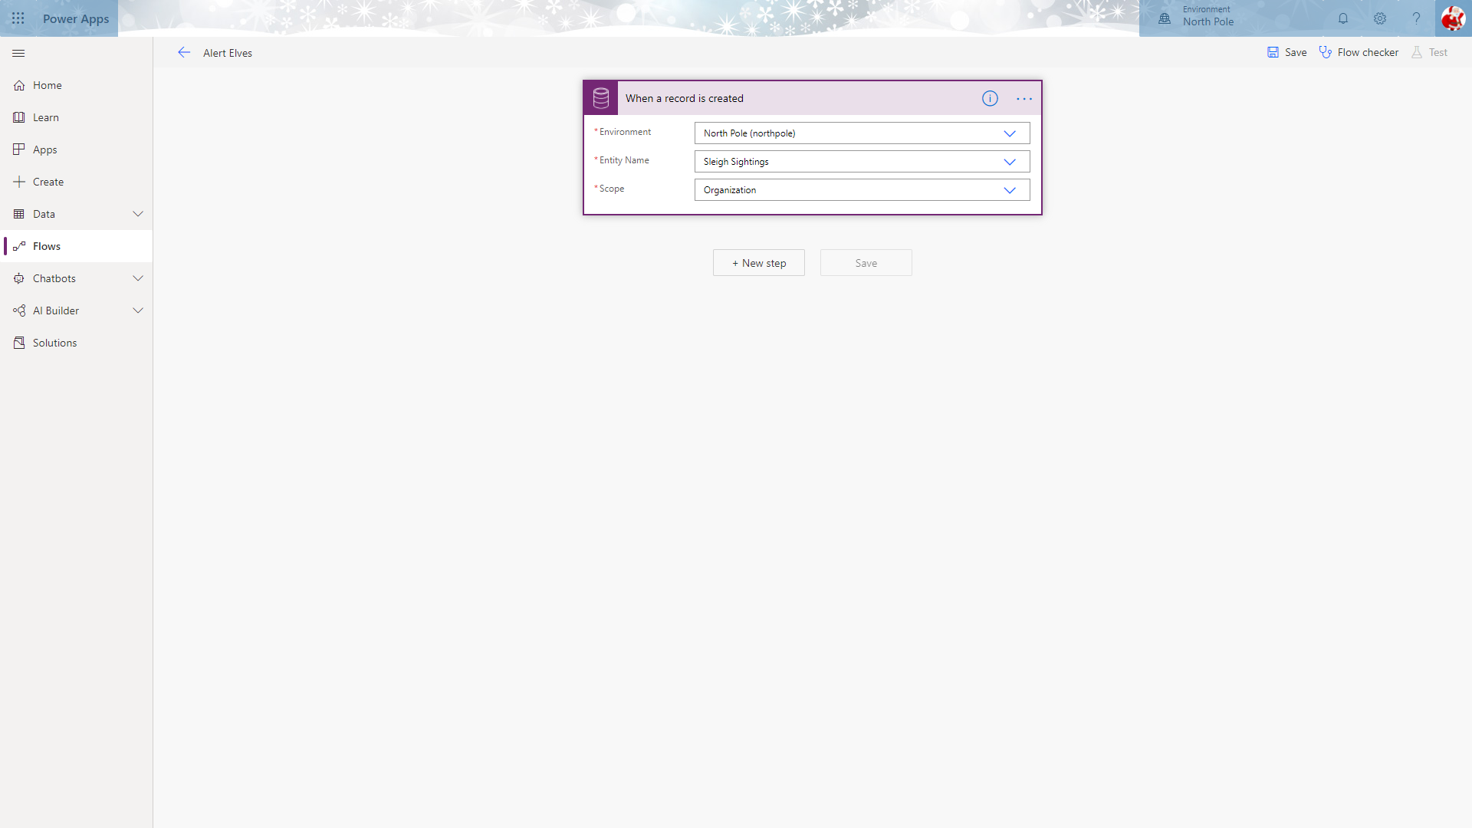

To send an email when a new sleigh is sighted, click the **New Step** button.

In the **Choose and action** panel, type “Send Email” into the search box to list available steps and select **Send an email (V2)**.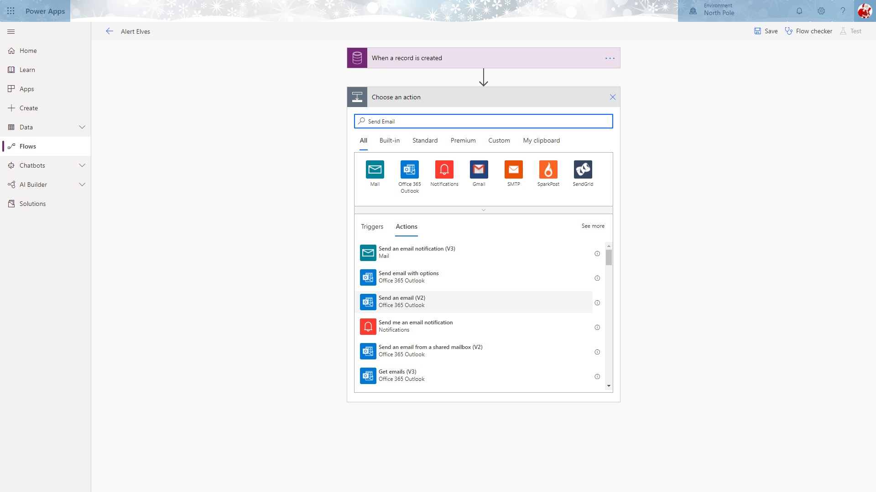

The step will change to display the properties of the send and email step.

Enter an email address to send the email to, a subject and a body.

Within the body, you can select a field from the displayed list to enter a placeholder that will be replaced when the email is generated.

When you have finished, click **Save** to save the flow then close the designer to return to the app maker experience.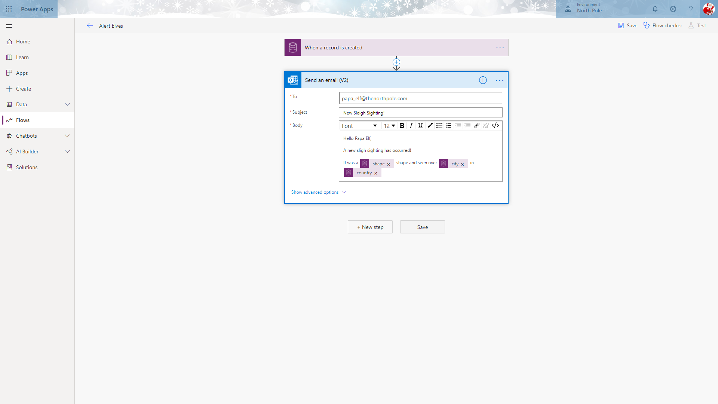

Your flow should now be displayed under **My flows** in the **Flows** screen.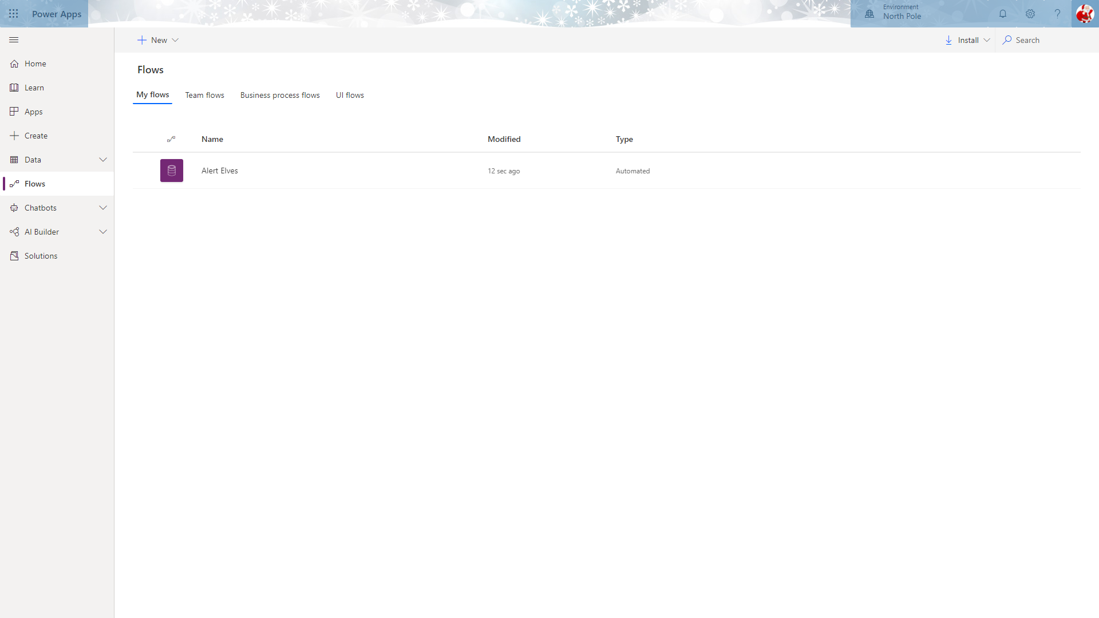

# Lab 5: Configuring the Sleigh Sightings Canvas App

In this lab we will learn how to configure a basic Power Apps (Canvas App) that the elves in black team can use on the road to capture information for the Mid office sightings management team to leverage. This app needs to be as simple and user friendly as possible.

## Solution Components

Power Apps : Canvas Apps

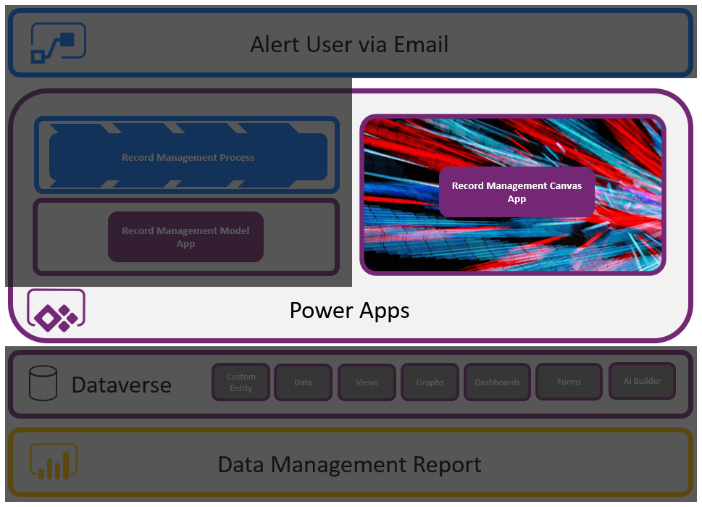

## Let’s Begin

### PowerApps Canvas App

Navigate to [*https://make.powerapps.com*](https://make.powerapps.com) and select **Apps**. To create your new Canvas app select **New App** and then select **Canvas**.

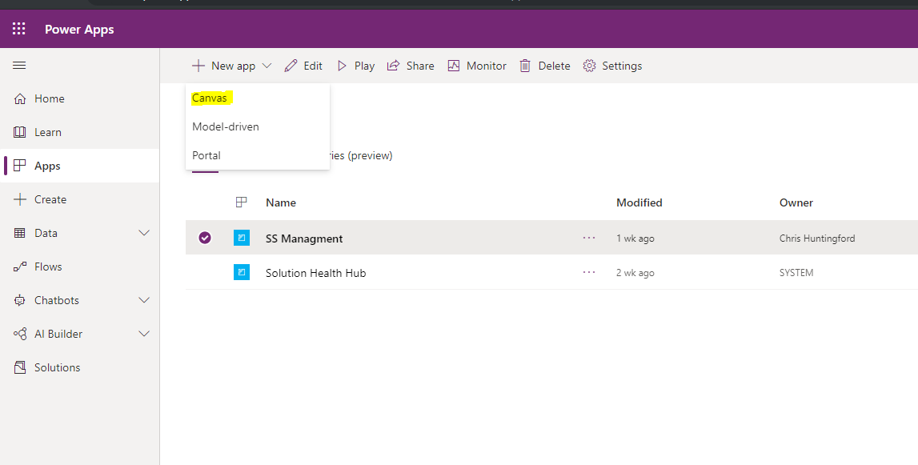

You will be taken to the canvas app splash screen where you will be encouraged to start from data. We will be creating your first canvas app by leveraging data from Microsoft Dataverse. To begin the process, select the **Common Data Service: Phone layout** option.

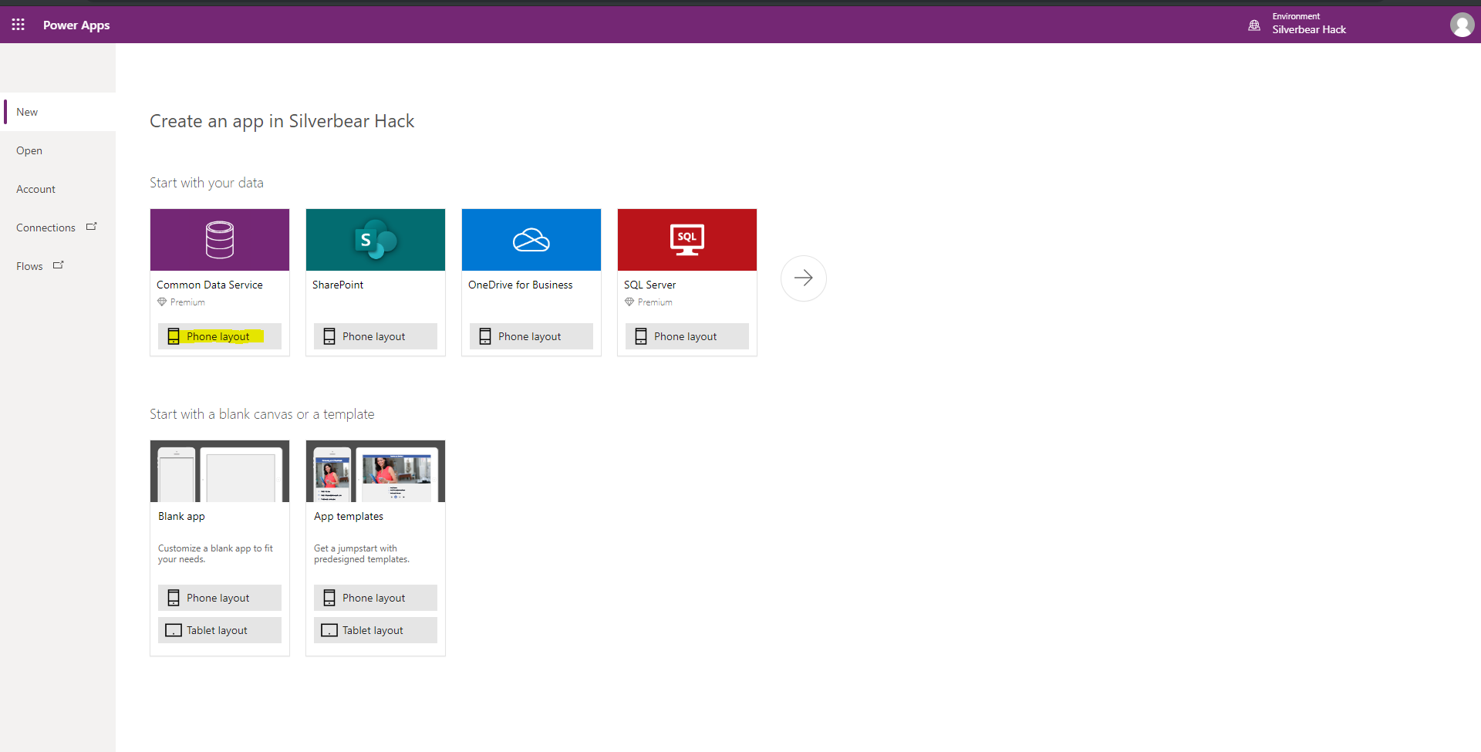

You will be prompted to create a new connection to the Common Data Service (Dataverse). To do this, select **Create**.

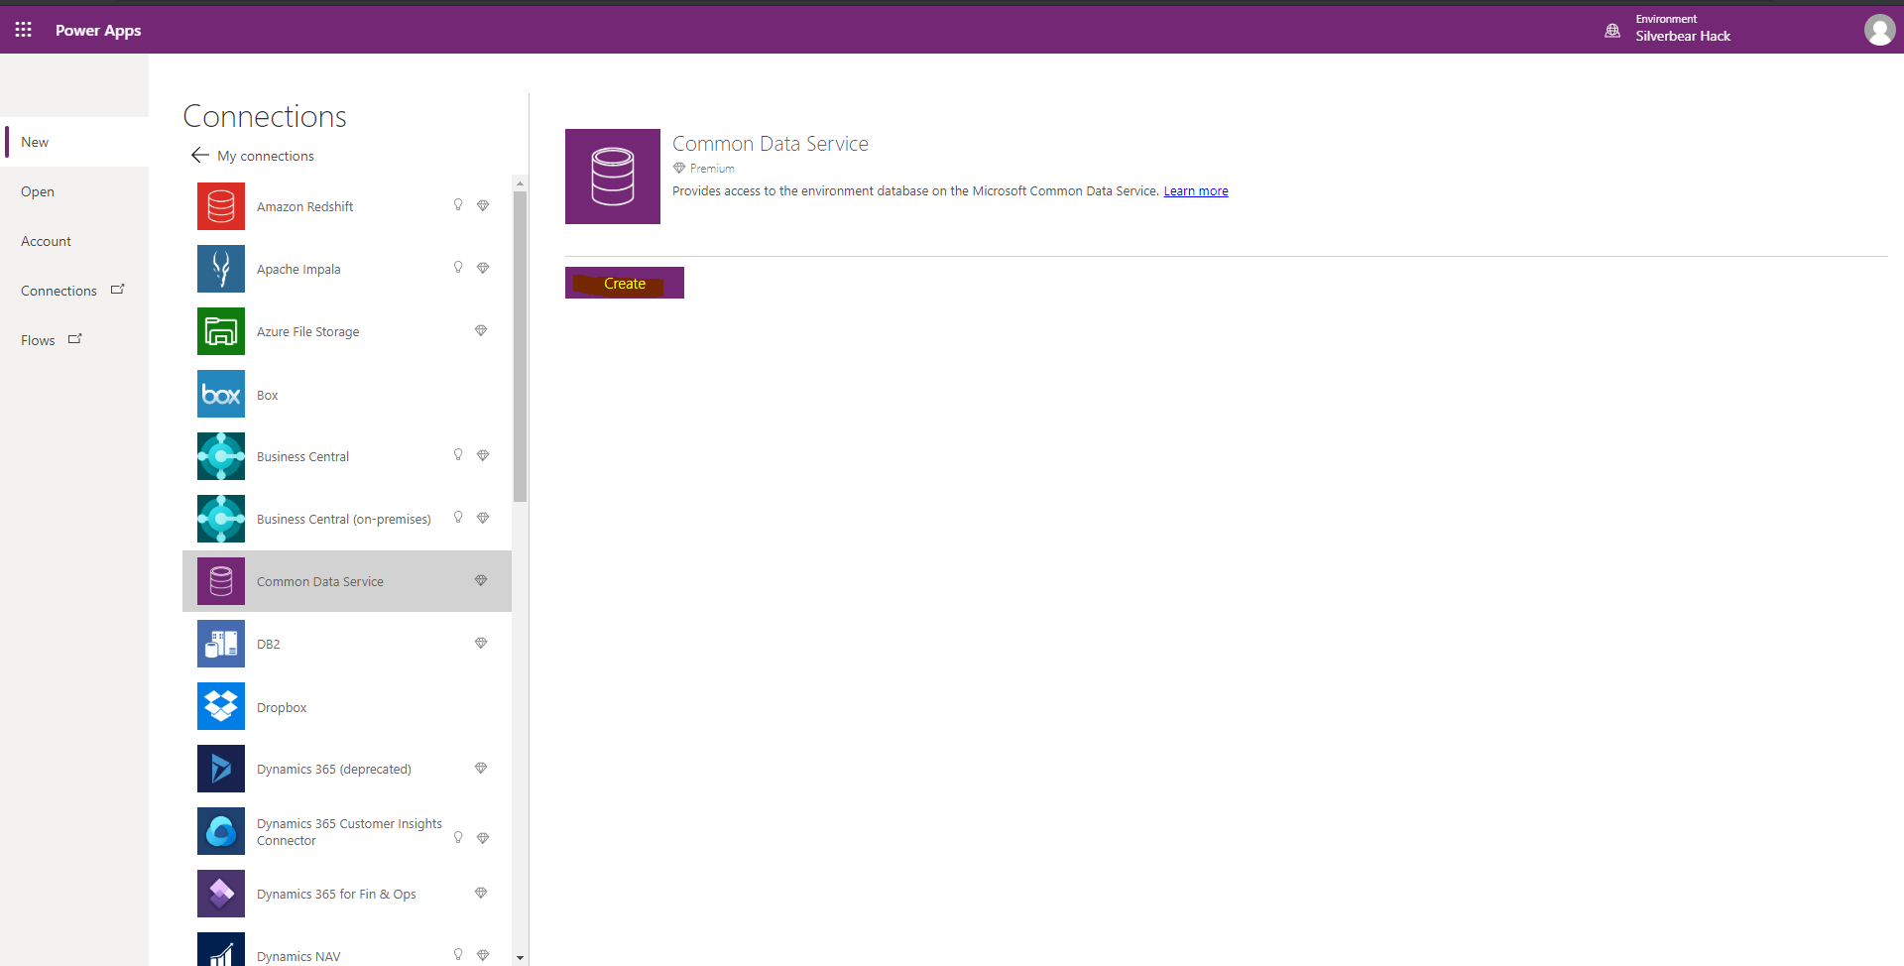

Once you have made the connection, you will be shown a list of tables.

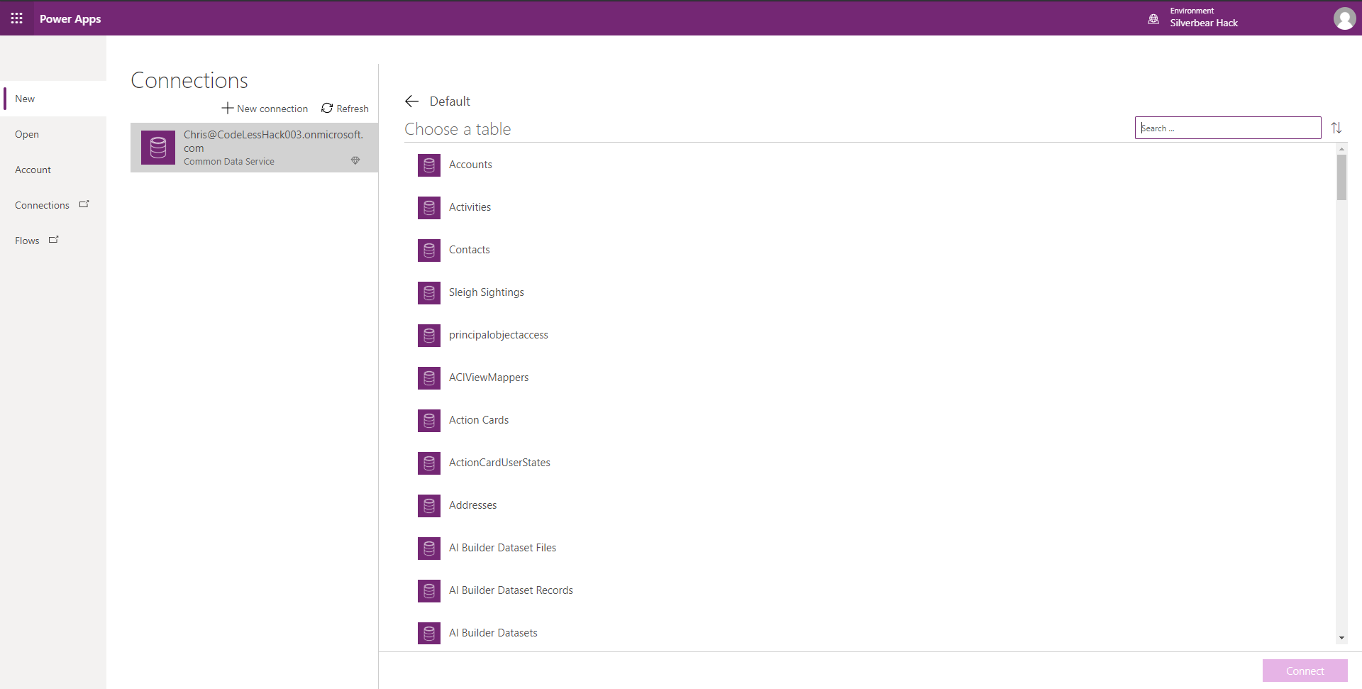

Filter this list by looking for the **Sleigh Sightings** table. Select the **Sleigh Sightings** table and then select **Connect**.

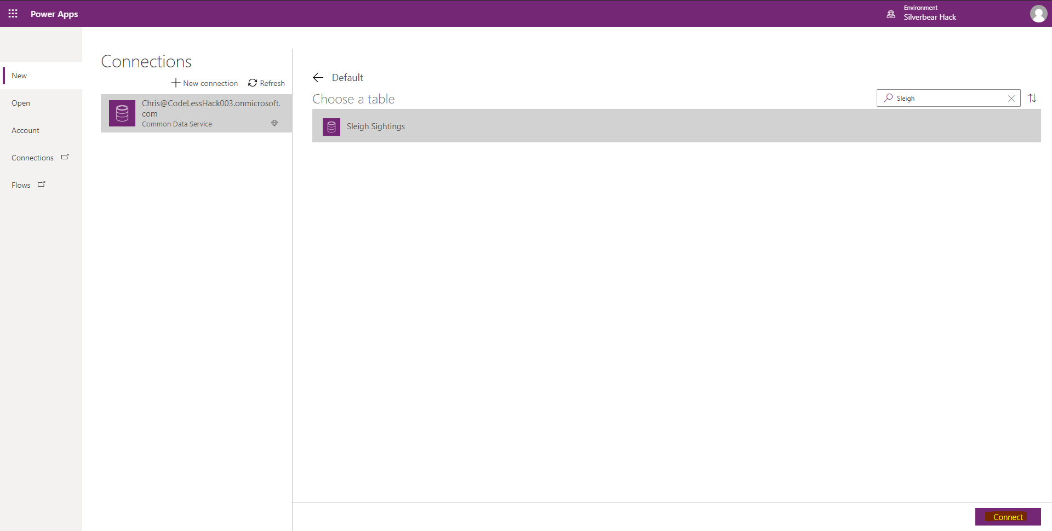

The Power Apps studio will then leverage the data you have already added to the Sleigh Sightings table and your first 3 screen Canvas app will automatically be created for you.

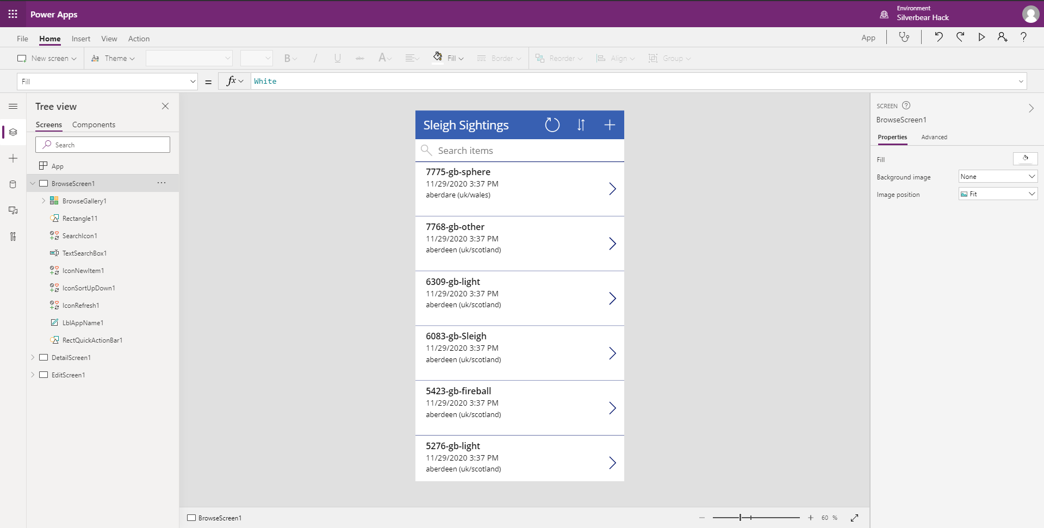

On the left panel, in the tree view, you can navigate between different screens and components. Practice by moving between the various screens now.

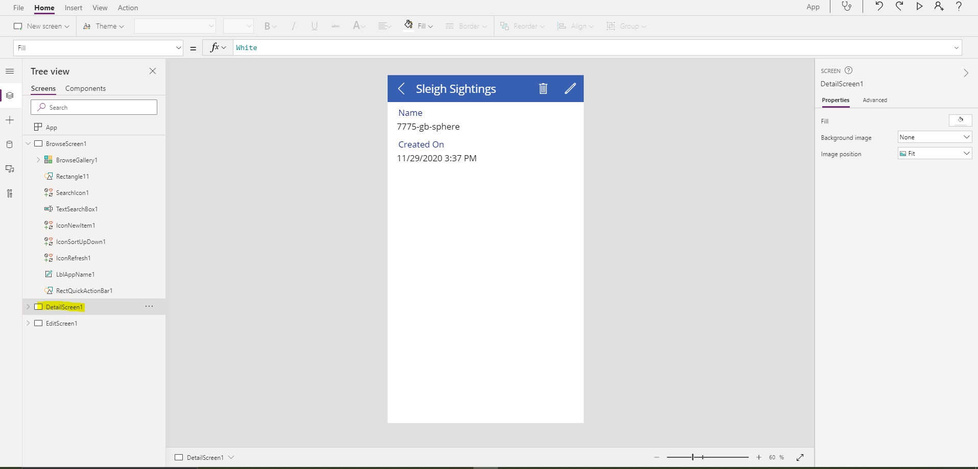

Test out your app by clicking the **Play Button (****)** .

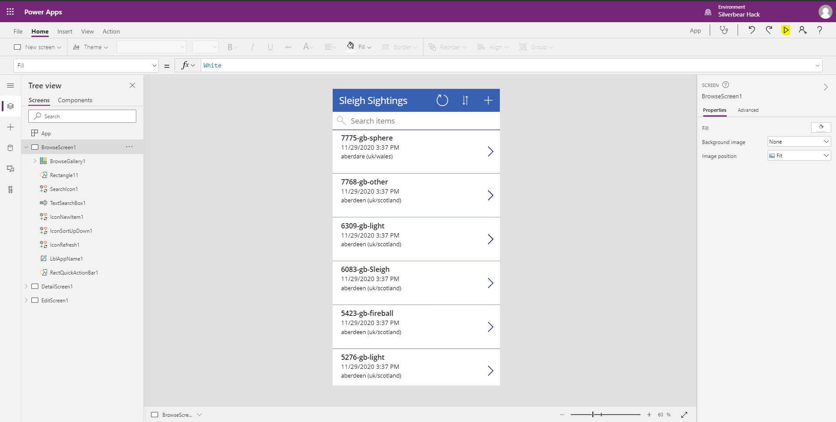

This will place your app in “Run” mode where you can interact with components and navigate between the various screens.

The **Browse Screen** will list the records in the Dataverse “Sleigh Sightings” table. To get more information about the various records, select the **arrow (****)** icon in the gallery to view the details of the record.

To edit the detailed record select the **Edit (****)** icon from the menu on the very top of the app.

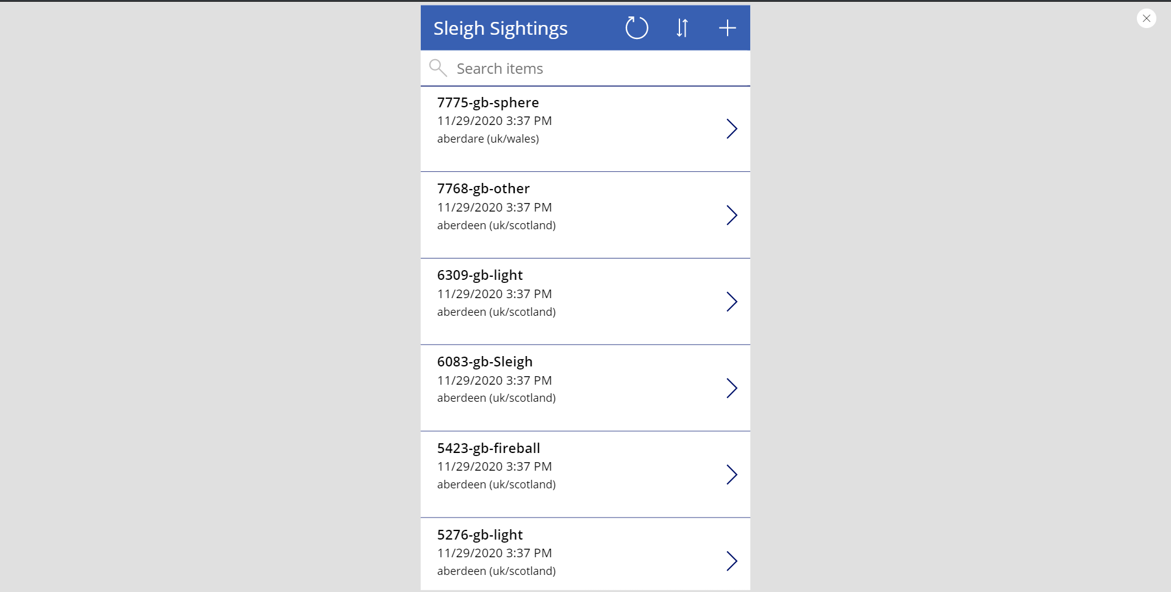

To exit “Run Mode”; Click the **Close** button () on the top right of the screen.

We will now edit the app to make sure users can capture new potential Sleigh Sighting records. To do this, Its important to make sure we add the correct fields to the input forms. We will start with the “Detail Form”. To access this navigate to the tree view on the left of the page and select the option to expand this screen and view all of the components.

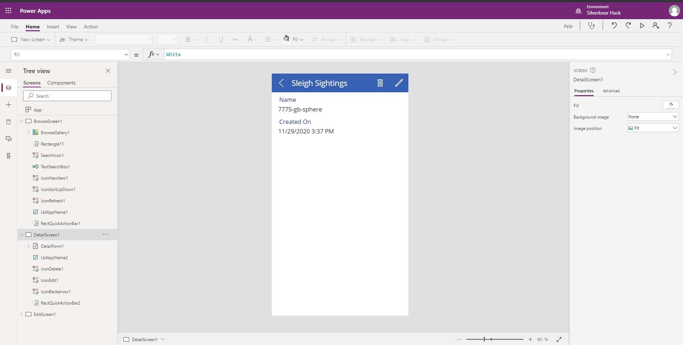

You will notice that there are only 2 fields that are visible on the page. We will add some more fields to make sure the users know exactly which record they are interacting with.

In the navigation pane, within the **DetailScreen1** select the **DetailsForm1**. You will notice that when you select the component from the tree view, the component is shown as selected in the app canvas. You are now able to change the properties of this component.

In the panel, on the right hand side of the page, select the **Edit Fields** option.

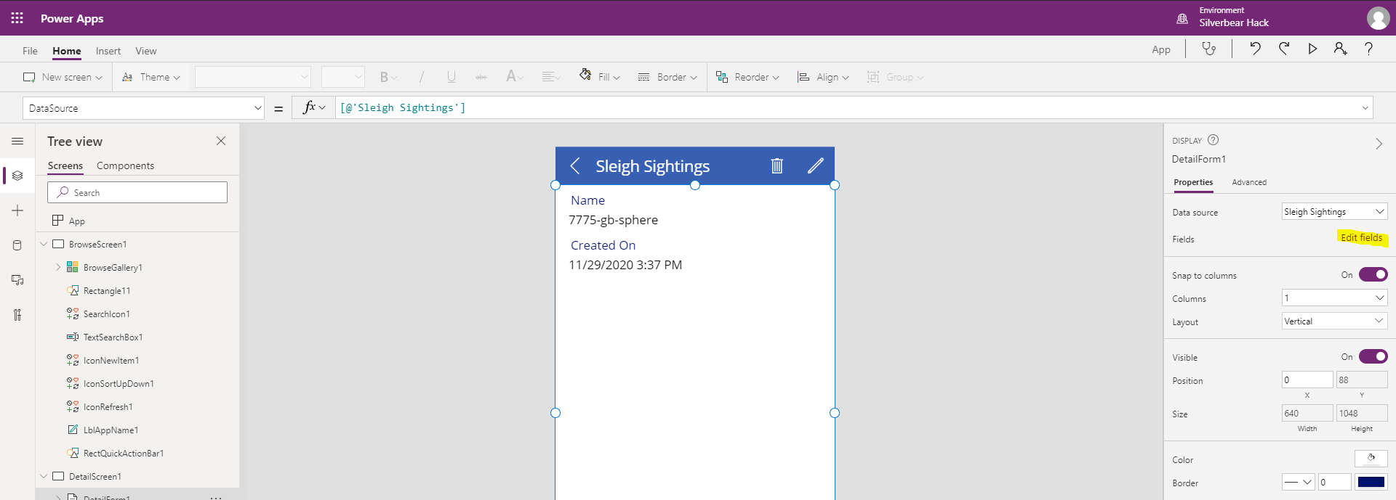

A panel will appear. Select the **Add Field** option.

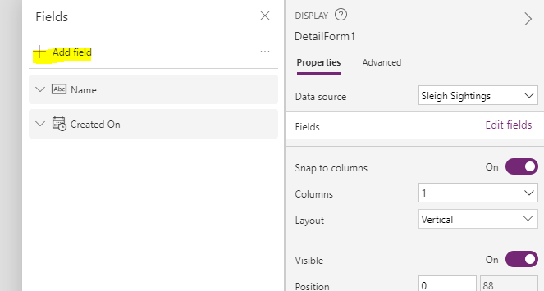

You will be presented with a menu of all of the fields within the **Sleigh Sightings** table in Dataverse. Select the following fields from the list:

* City
* Comments
* Country
* Date Posted
* Duration
* Lat
* Long
* Shape
* SS Status

Once the fields have been selected, click the **Add** button to make sure the fields re then added to the **DetailForm1.** 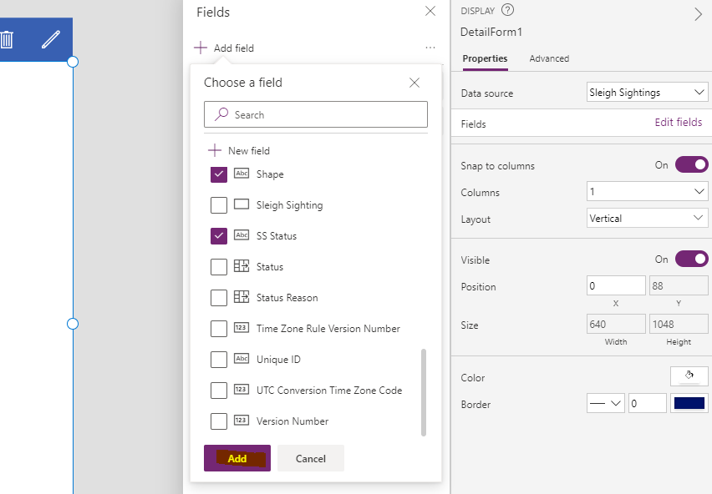

When the panel is closed yu will be presented with the latest version of the form.

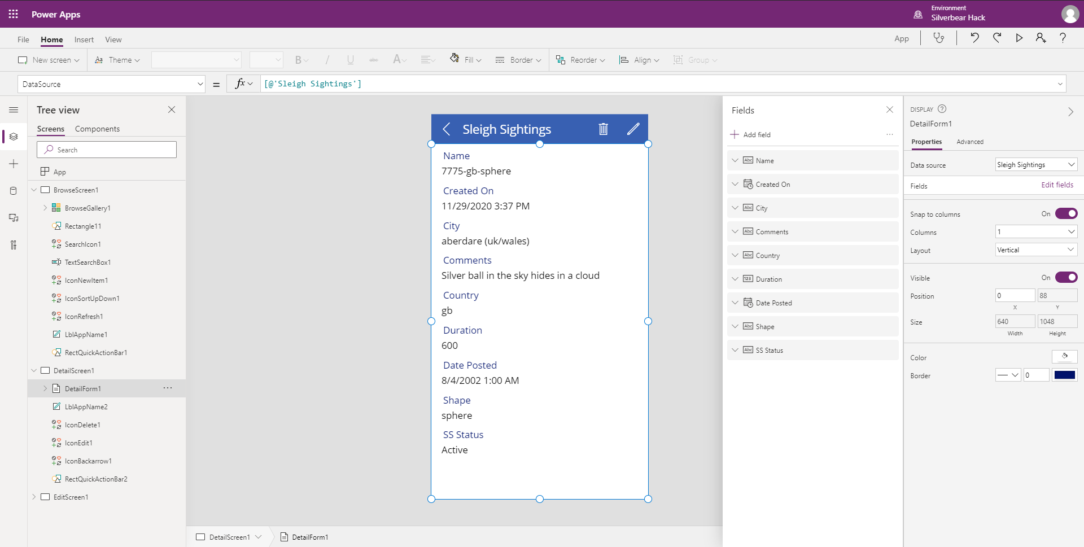

Please be sure to save your app regularly as you go.

We will new update the **EditForm1** on the **EditSceen1.** To do this, run through the EXACT same process as above,except make sure to edit the **EditForm1.**

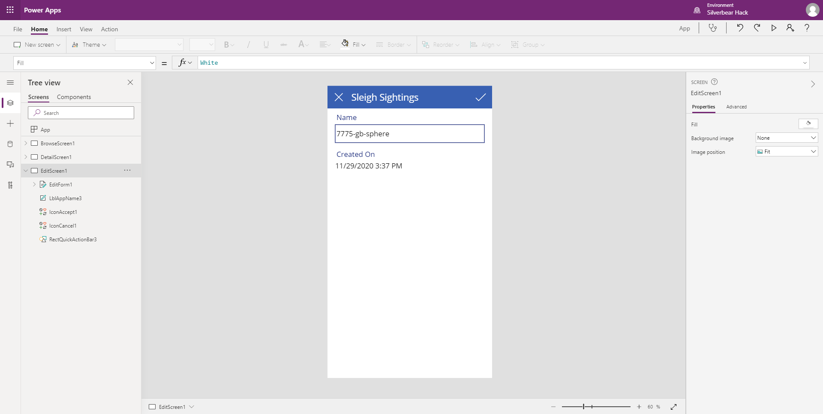

After you have addeed the relevant fields, your form will look as follows:

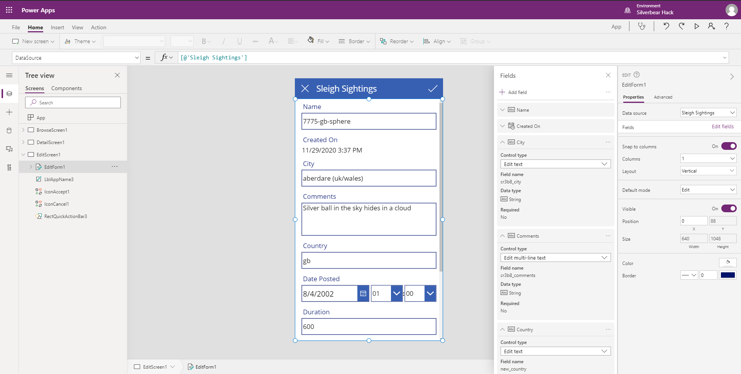

One of the most important parts about data cature is the ability to automate as much of this as possible.

Firstly, lets remove unnecessry fields from the form. To achieve this, in the **Fields** panel, click on the ellipses next to the relevant fields and select **Remove.** You only need to do this for the **Createdon** field.

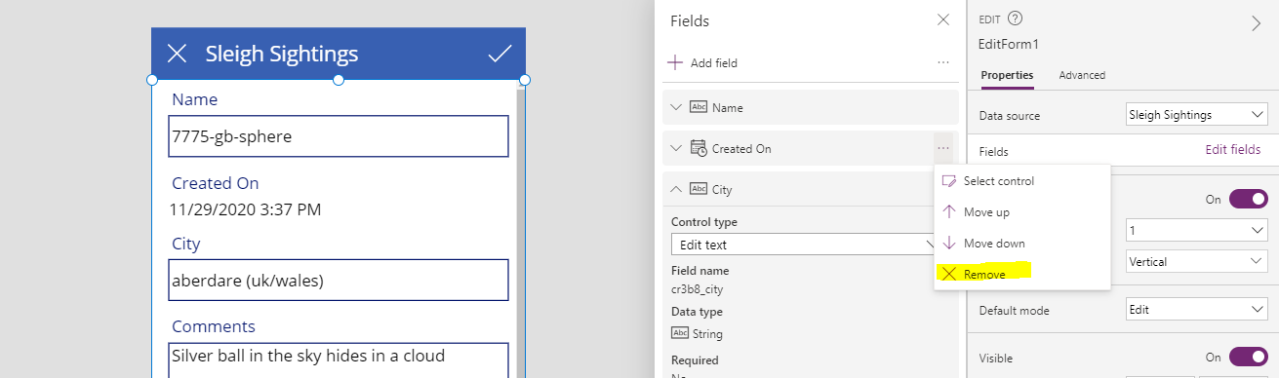

We will now automate some of the data capture by adding Power Apps expressions to the datacards on the form. As a standard, when a Power Apps form is connected to data in Dataverse, the fields are locked. We need to unlock the fields we would lik to edit.

In order to achieve this, select the relevant data card in the tree view within the form, right click and select **unlock**.

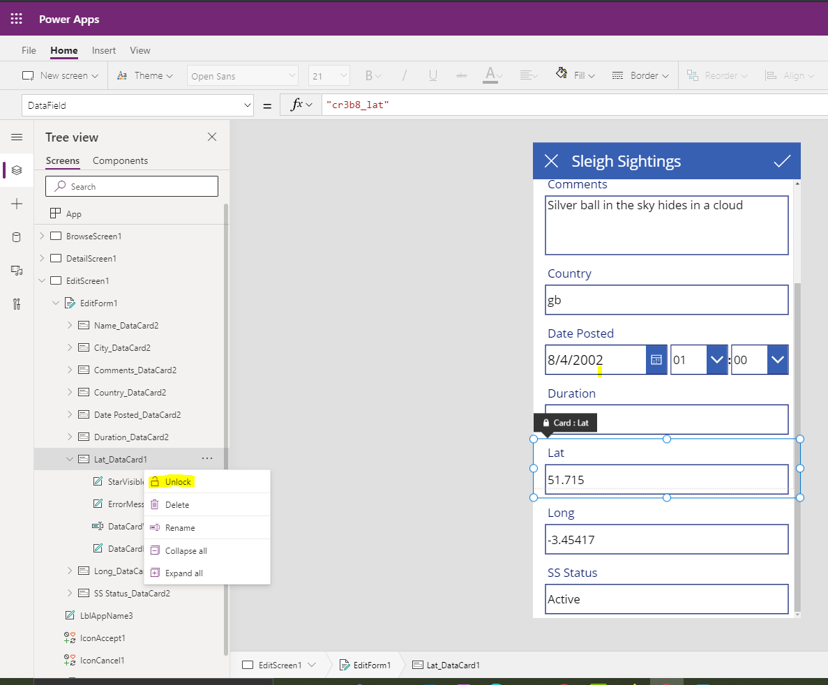

The following data cards need to be unlocked :

* Lat_DataCard1
* Long_DataCard1

We will now set the Latitude and Longitude of the UFO case automatically based on your location. Select the **DataCardValue16** component from the tree view.

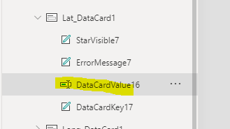

Navigate to the Expression bar at the top of the screen and select **Default** from the list.

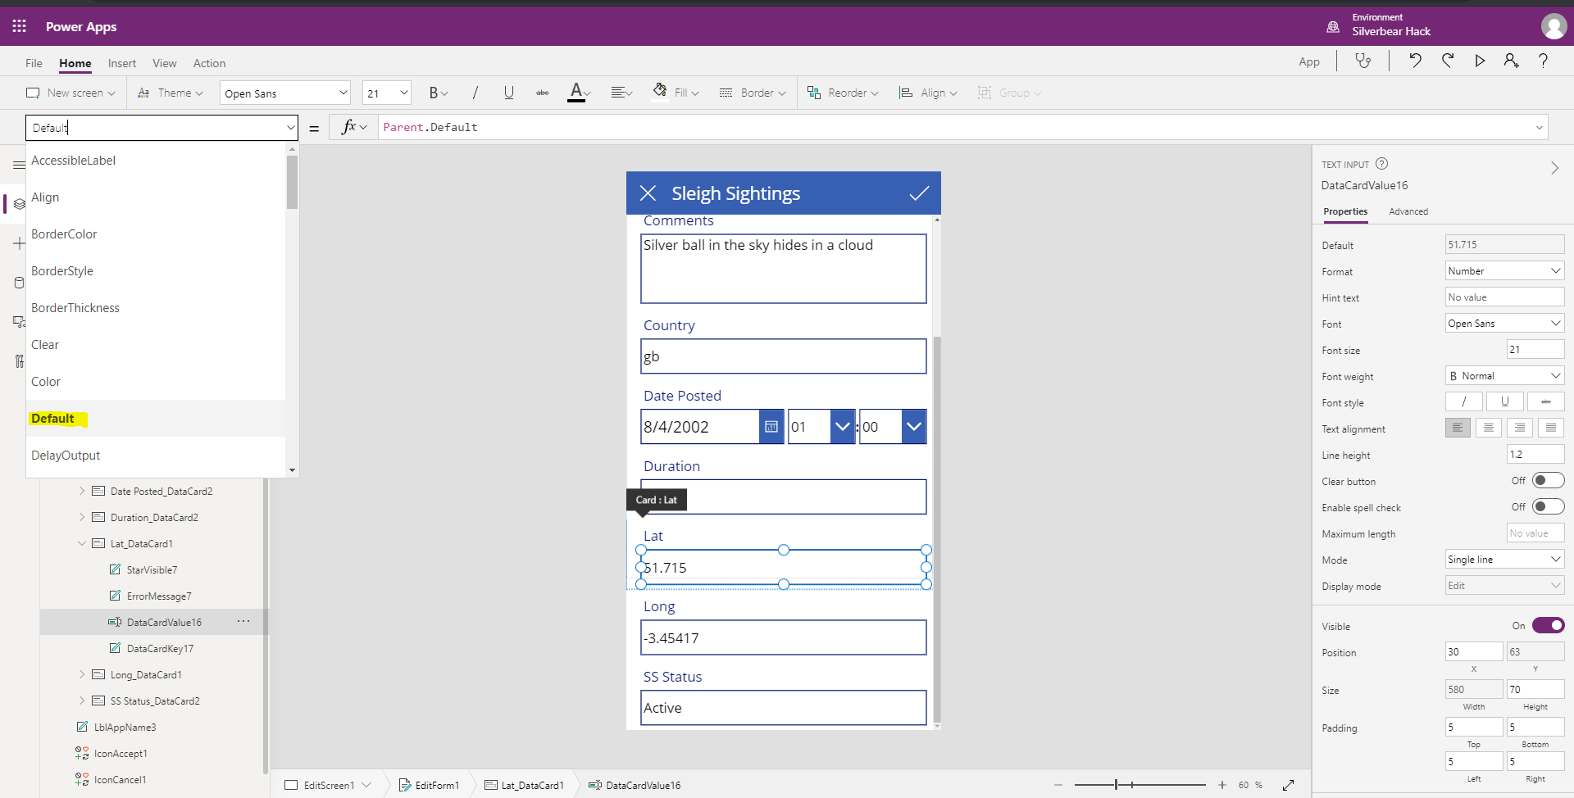

In the expression pane enter in the following expression:

Location.Latitude

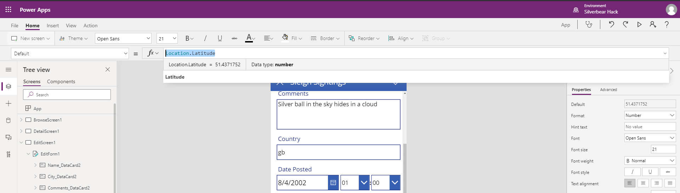

This will automatically update the value in the field on the form.

Follow the same process for the Longitude data card to make sure the correct data is stored & managed.

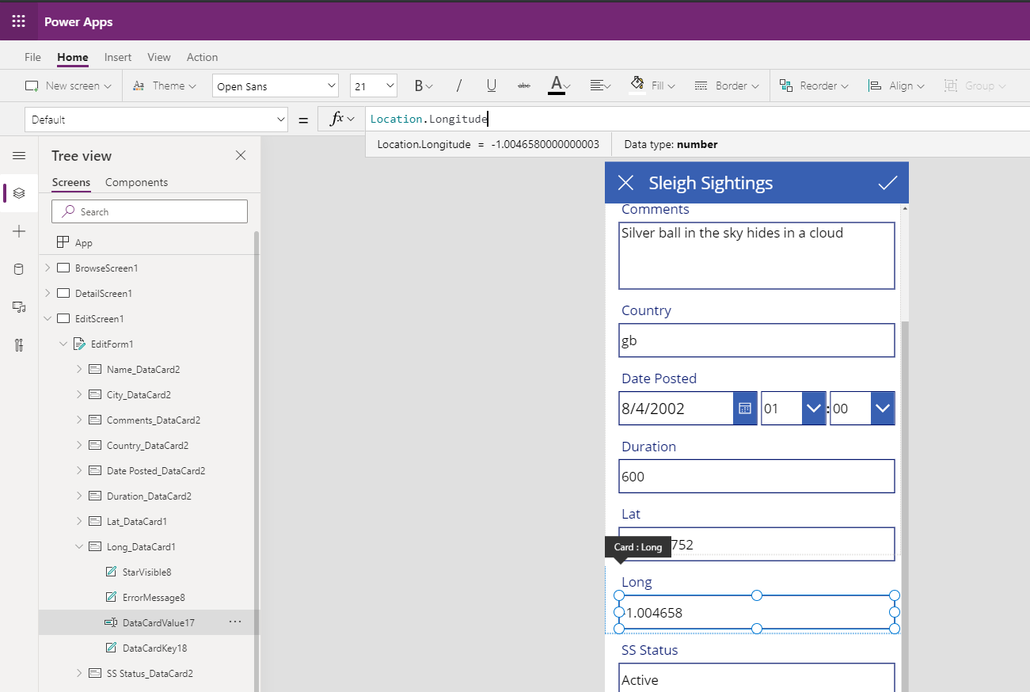

We are now able to capture and manage data within the canvas app. Please save your app and test it out by running it. You will be able to go back to the model driven app in the previous labs to review the dat captured.

In the final part of the canvas app build, we will focus on theming / styling the app. In these steps we are providing guidelines, but please feel free to select whichever themes and images you would like.

To start off, select the **home** option in the menu and then the **Theme** option. You will see a list of available, built in themes you may select from.

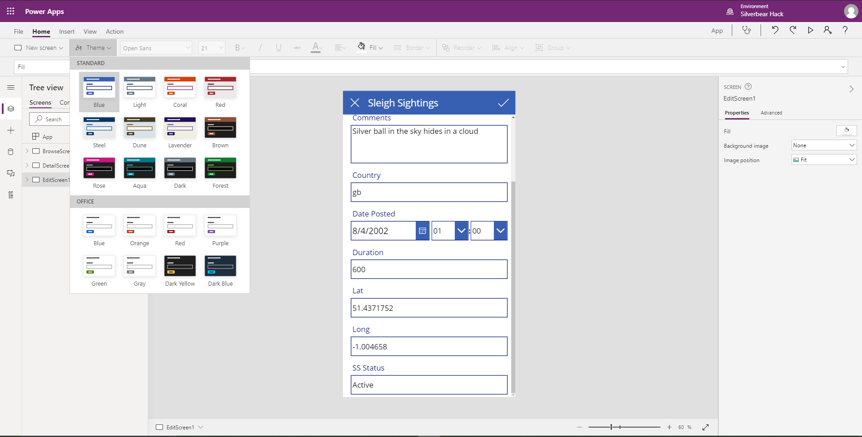

Pick the theme you feel matches your app look & feel in the most appropriate manner. This will change the theme of all of the core, out the box comoponents within the app.

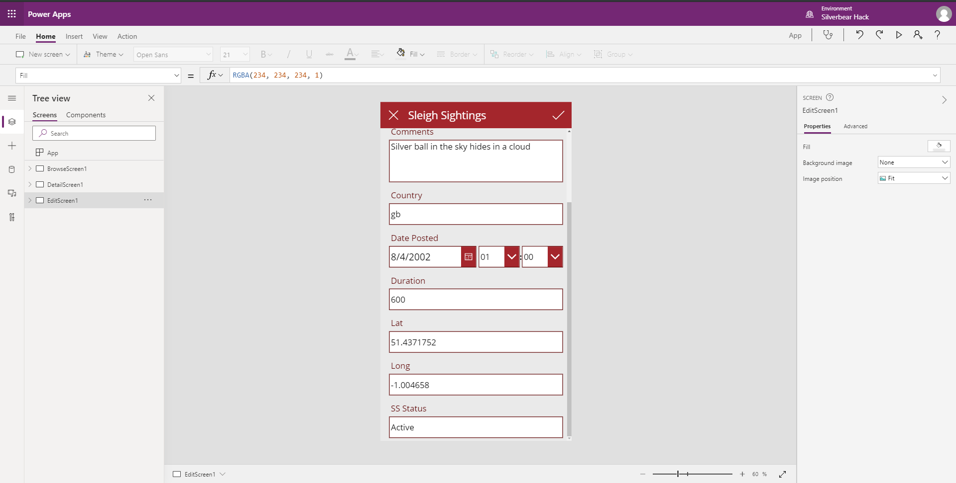

We will now add a “Splash Screen” that will welcome new users into your app experience. To start this process navigte to the **home** screen and then select **New Screen** from the menu. Select the **Blank** option from the list.

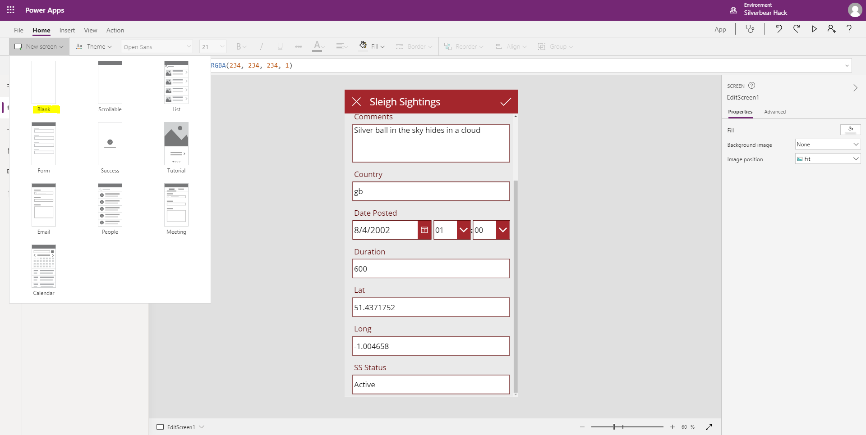

A new screen will immediately be added to the tree view on the left within your app. Move your new screen to the top of the list by clicking on the ellipses and selecting **Move up**.

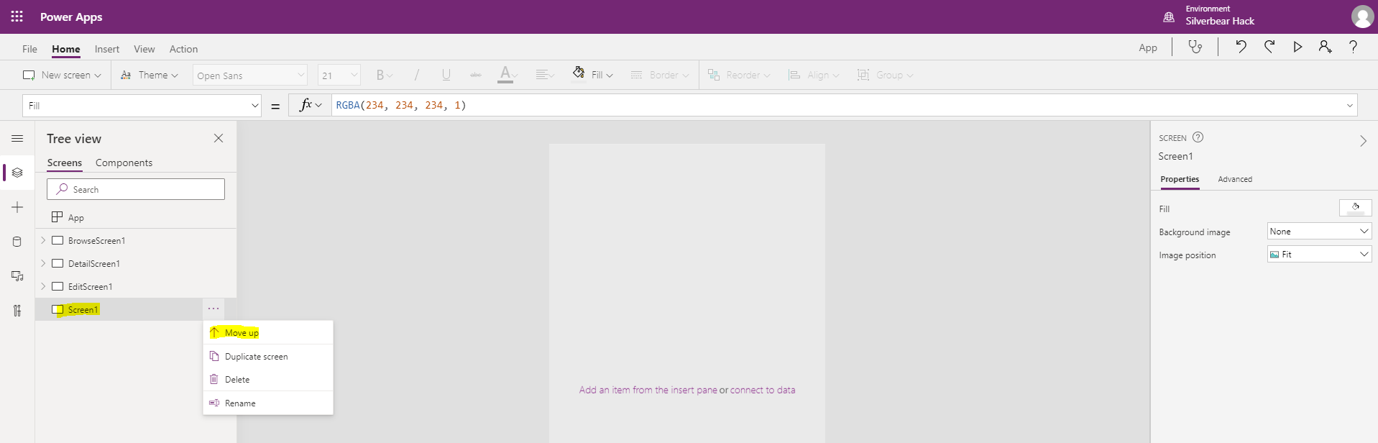

Double click on the screen name in the tree view and change the name to **SPLASH.**

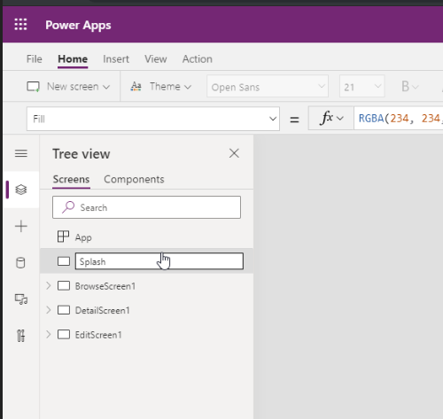

Add a new background image to your **SPLASH** screen by selecting **Background Image** from the properties panel on the left and then select **Add an Image File**.

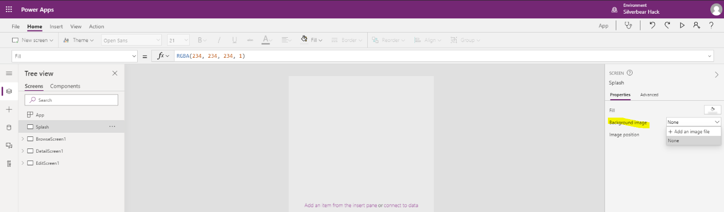

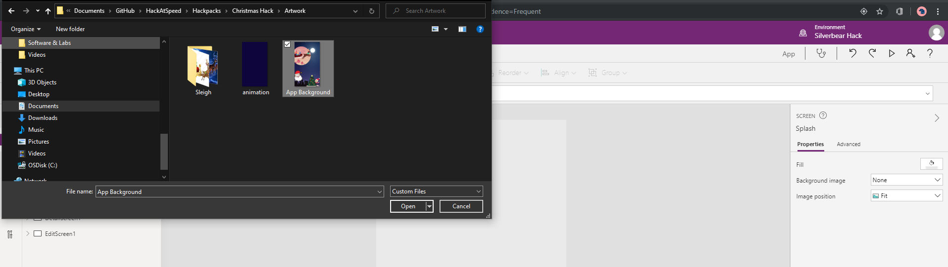

Your background willthen be set and visible on the Splash screen.

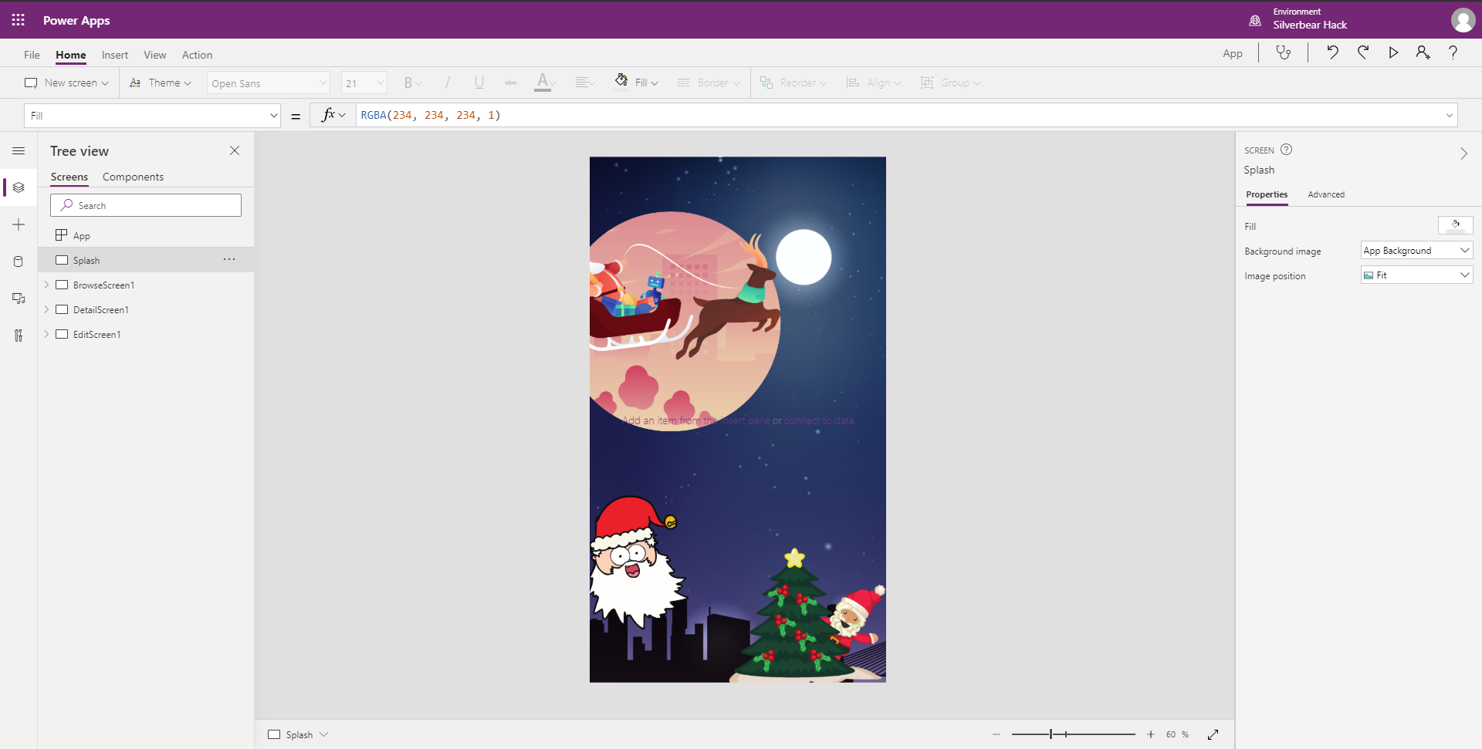

The final step in the process is to add the final navigation controles.Select the **Insert** option from the main menu and then select the **Button** component. This will add a new, themed button onto your splash screen.

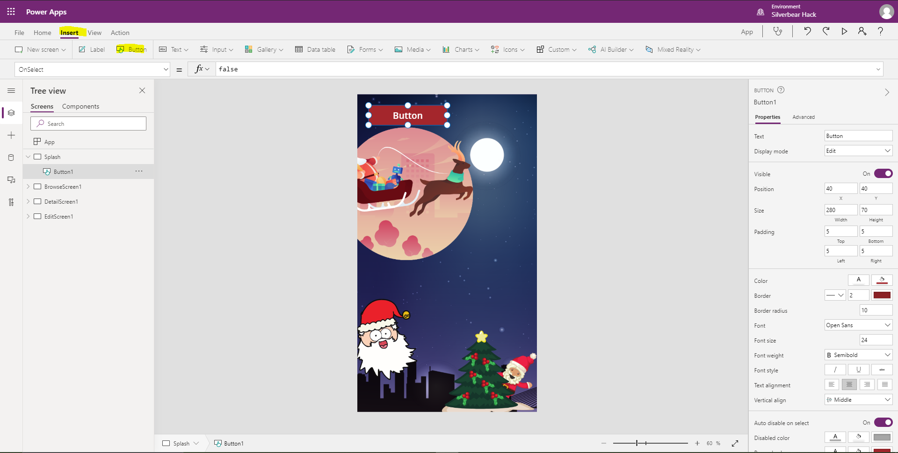

Drag the button to a preferred location on the page, double slick on the button and change the name to Add Sleigh Sighting. You can also resize the button as needed.

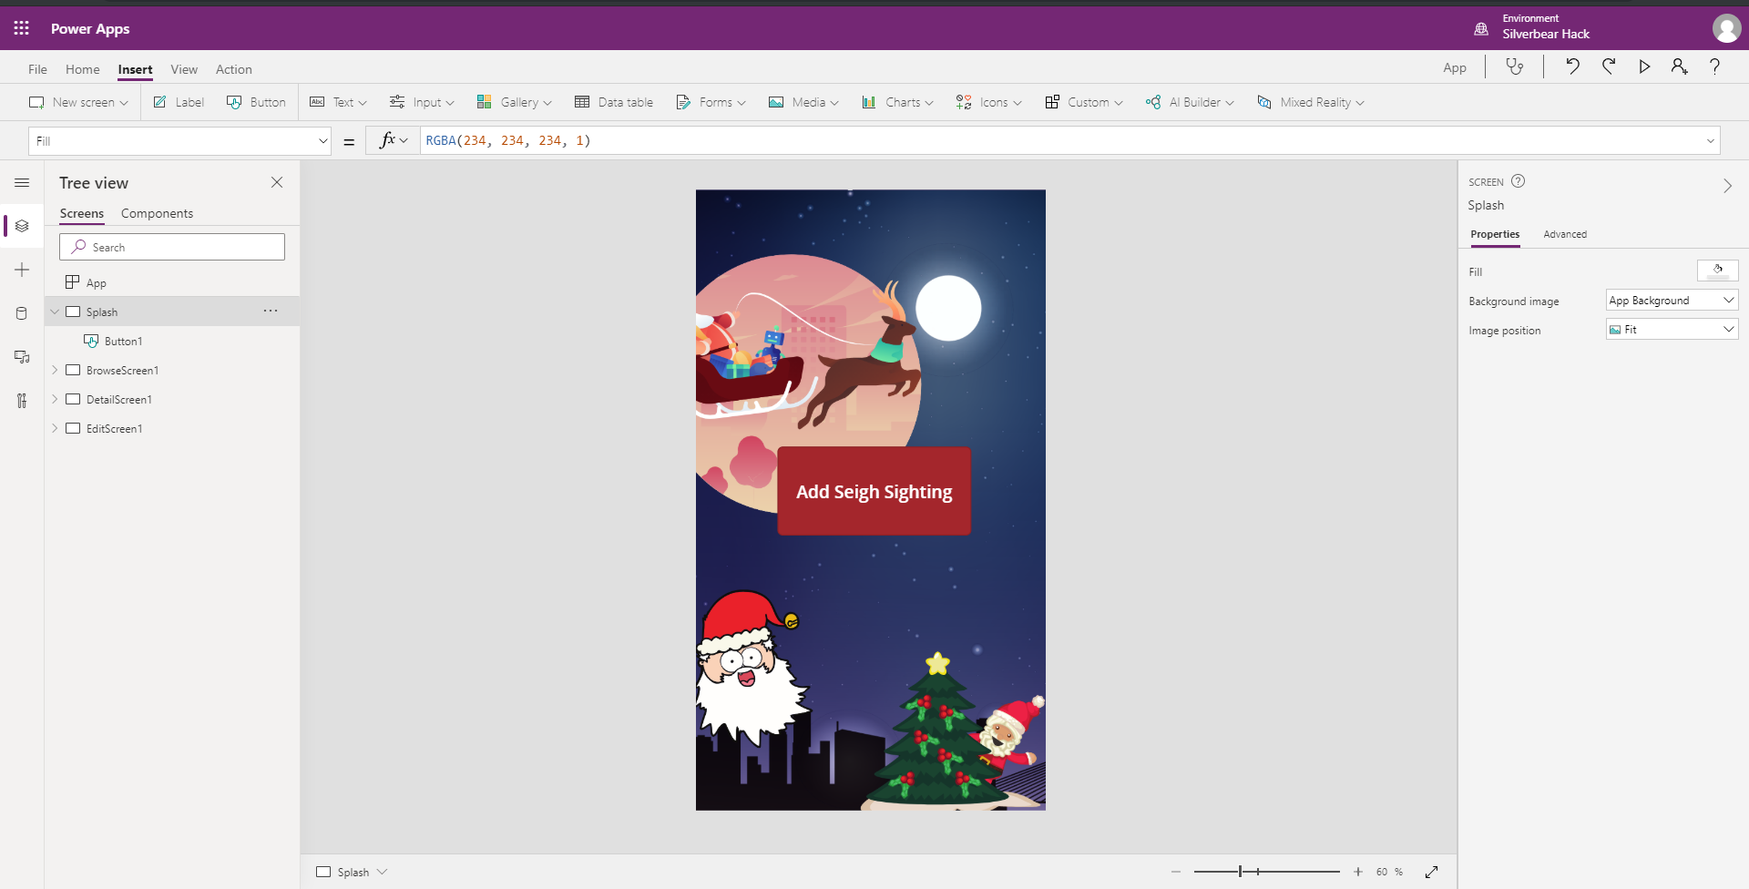

In order to enable navigation to the Browse page, navigate to the **Action** menu option and then select **Navigate**. You wll be presented with a list of the screens within the app. Select the **BrowseScreen**.

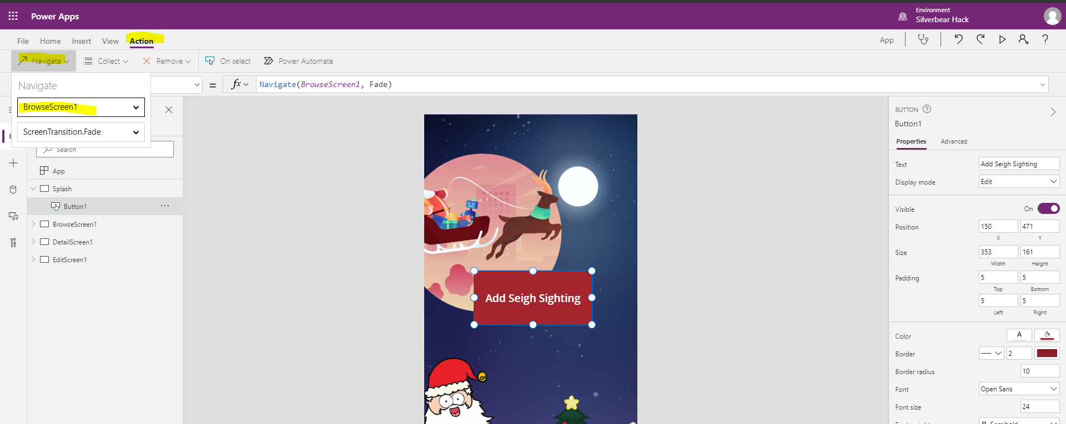

Save and Run your app to make sure the navigation works correctly. Capture a new Sleigh Sighting record and review in the Model driven app you created in the previous lab.

# Lab 6: Configuring a Basic Power BI Dashboard

In this lab we will learn how to configure a basic Power BI report and Dashboard in order to allow Mid office users the ability to view data in a format that is easy to understand and interactive.

***Please Note:***

***This lab can be completed independently, with only Lab 1 being and no support of the other labs.***

***This part of the hackathon is totally optional and instead of building this part, you can simply import the “Sleigh Sightings base.Pbix” Power BI file into your environment.***

## Solution Components

Microsoft Power BI

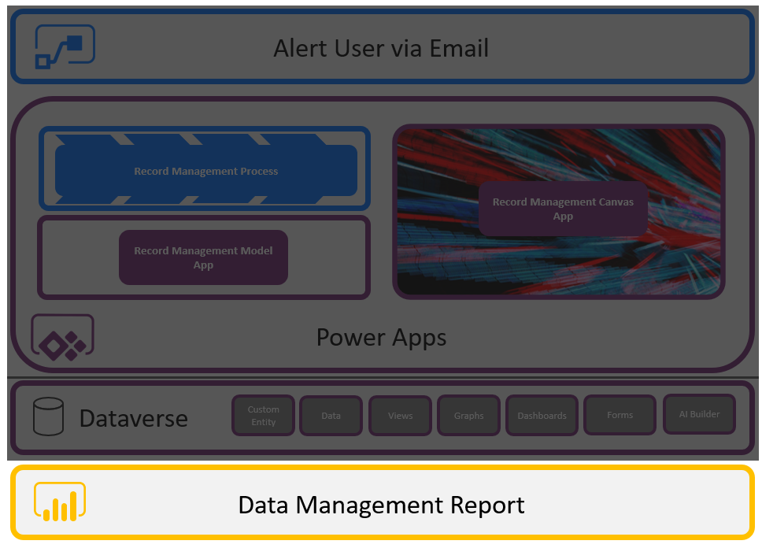

## Let’s Begin

### Power BI Desktop

To access Power BI, Navigate to <https://app.powerbi.com/home>. Your view may be defferent to the one below, depending on the user you are lebveraging to access the Power BI application.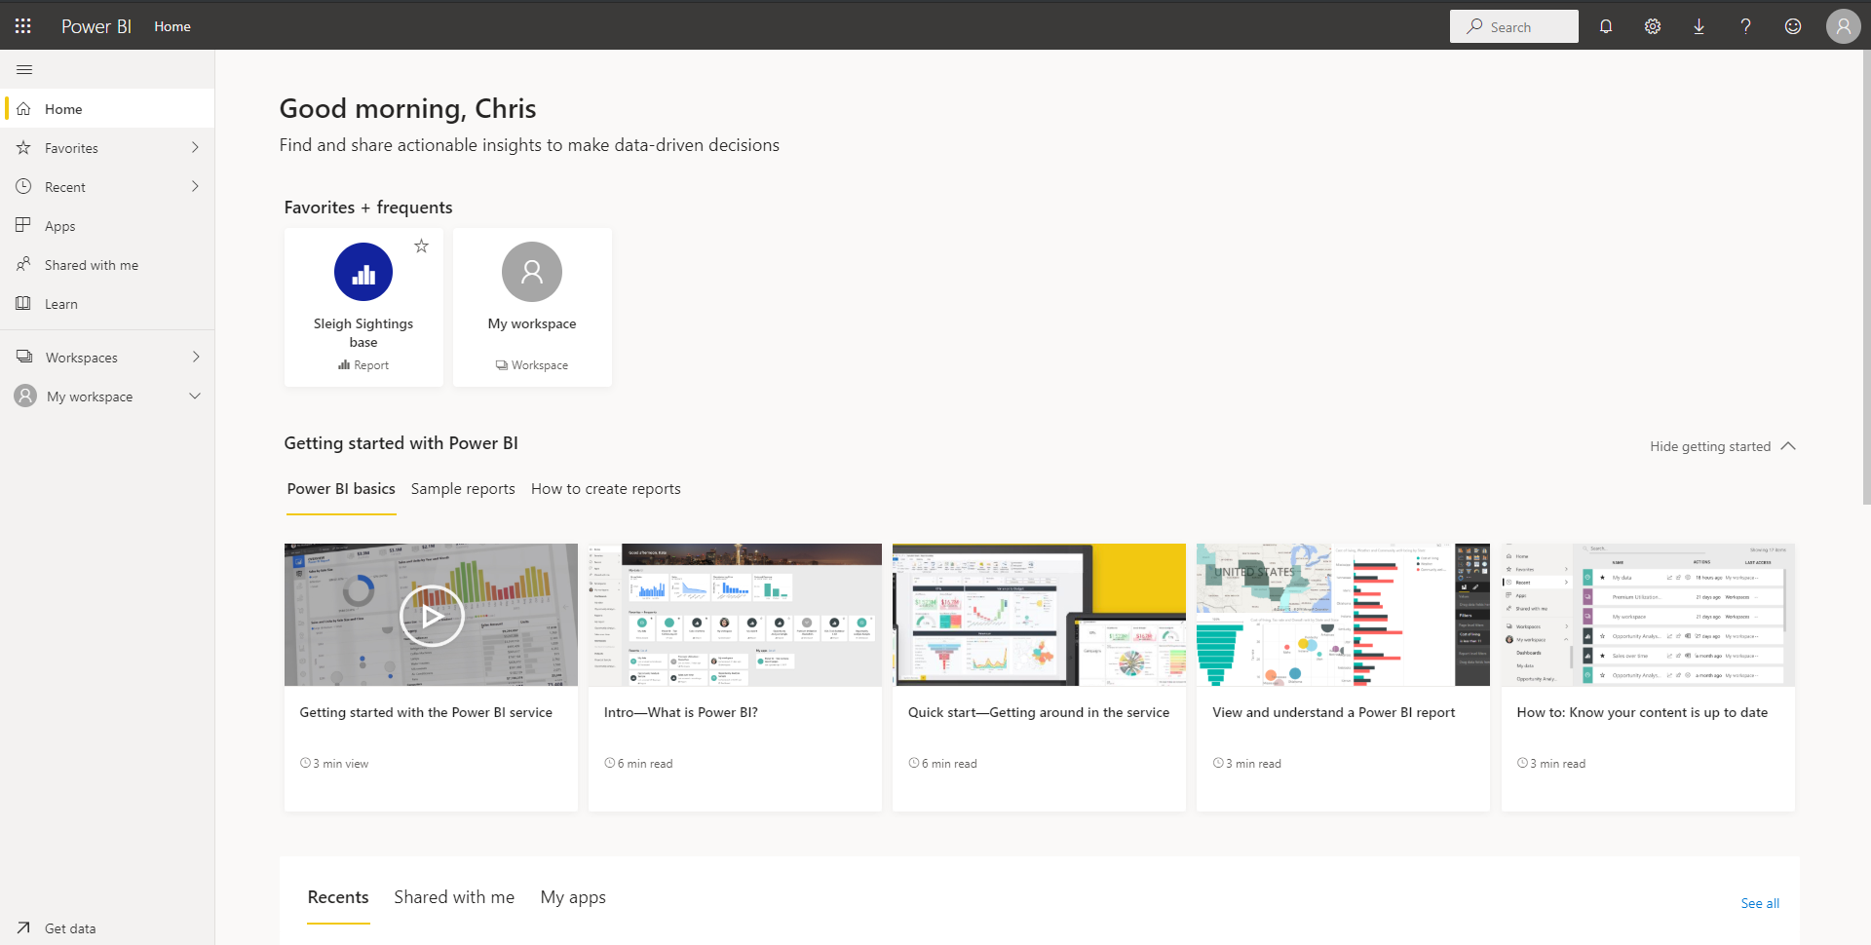

Each person using Power BI has their own workspace where their own personal Power BI reports and dashboards can be created. On the left hand side of the page select **My Workspace**. Depending on the user you have legged in with, you may see several reports that are available to you.

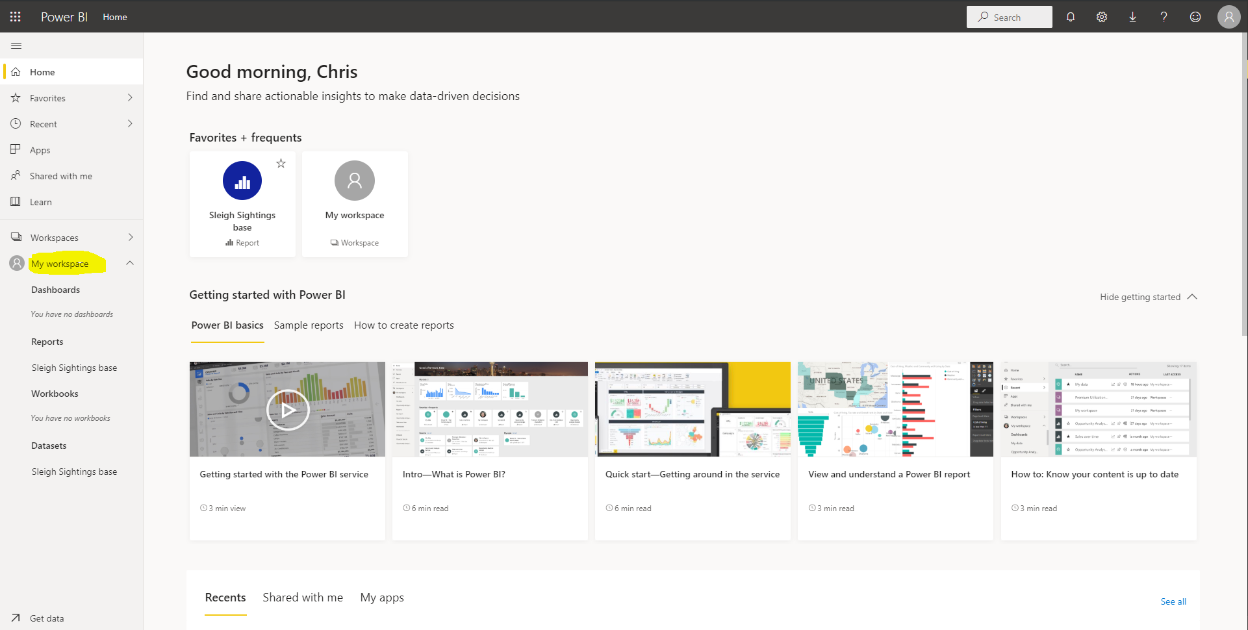

Select the **Sleigh Sightings Base** report that has been pre-created and connected to data. You will notice a page with a Christmas backdrop. This is where you will be designing your Power BI report.

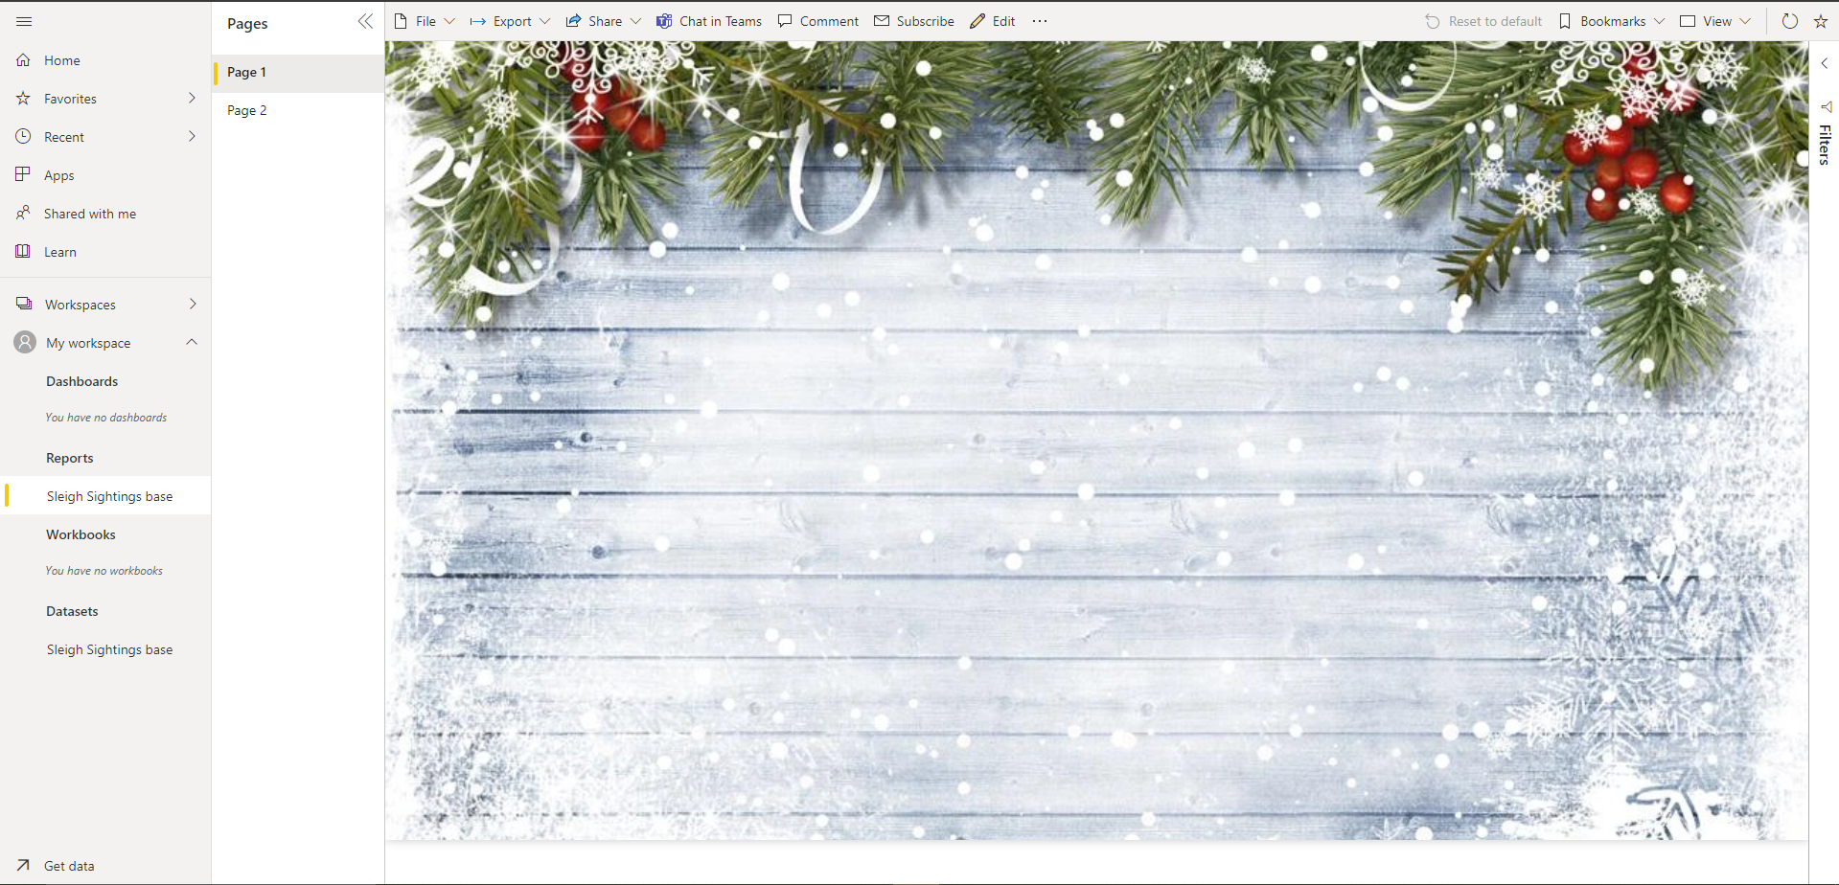

To start your Power BI report build, select **Edit** from the tool bar.

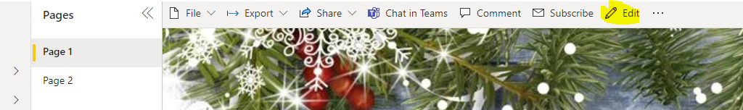

The report will be placed into Edit mode. You will see that 2 panels have appeared on the right hand side of the screen.

The Visualizations panel will enable you to add Power BI visualisations to the report canvas. These will help you clearly visualise and understands your data.

The Fields panel contains the data fields that you have available to you from the Microsoft Dataverse table. These fields will be used in the visualisations.

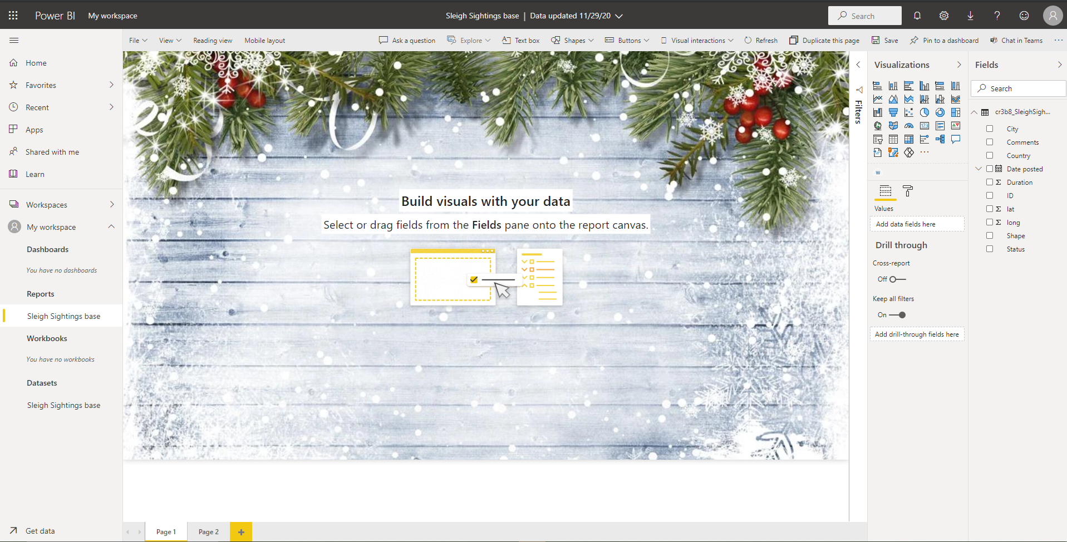

TO build your first visualisation, lets take a look at the Sleigh Sightings by shape. To do this select the Pie Chart Visualisation from the list. This will automatically add your pie chart to the report canvas in the top left. 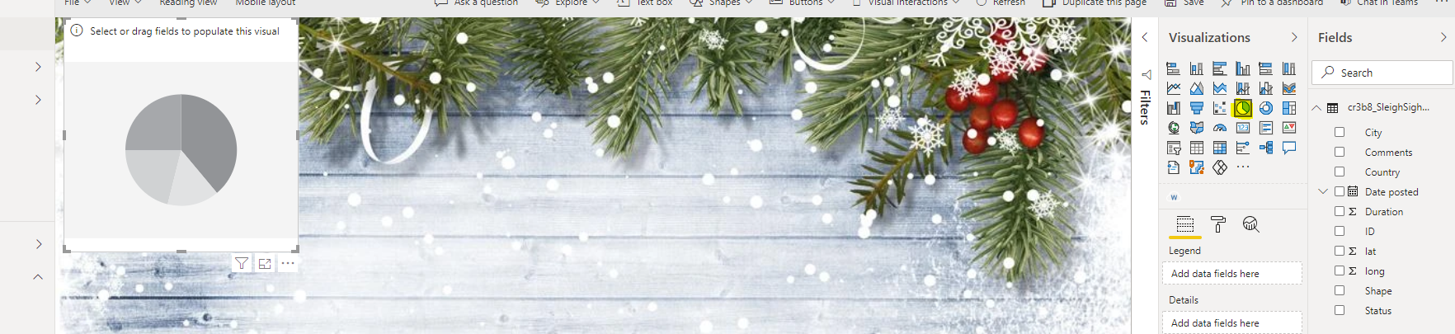

We now need to work out the number of sightings. To do this, make sure your pie chart visual is still selected.

From the right hand **Fields** panel drag the **ID** in to the **Values** property of the Pie Chart.

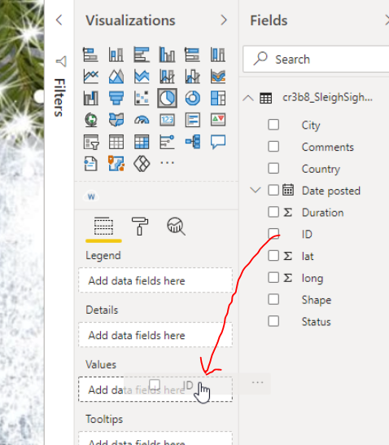

You will notice that the ID field is automatically counted in the pie chart **Values** property and the pie chart in the report canvas has been completely saturated with 2000+ records.

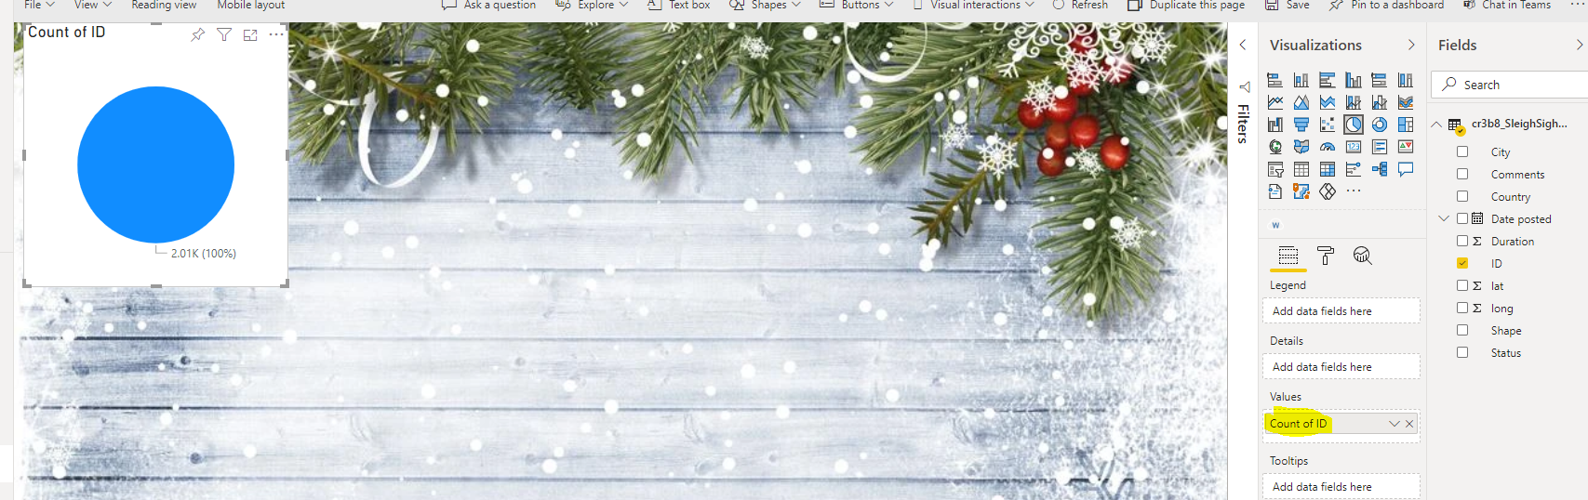

We now need to filter those records by the sleigh shape. To do this, drag the **Shape** field from the **Fields** column into the **Legend** property of the pie chart visualisation. 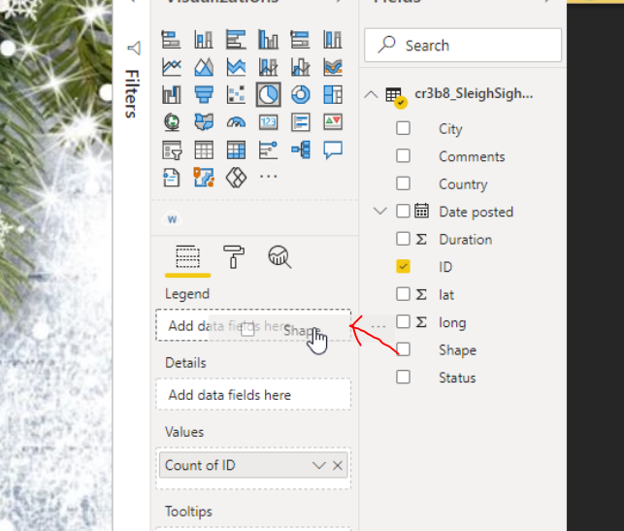

As you do this, you will notice that your Pie Chart visual in the report canvas changes to show the number of Sleigh Sightings by shape.

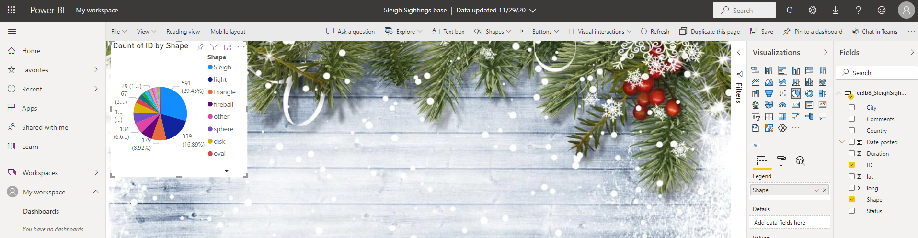

We will resize the visual to make sure that users are easily able to interact with the data. To do this, simply hover over one of the corners until the resize double arrow is visible.

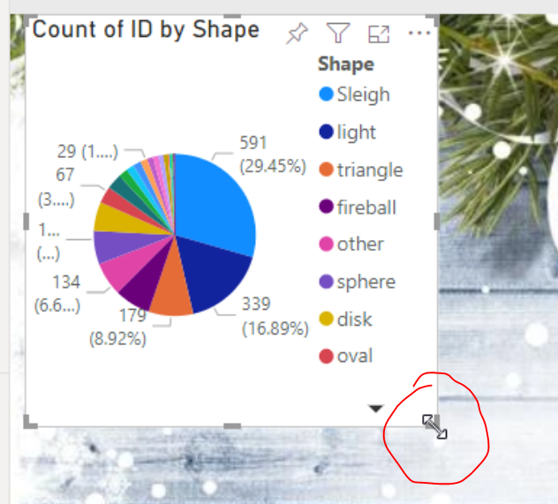

Simple drag the corner of the chart to make it larger and more accessible to users. Use your digression on the size. You can always resize later.



As you can see by the data shown in the visual, Santas sleigh has been spotted a number of times.

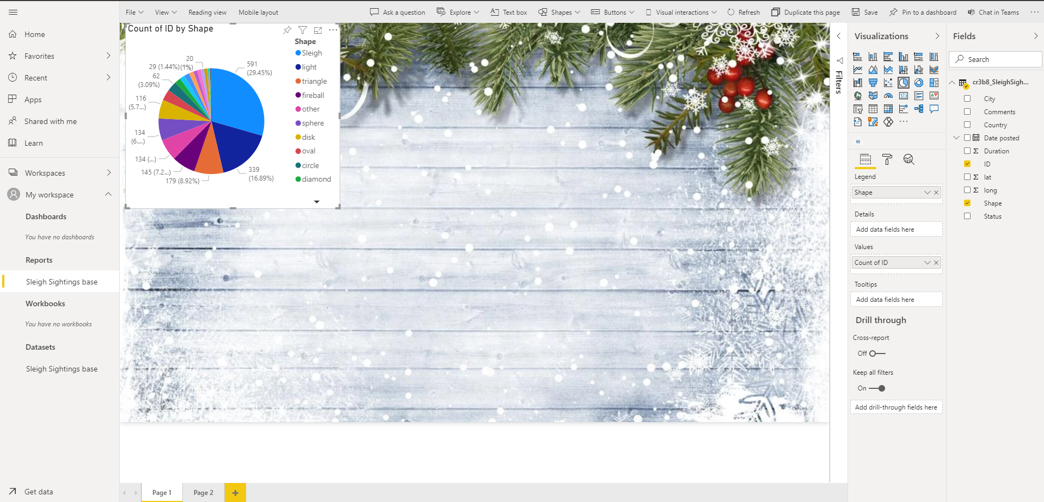

Now that we have added the first visual, we will use these principals to add the rest of the elements top the reports canvas.

**VERY IMPORTANT:** *Please* **DESELECT** *the current pie chart visual by clicking in the empty space on the report canvas. If yhou do not do this, you will simply end up changing the pie chart visual. It will be evident you have done this when there arent multiple properties available in the* ***visualization*** *panel.*

The below image highlights blank space indicated by the red marker and the **Visualization** panel highlighted in yellow.

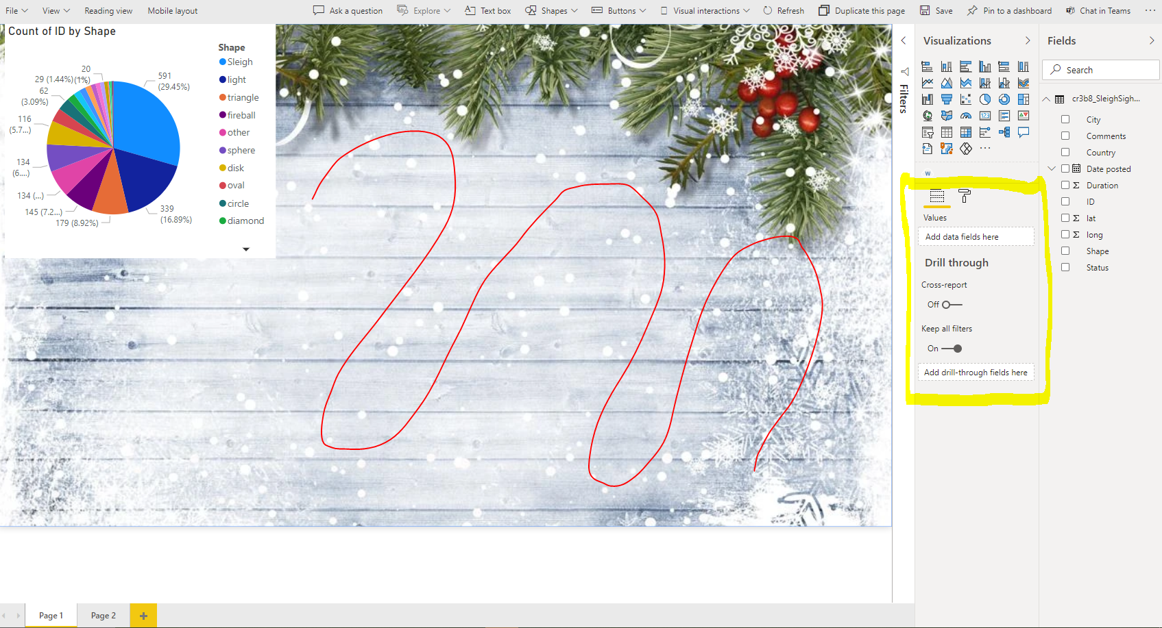

Next we will add a Map showing where in the world the sightings have been logged. This visual makes use of the **Latitude** & **Longitude** fields as well as the **Shape** field.

Select the **Map** visual from the **Visualization** panel. This will automatically add the map visual to the report canvas.

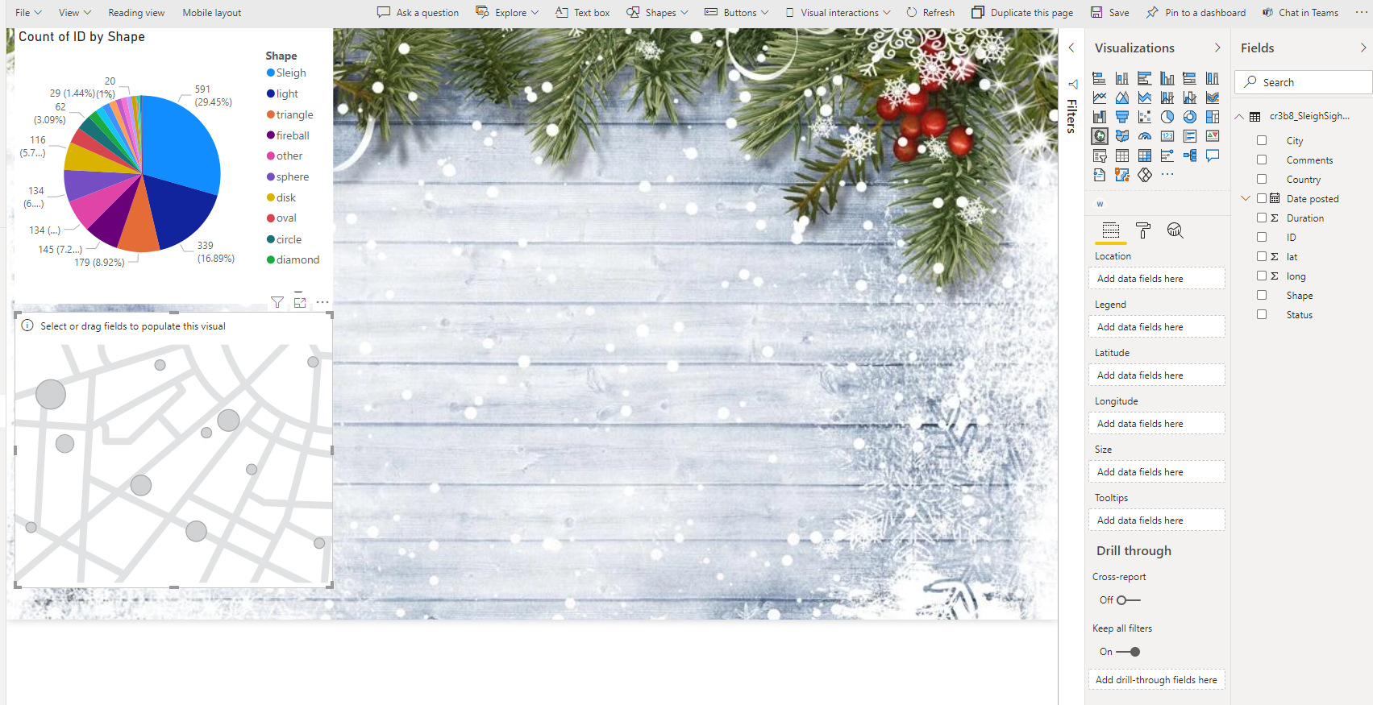

The Map visual has a lot of properties that are visible in the **Visualization** panel. We will populate the following properties with the following fields:

* Legend : Shape
* Latitude : Lat
* Longitude : Long

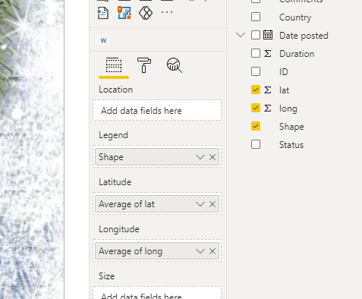

When dragging numeric fields into Latitude and Longitude properties in the map, often the numbers arent translated as Latitude & Longitude. You may get an error on the map visualisation.

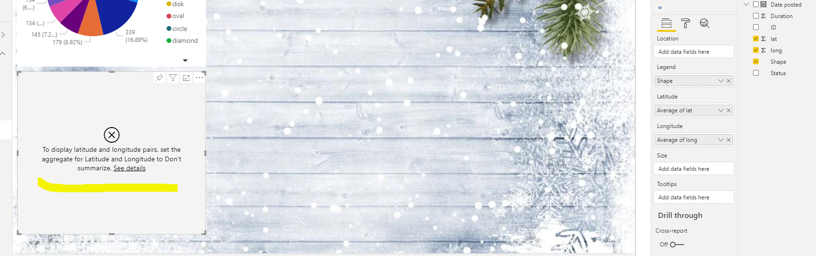This will involve a simple fix. Simple select the dropdown in both the Latitude and Longitude fields in the **Visualization** panel and select **Don’t Summarise.** This will then allow the data to be translated correctly by the map visualisation.

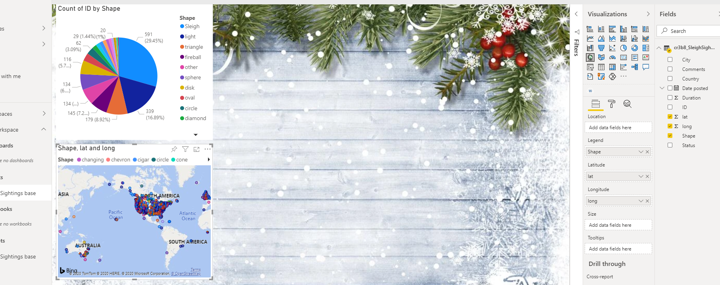

As you can see, most of the sleigh sightings have taken place in North America.

We will move and resize the map visual to make sure users can access the data more effectively. To move the visual, simply click on the top of the map visual and drag it to the relevant location on the map.

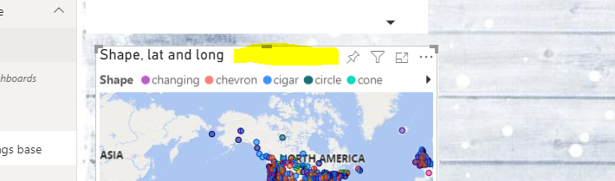

Resize the visual as you previously did with the Pie Chart.

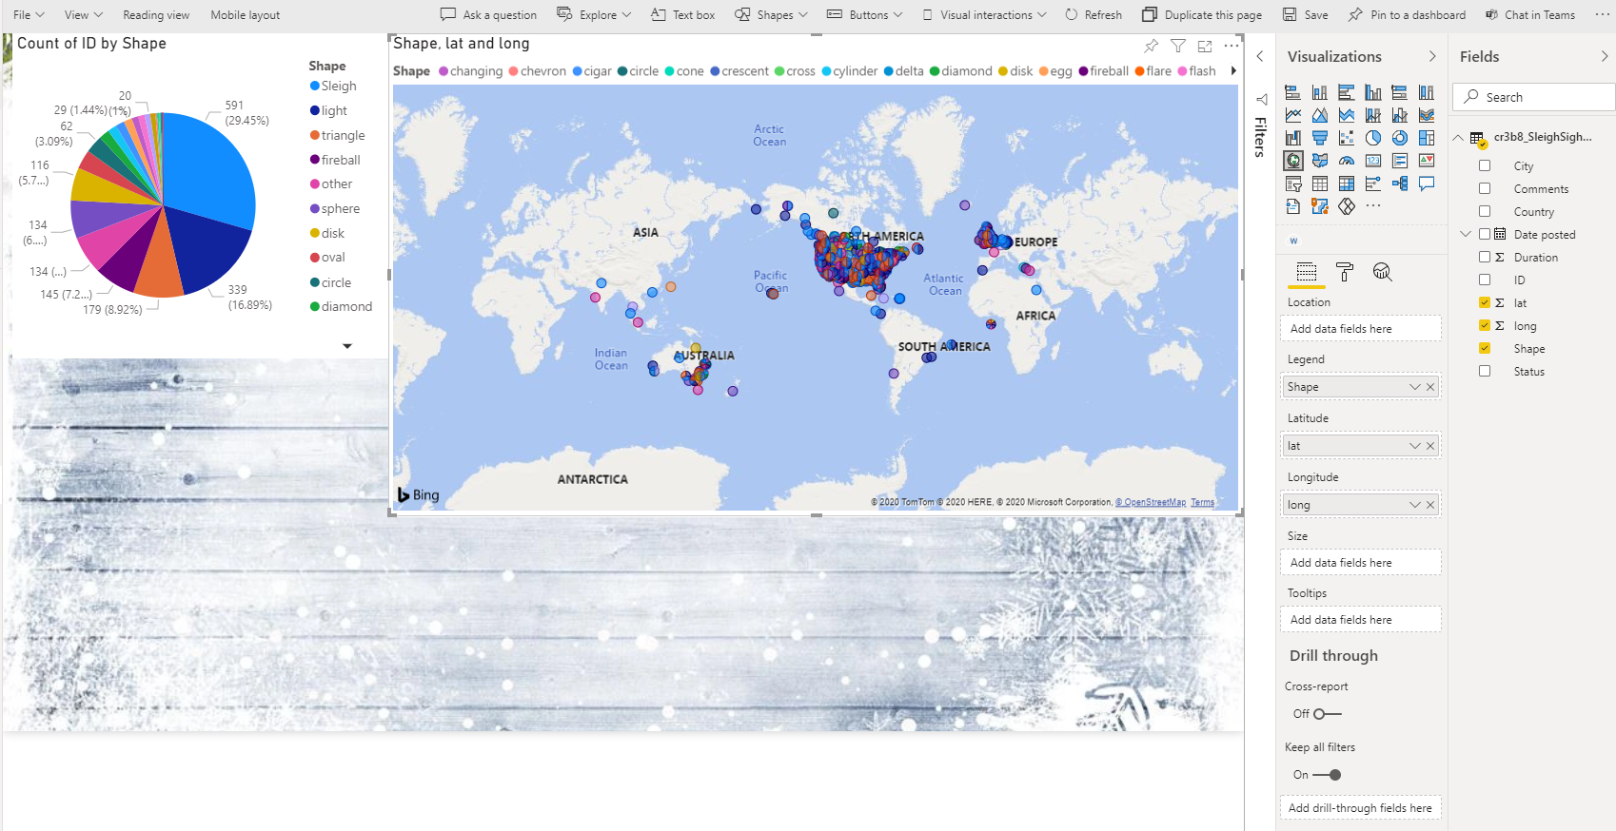

The next visual we will be adding is a **Line Chart** visual. This is so that we can map the number of sightings by date. To do this make sure to click into one of the blank areas to deselect the map. The **line chart** visual will be automatically added to the report canvas.

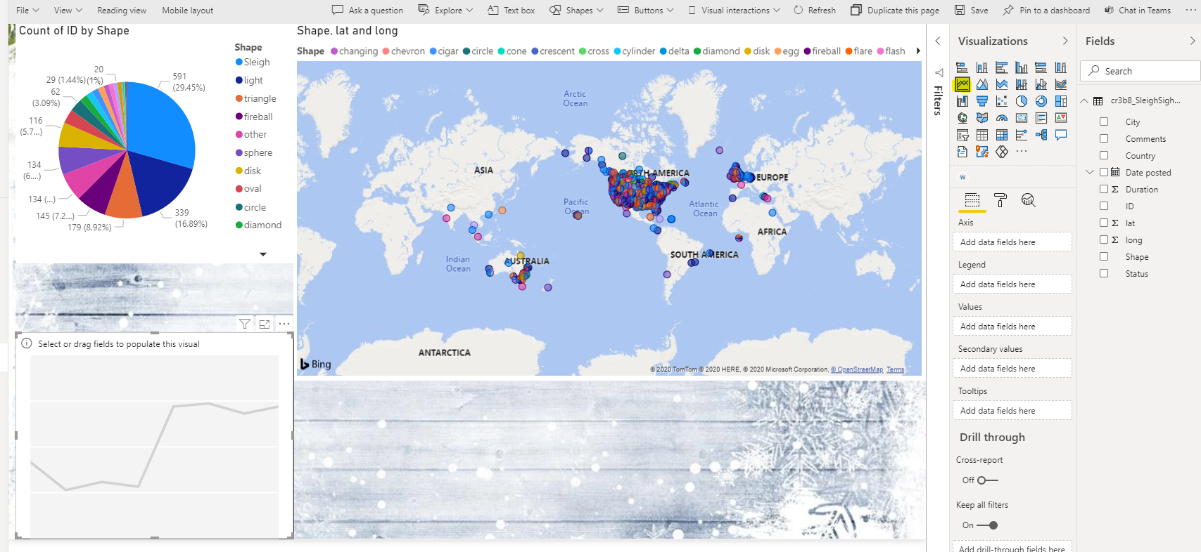

With the line chart still selected drag the following fields ionto the matching visualisation properties:

* Axis : Date Posted
* Values : ID

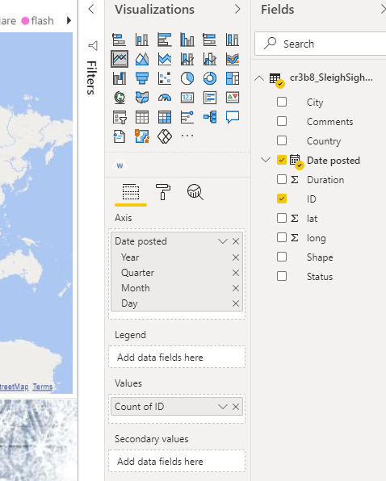

That data will be translated to sightings over time within the line chart.

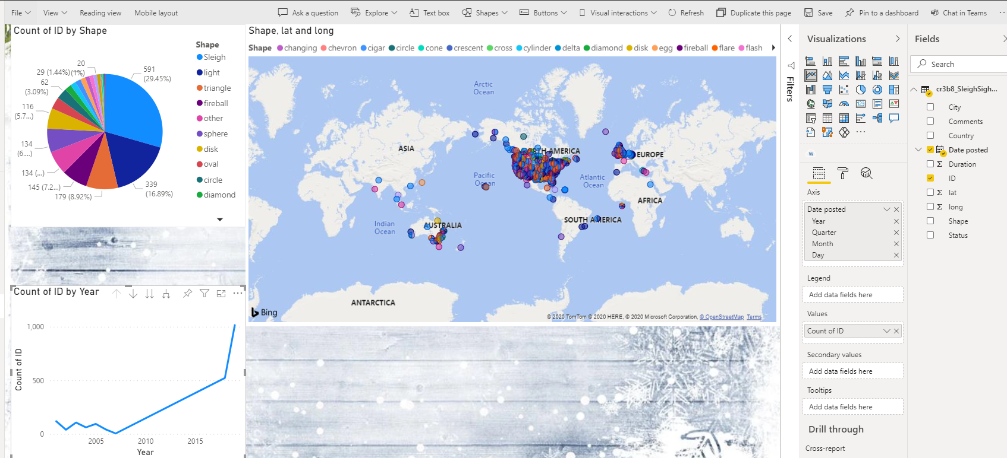

Using the move & resize principals from the previous step, fit the chart into the report in a manner that makes sense.

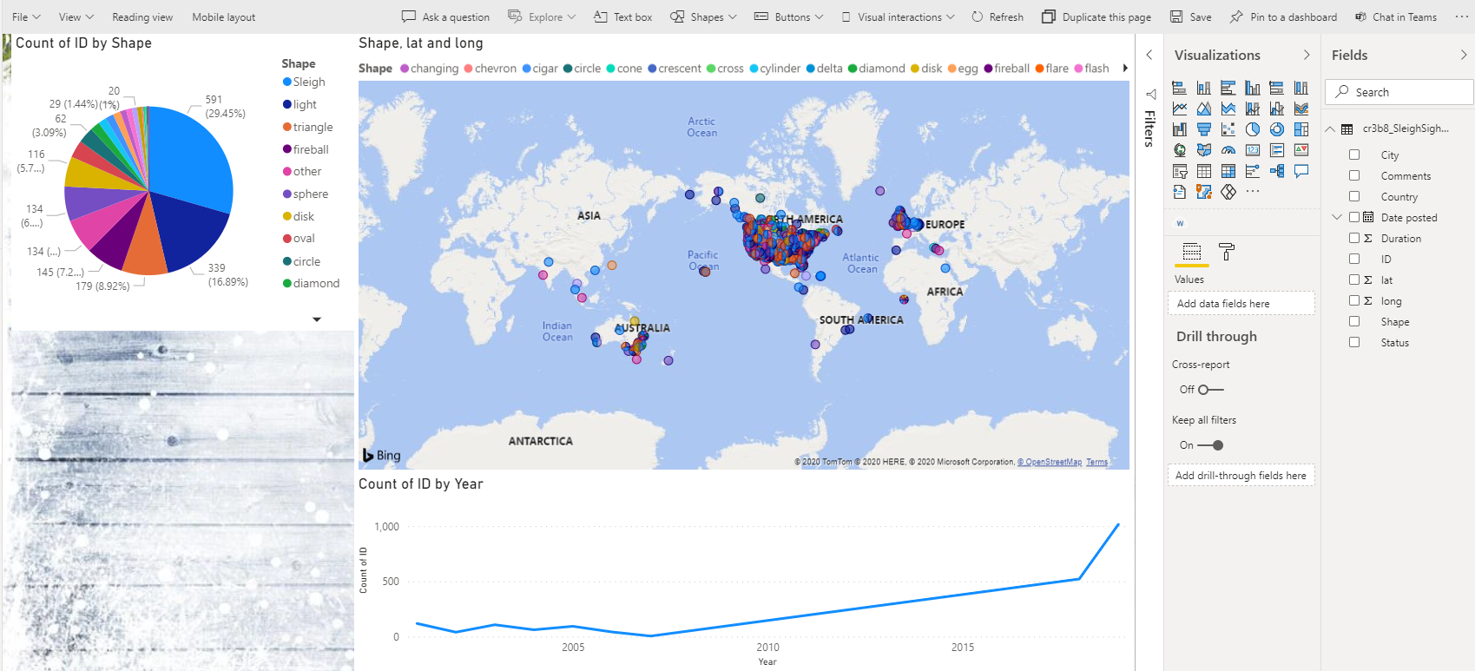

We will now analyse the sightings data by city. From the **Visualization** panel, select the **Stacked Column Chart.** This will be added to the report canvas.

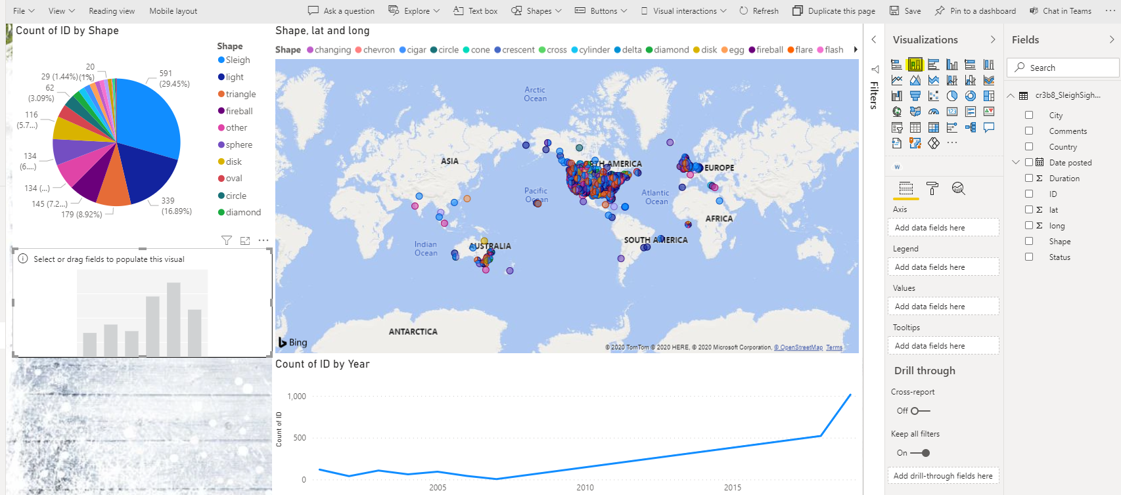

To better understand the sightings by city, map the following fields to the visualisation properties:

* Axis : Country
* Calues : ID

The column chart will then show the number of sightings by country.

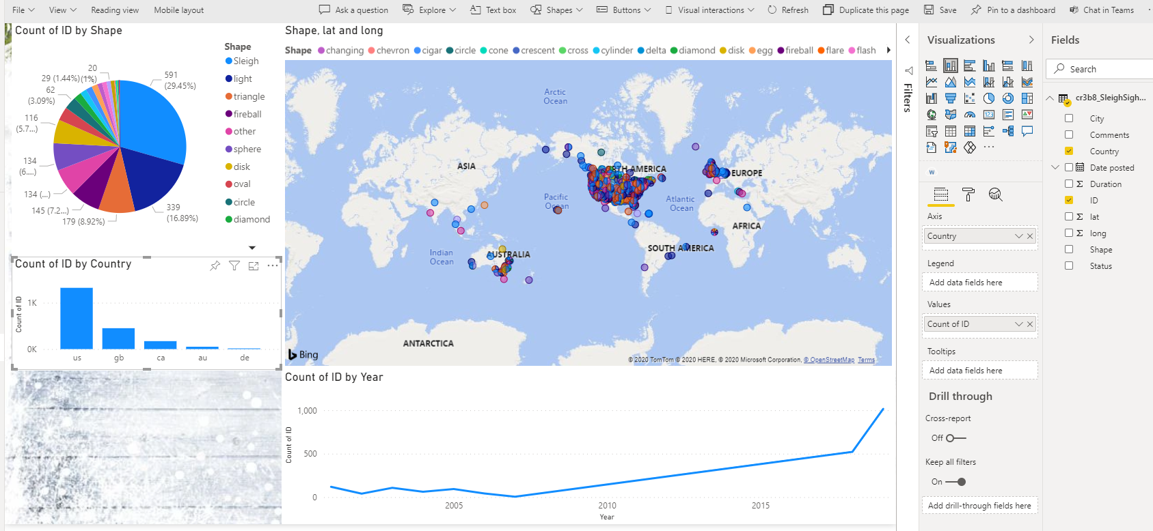

Finally, the last visual will enable us to better undderstand the details of the sightings. We will be using a custom visual that has already been uploaded to yhourt Power BI report for you.

Remember to deselct the current visual before adding a new one. Select the **Word Cloud** visual from the **Visualization** panel. This new visualisation will be added to the last remaining slot on the report canvas.

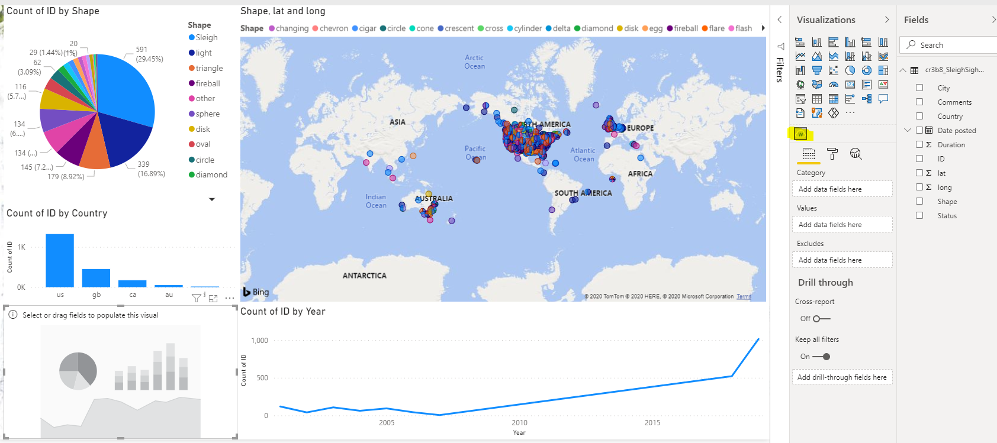

To better understand the details of the sightings map the following fields to the visualisation properties:

* Category : Comments
* Values : ID

Change the value in the ID field from **First ID** to **Count ID**.

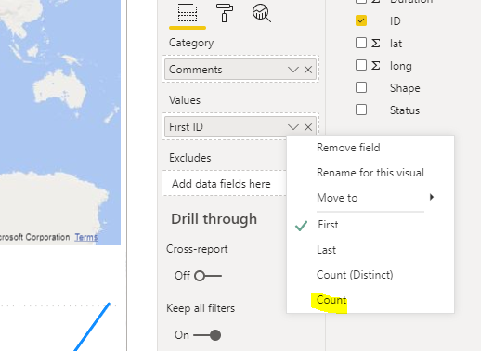  
The word cloud will look something like the image below :

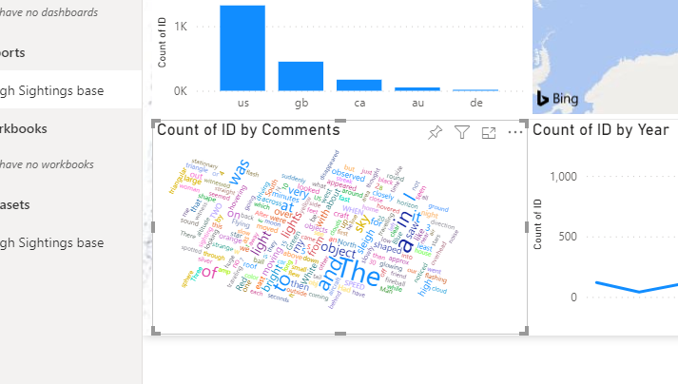

This is great, but irrelevant words are being included in the report that provide very little to no significant vcalue to us. These are calles “Stop Words” (Such as : And, a, but, is, that) We want to exclude these words from the visual.

Make sure the **Word Cloud** visual is still selected. In the **Visualization** panel, seklect the Format option to view all formatting properties.

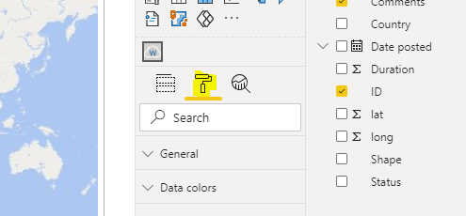

Scroll down until you find the **Stop Words** property. Expand that and turn on the **Default Stop Words** option.

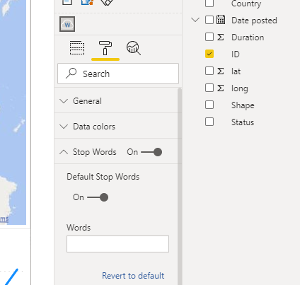

This will change the way the word cloud visulaisation displays information.

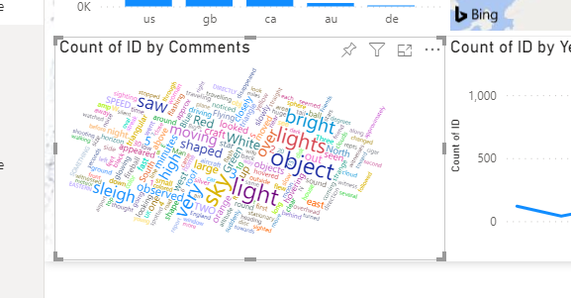

Congratulations, you have created your Santa Sleigh Sightings Power BI repoirt. Please save this report before you test it out by selecting the **Save** option from the tool bar.

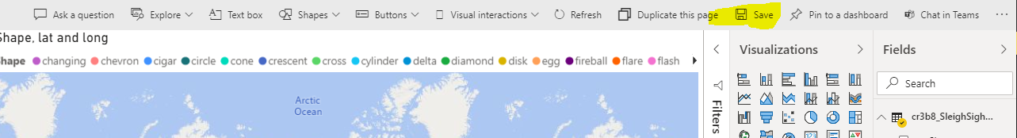

Once your report has been saved, Select the **Pin to Dashboard** option from the toolbar.Enter in the dashboard heading **Sleigh Sightings,** and then select **Pin Live.**

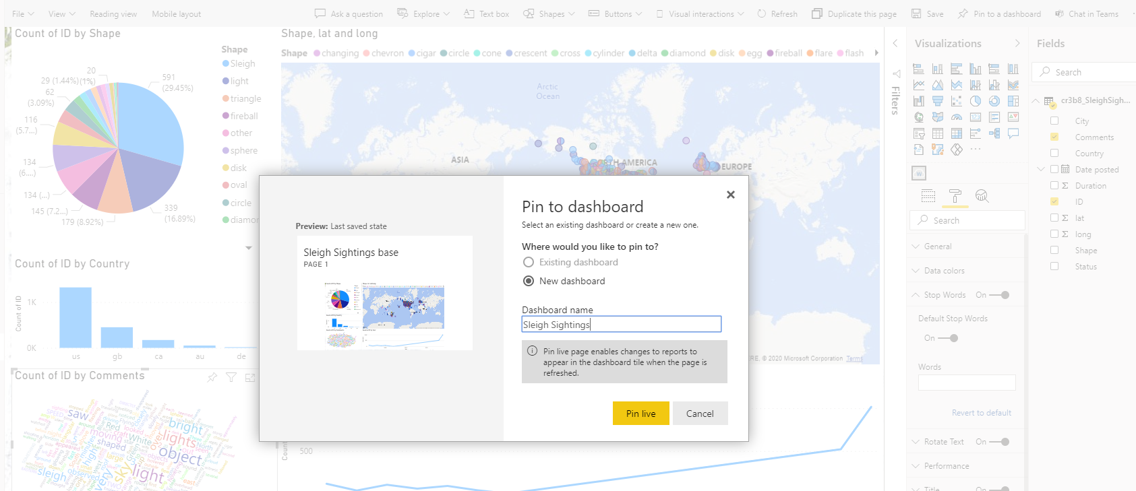

You will see that the new **Sleigh Sightings** dashbvoard has been added to the **Dashboards** within **My Workspace**.

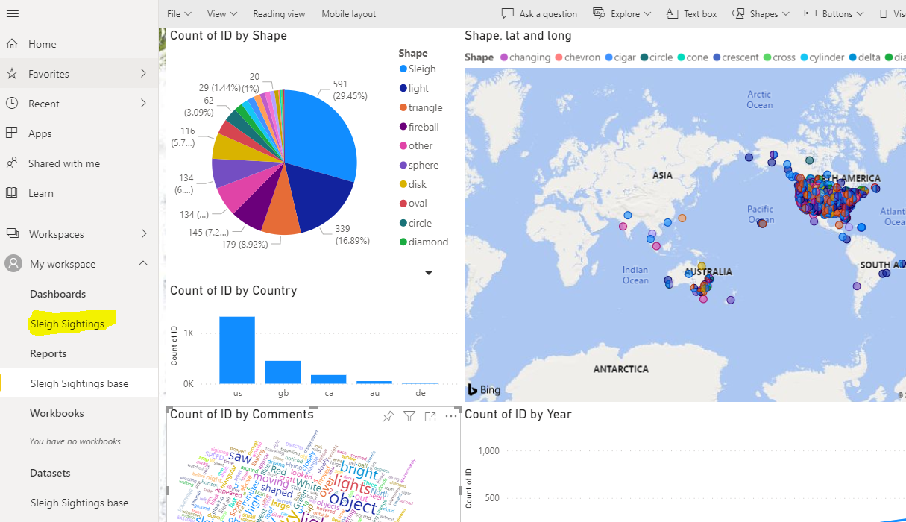

To test your new dashboard simply select **Sleigh Sightings**.

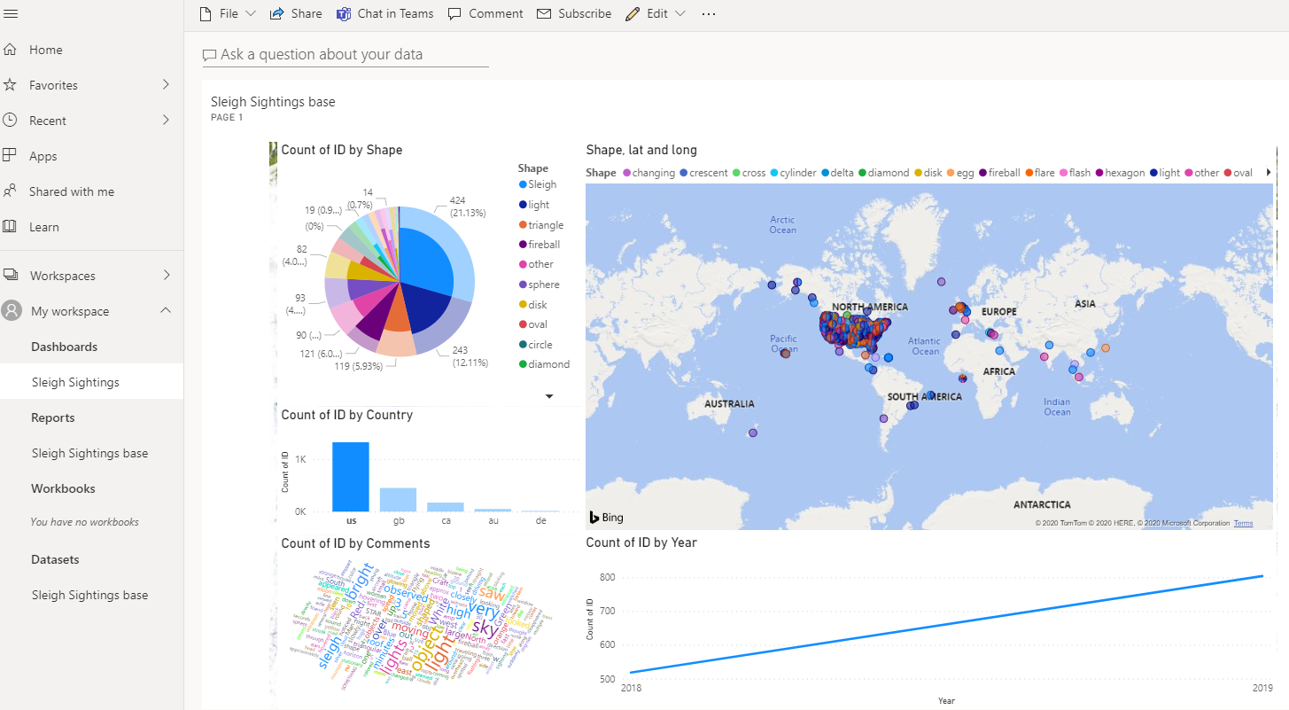

You will then be able to select various elements on the dashboard to drill into the data to understand it further. As we can see, wehen drilling into the **US** in the Bar chart visual, the data in the dashboard significantly changes.

# Final Learnings

The Microsoft Power Platform provides immediate value to businesses in an incredibly short amount of time by allowing users the ability to create solutions to solve problems and fill gaps in organisations typical SaaS type applications cannot normally solve. It’s Flexibility and ease of use provide makers with a performant, scalable and affordable platform that has the capacity to be adopted in all areas of the business.

